H2 console.

1. Enter the following line in the application.properties file:
   1. Spring.h2.console.enable=true
2. Restart the server i.e. run Spring5webappApplication.
3. Look for the following lines in the console log to get the database name for this session:
4. main] o.s.b.a.h2.H2ConsoleAutoConfiguration : H2 console available at '/h2-console'. Database available at '**jdbc:h2:mem:c2eff049-bffe-4fb6-9977-0b0a00ed00e1'**

This is the database name, copy and paste into the JDBC URL as shown below

1. Start your browser and enter the following:

//http:localhost:8080/h2-console

No password required.

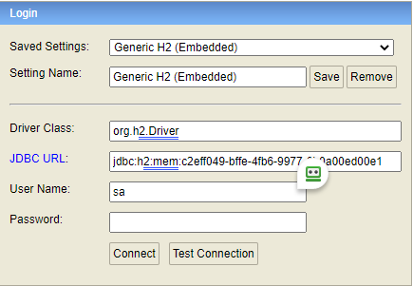

**Spring MVC**

**Spring Framework’s Web Module**

MVC stands for Model View Controller

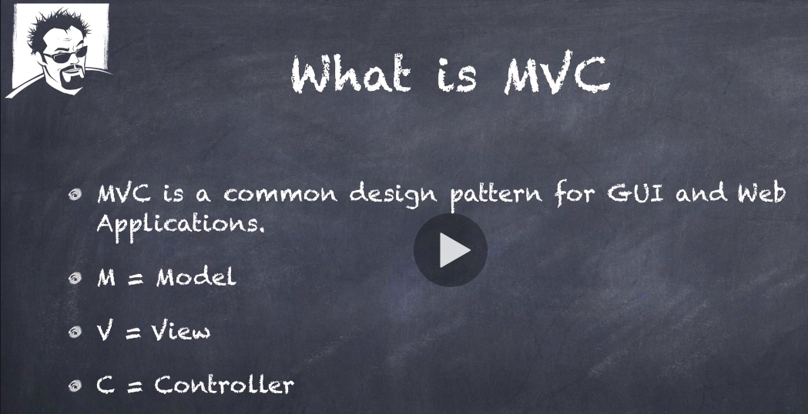

MVC is not unique to Sprint and versions of it is used throughout the development languages and their frameworks.

**Spring MVC**

**Spring Framework’s Web Module**

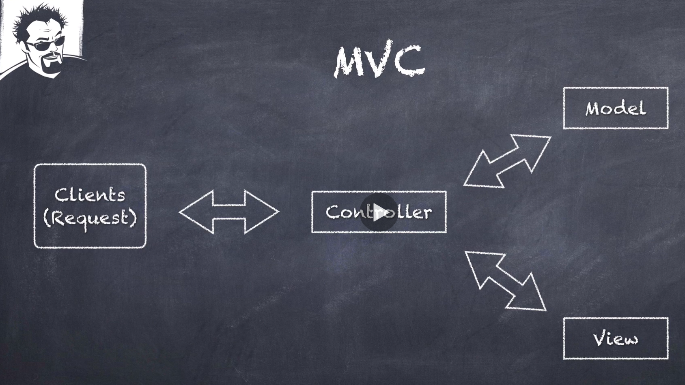

The controller gets the clients request, determines the model, and passes that onto the view.

The model should not contain any business logic, it should just be a data structure.

The Controller is a traffic cop deciding how to get the model who to ask the model from. Keep the Controller light.

The Controller is going to return the model to a view component.

The view component its purpose is to render the view for the client.

We are going to be using Thymeleaf templating engine to create the view, Thymeleaf is going to be taking the model (a POJO) and generates the HTML to return to the client.

**Spring MVC**

**Spring Framework’s Web Module**

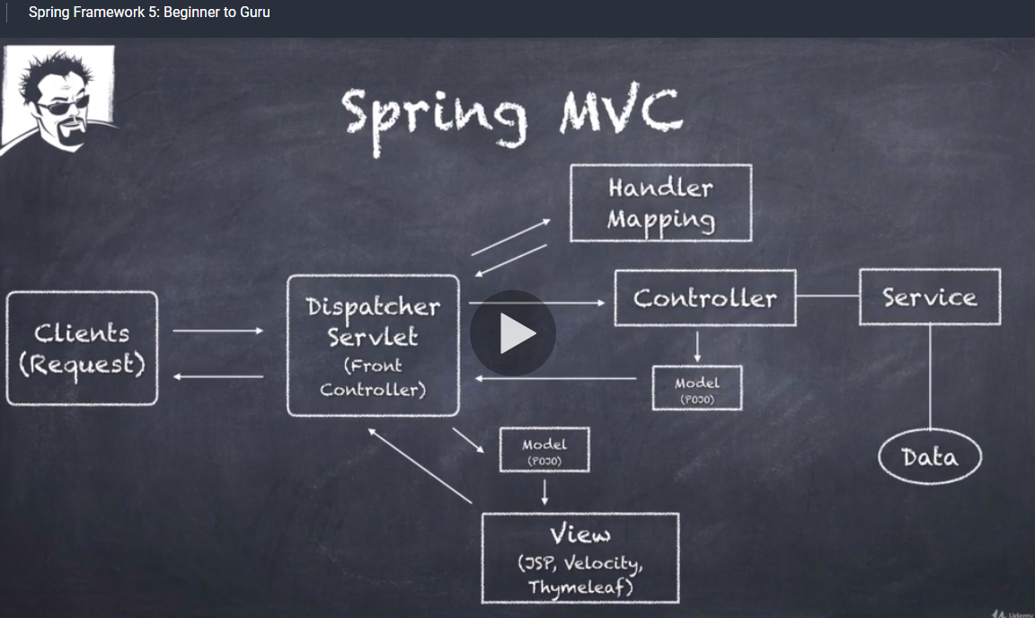

Now looking at MVC purely from a Sprint context.

1. Client request comes in, typically http, it could be for a web page or a REST services control.
2. The Dispatcher Servlet receives the request. It decides how to handle it and it refers to the Handler Mapping because you are going to a specific path and making a request from the server, so it says now where do I go for this.
3. The Handler Mapping determines the controller to be utilised and passes that back to The Dispatcher Servlet.
4. The Controller is typically going to have a service layer wired up to it.
5. The service layer is going to get the data and return it back to the controller.
6. The controller is going to take that data, the model which is just a simple POJO and that is returned to the Dispatcher Servlet.
7. In this case the Dispatcher Servlet knows what it wants to do for the view, it could be a Rest call and would return back xml or json, it could be for HTTP HTML and in that case we are going to invoke view a technology to render HTML such as JSP, Velocity or Thymeleaf. The HTML is then rendered back to the client.

Spring Controllers

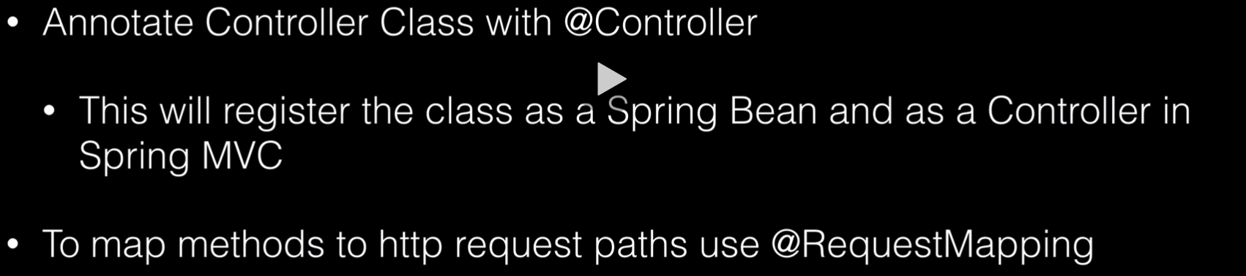

Introducing Thymeleaf

Pronounced (timeleaf)

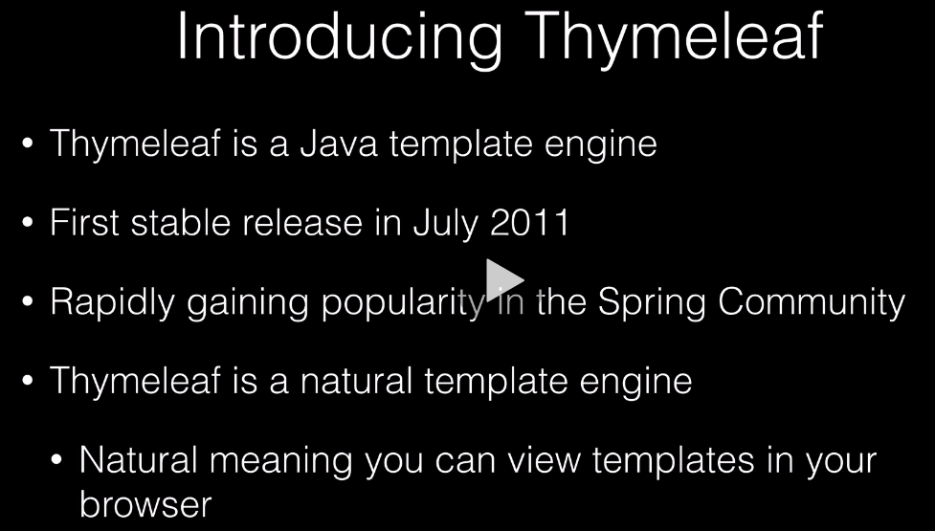

It is an alternative to Java Server Pages (JSP).



There are some outdated references on this, but it is an example.

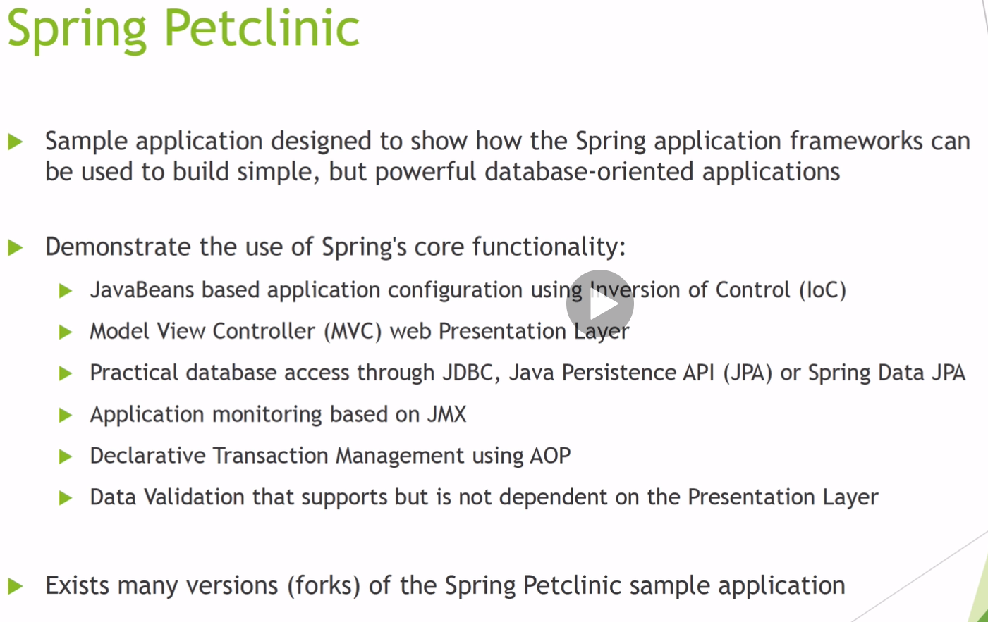

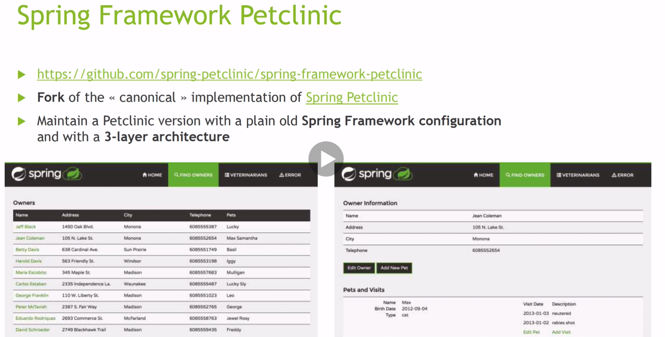

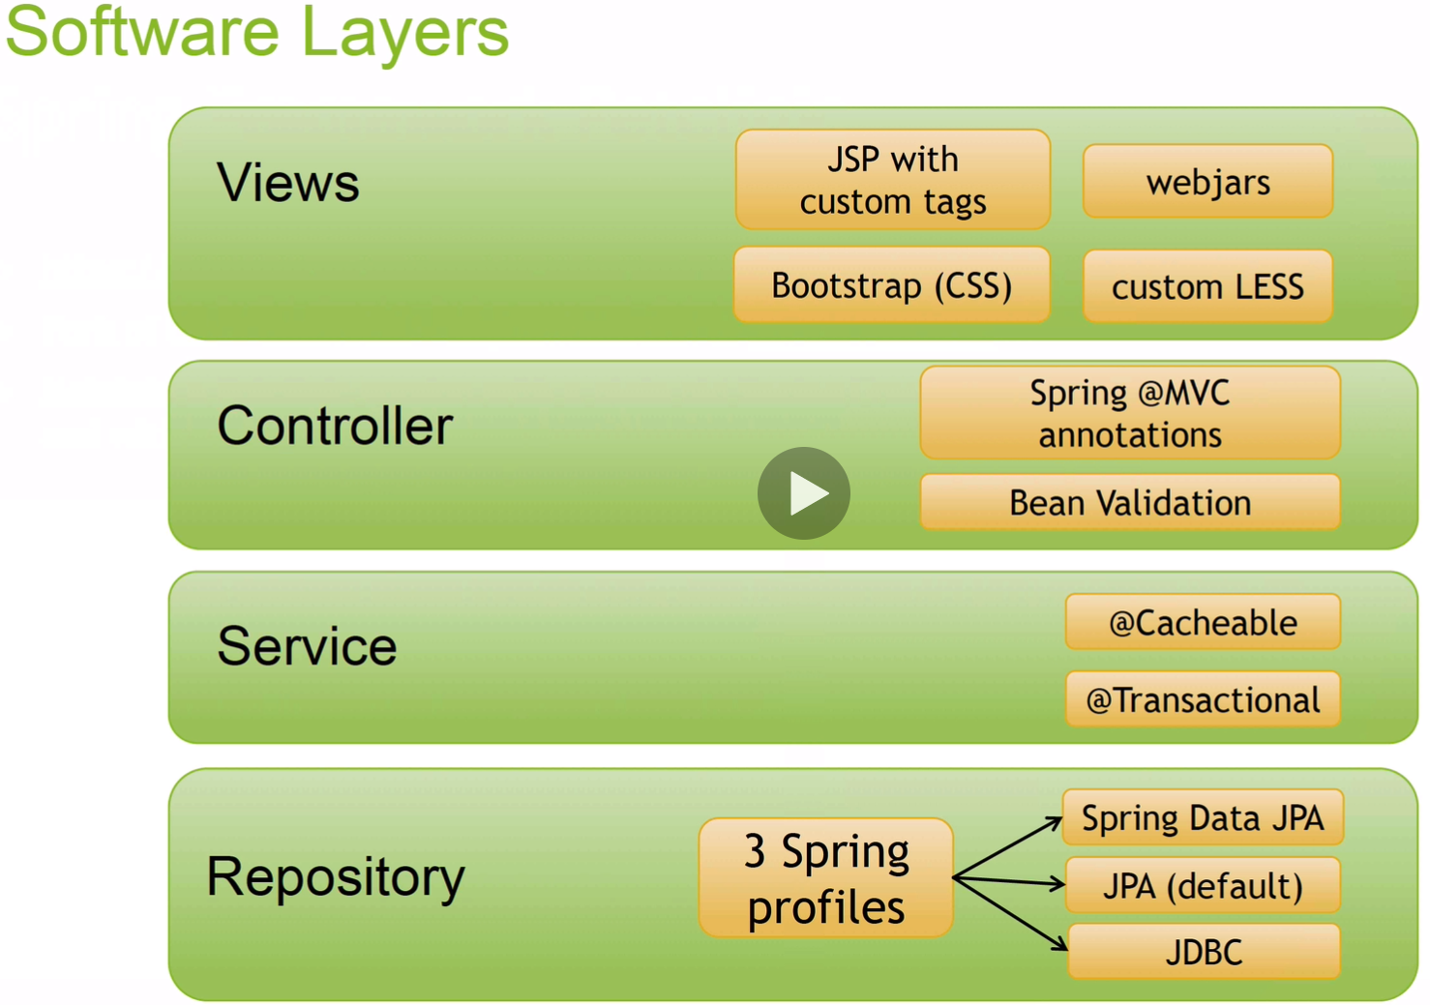

We will be using Thymeleaf and not JSP’s

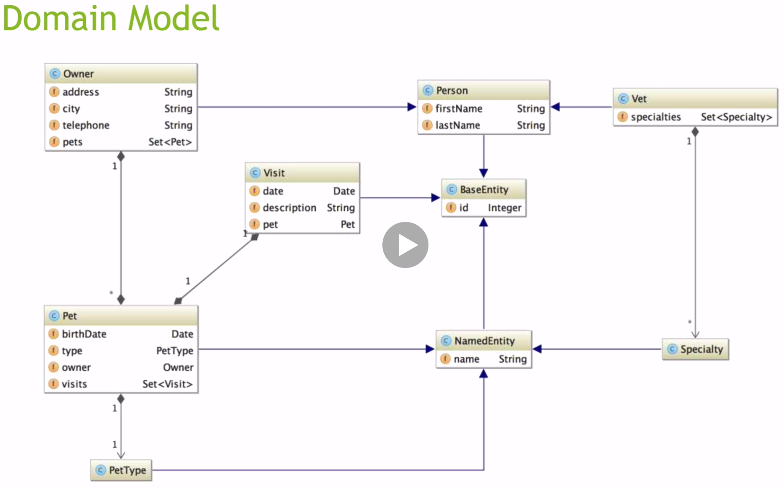

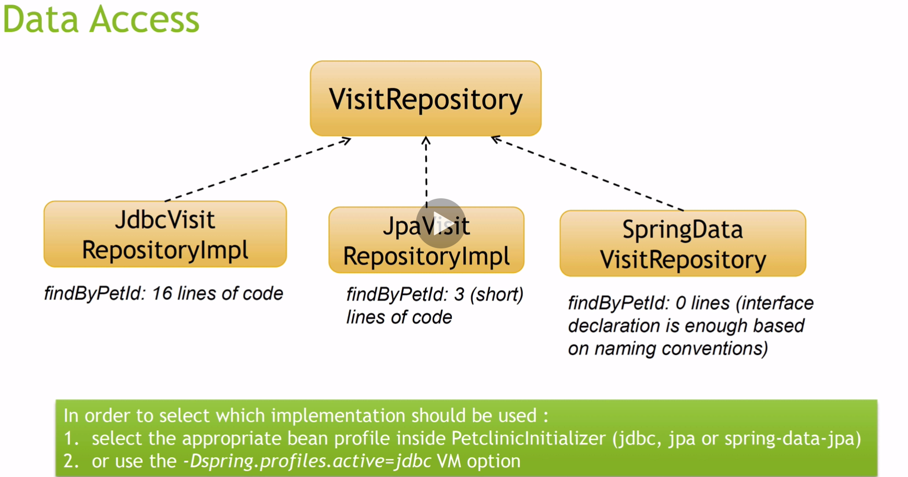

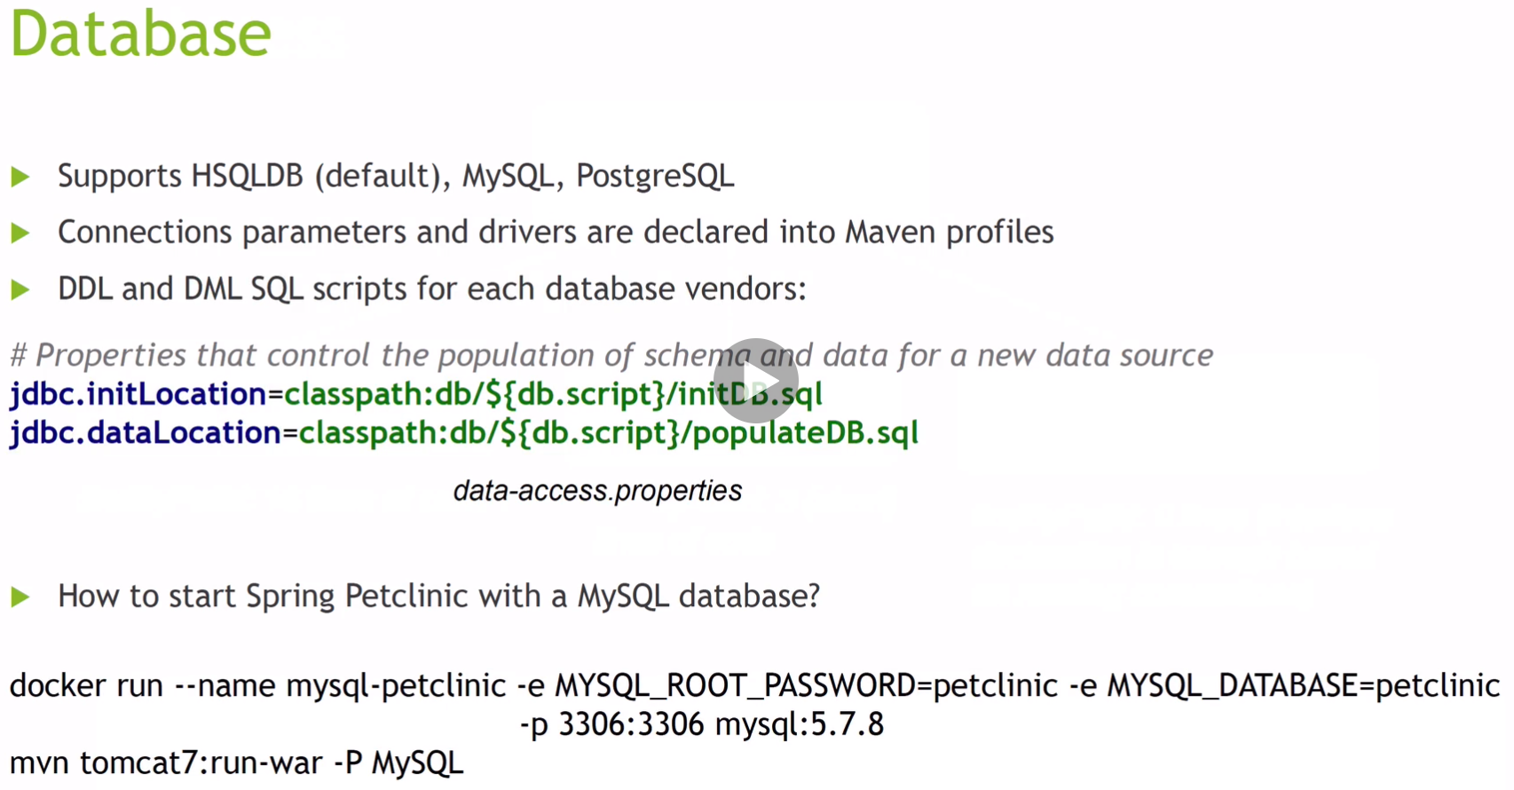

We will be using the h2 memory database.

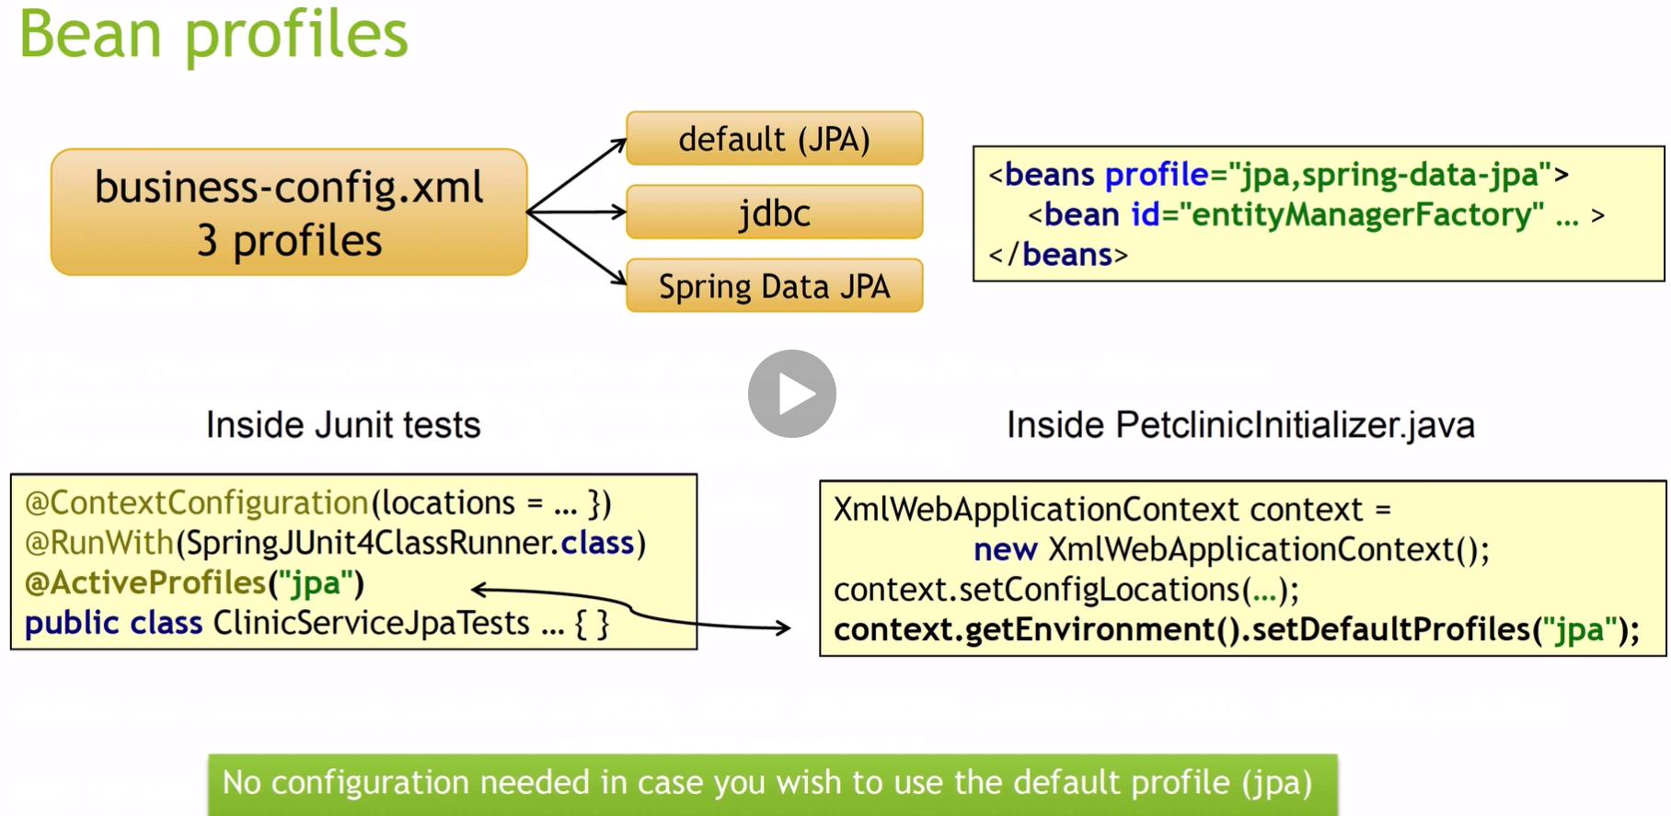

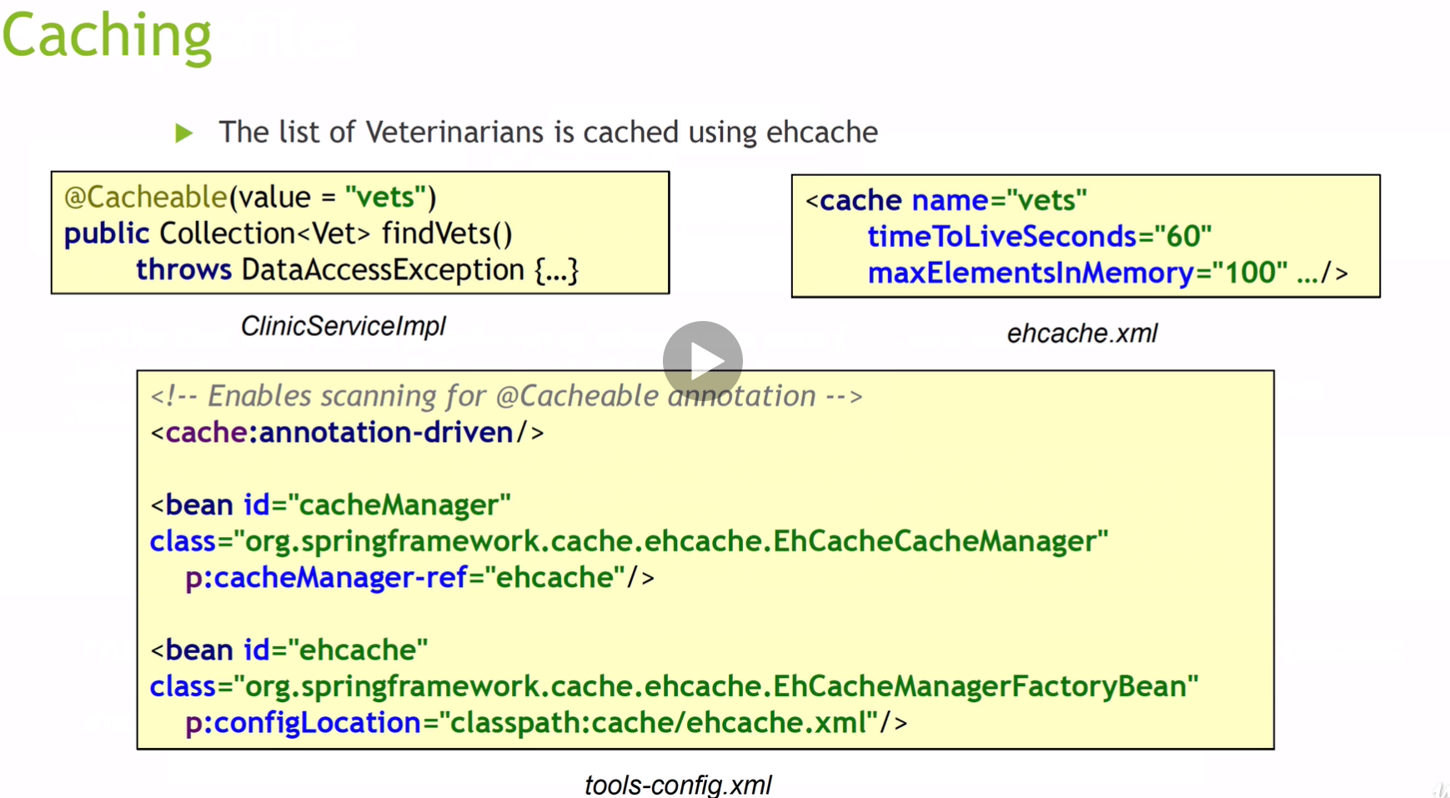

Our setup will not look like this because not too much xml is used in configurations today.

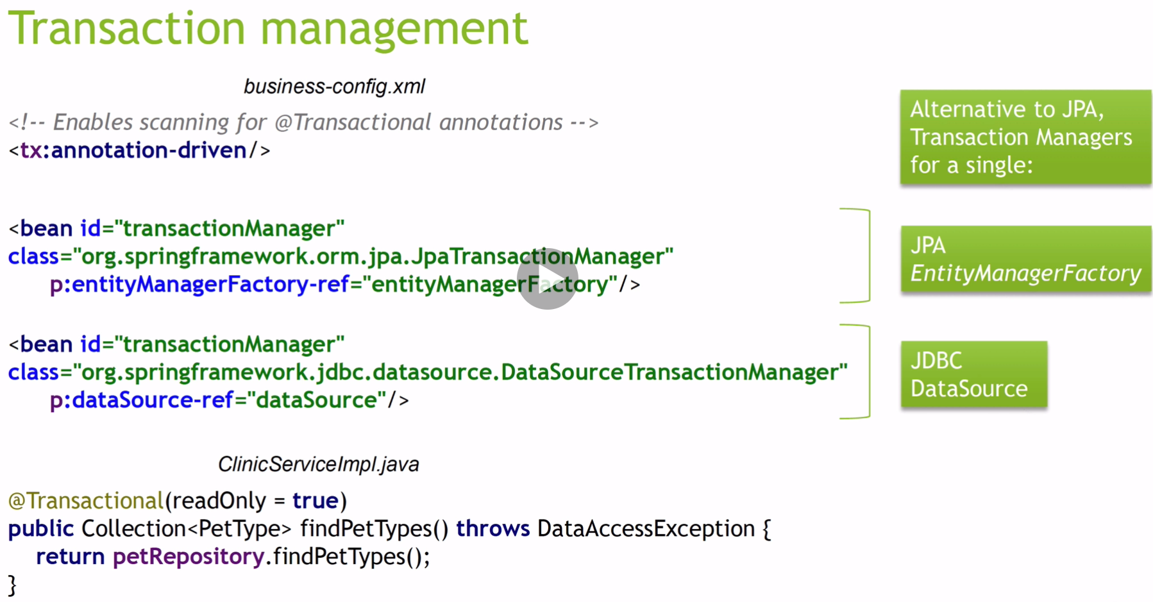

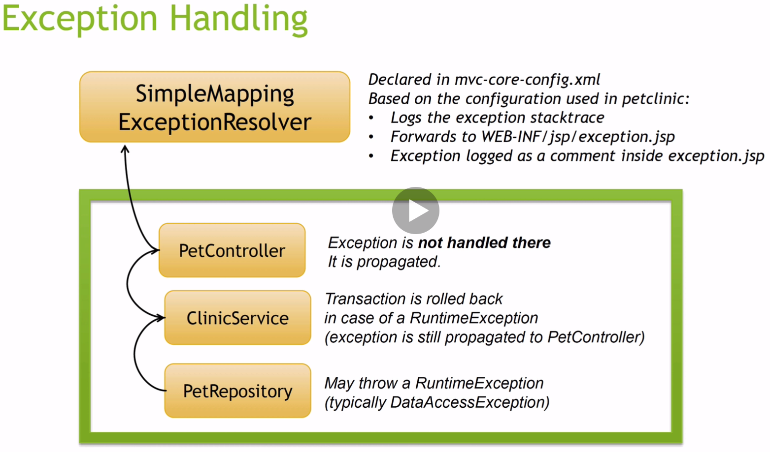

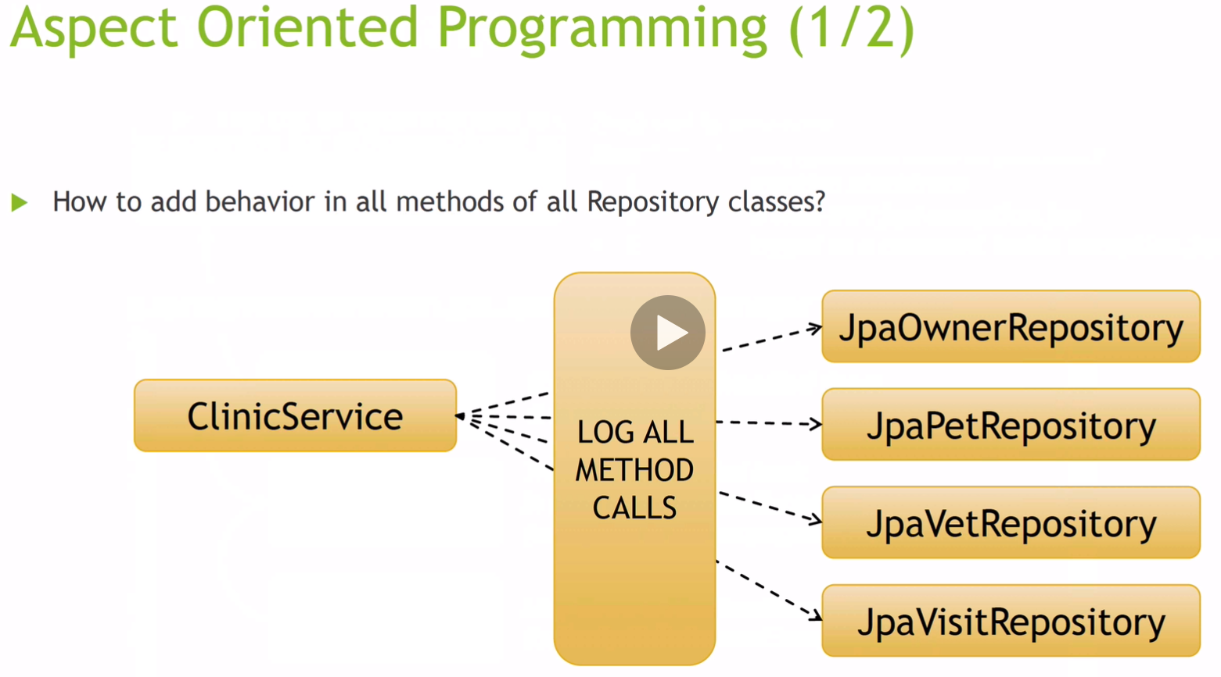

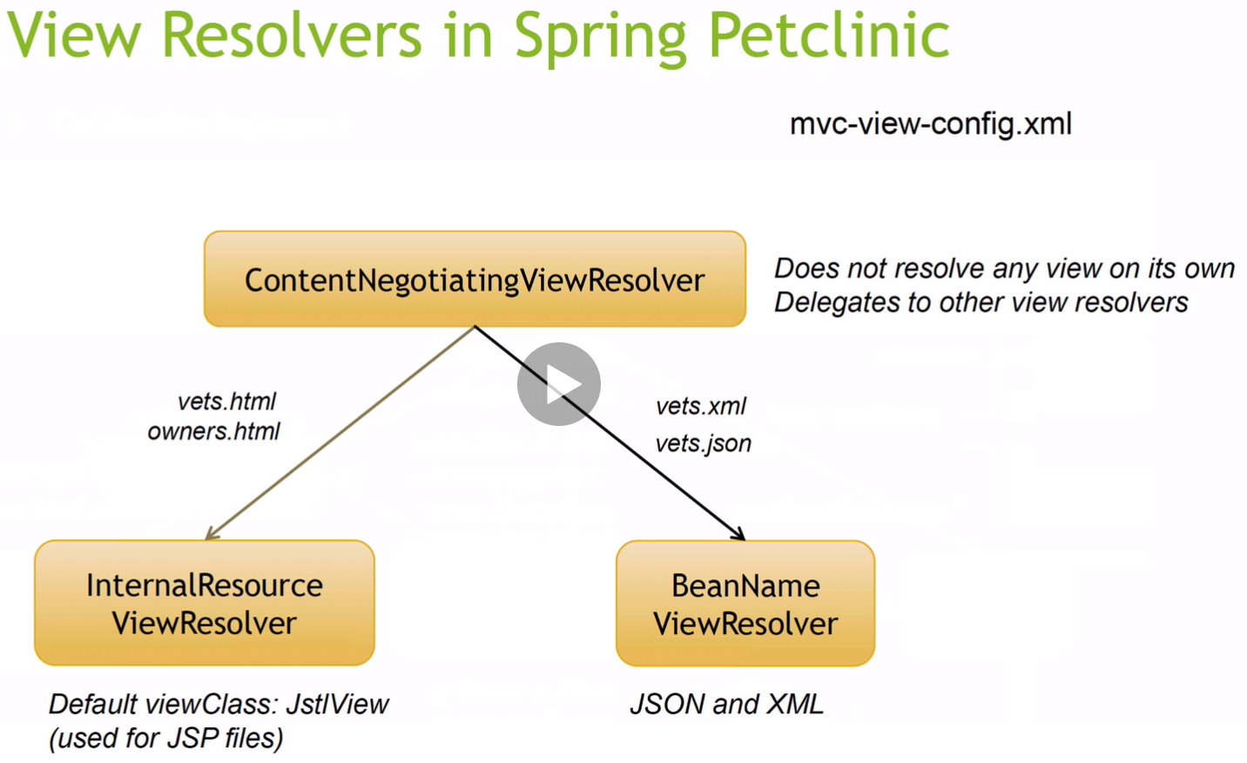

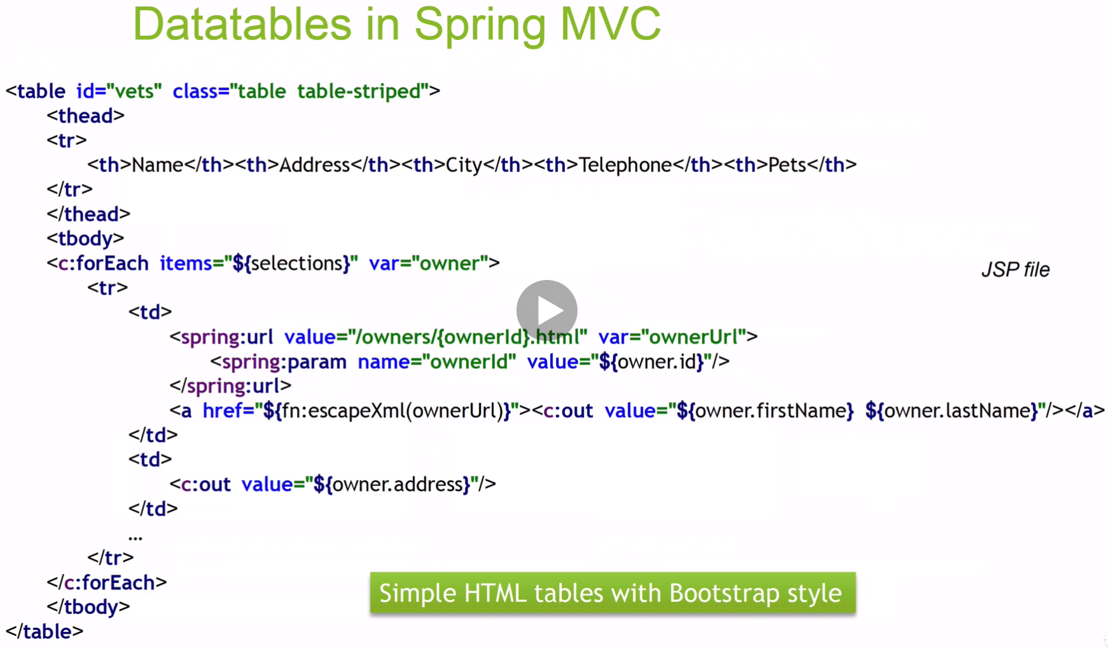

We will be using Thymeleaf instead of JSP.

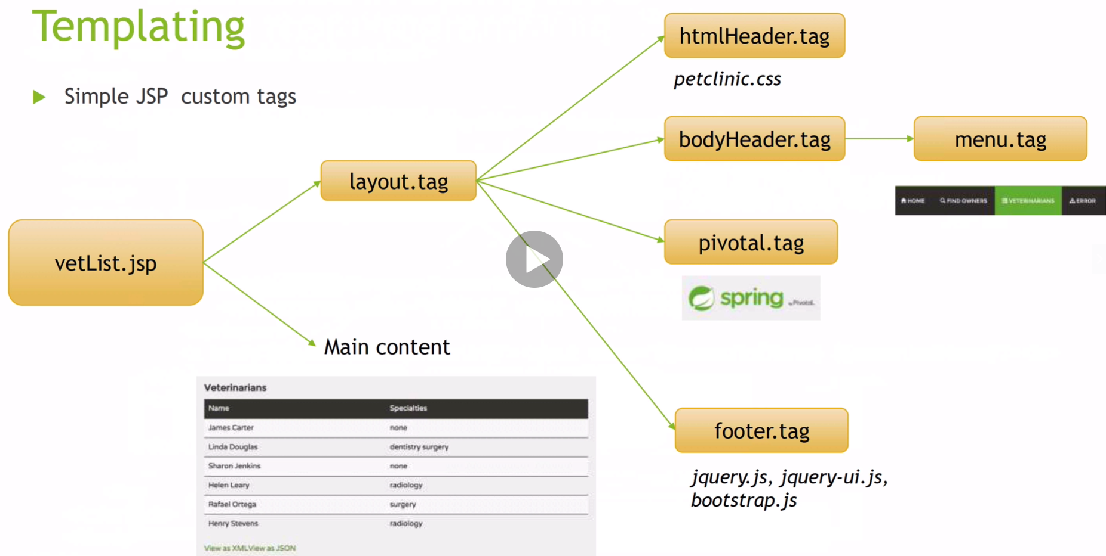

We will be using Thymeleaf instead of JSP.

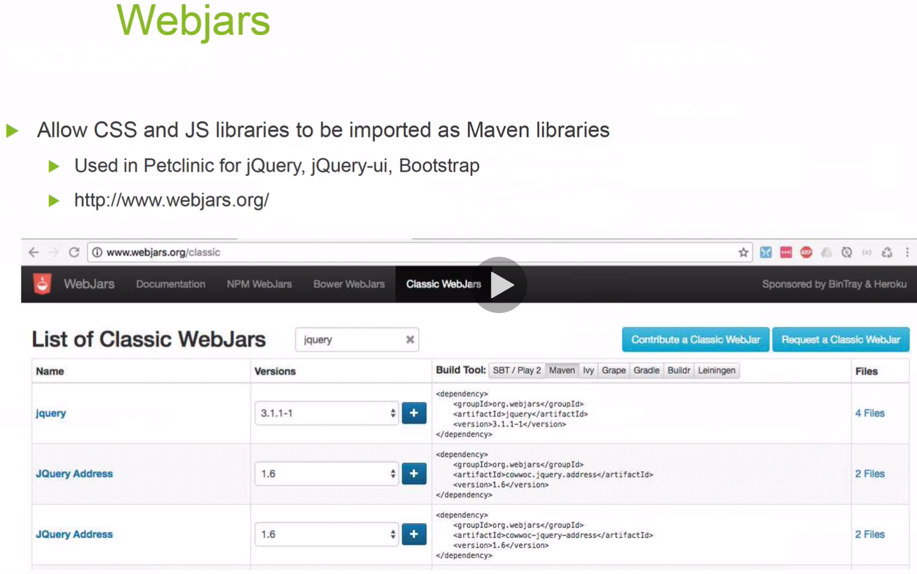

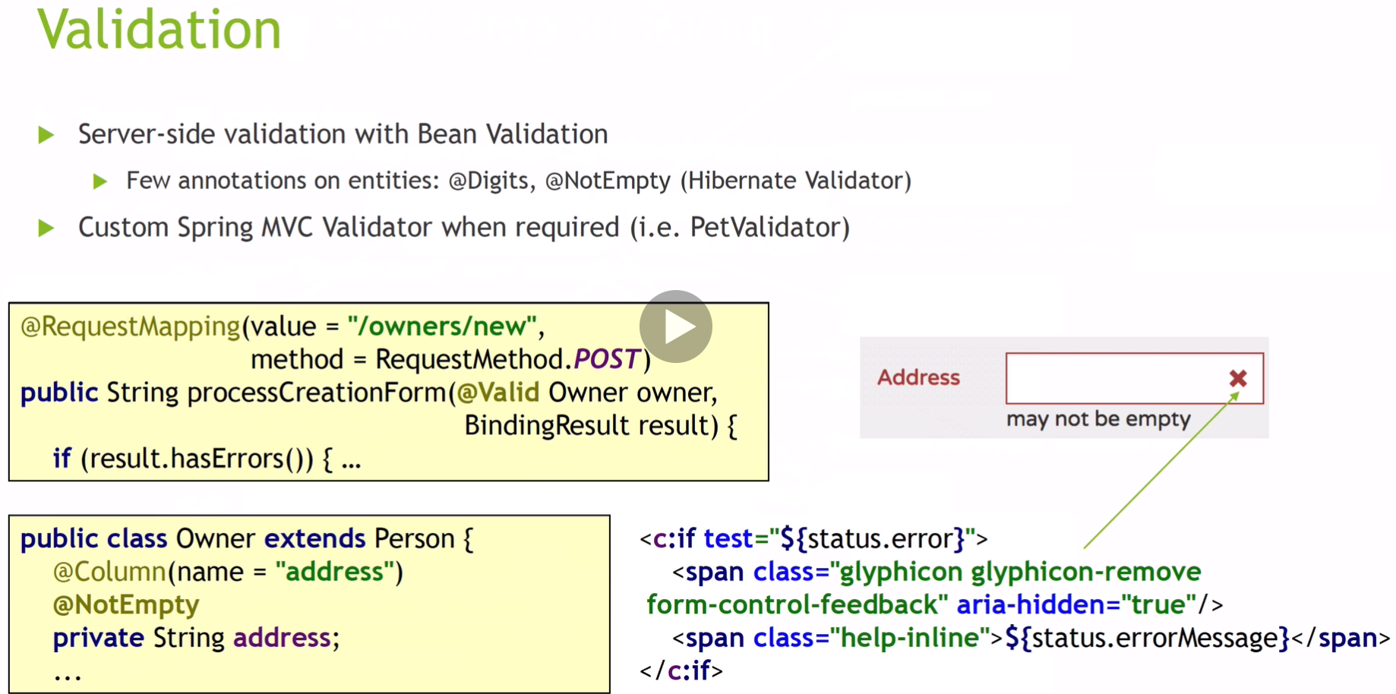

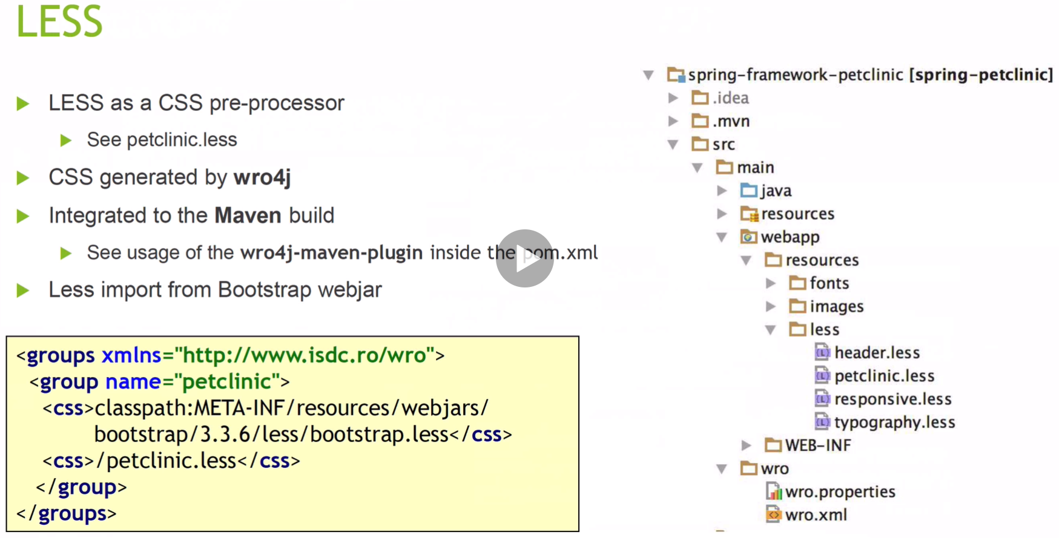

We will not be addressing the Less section.

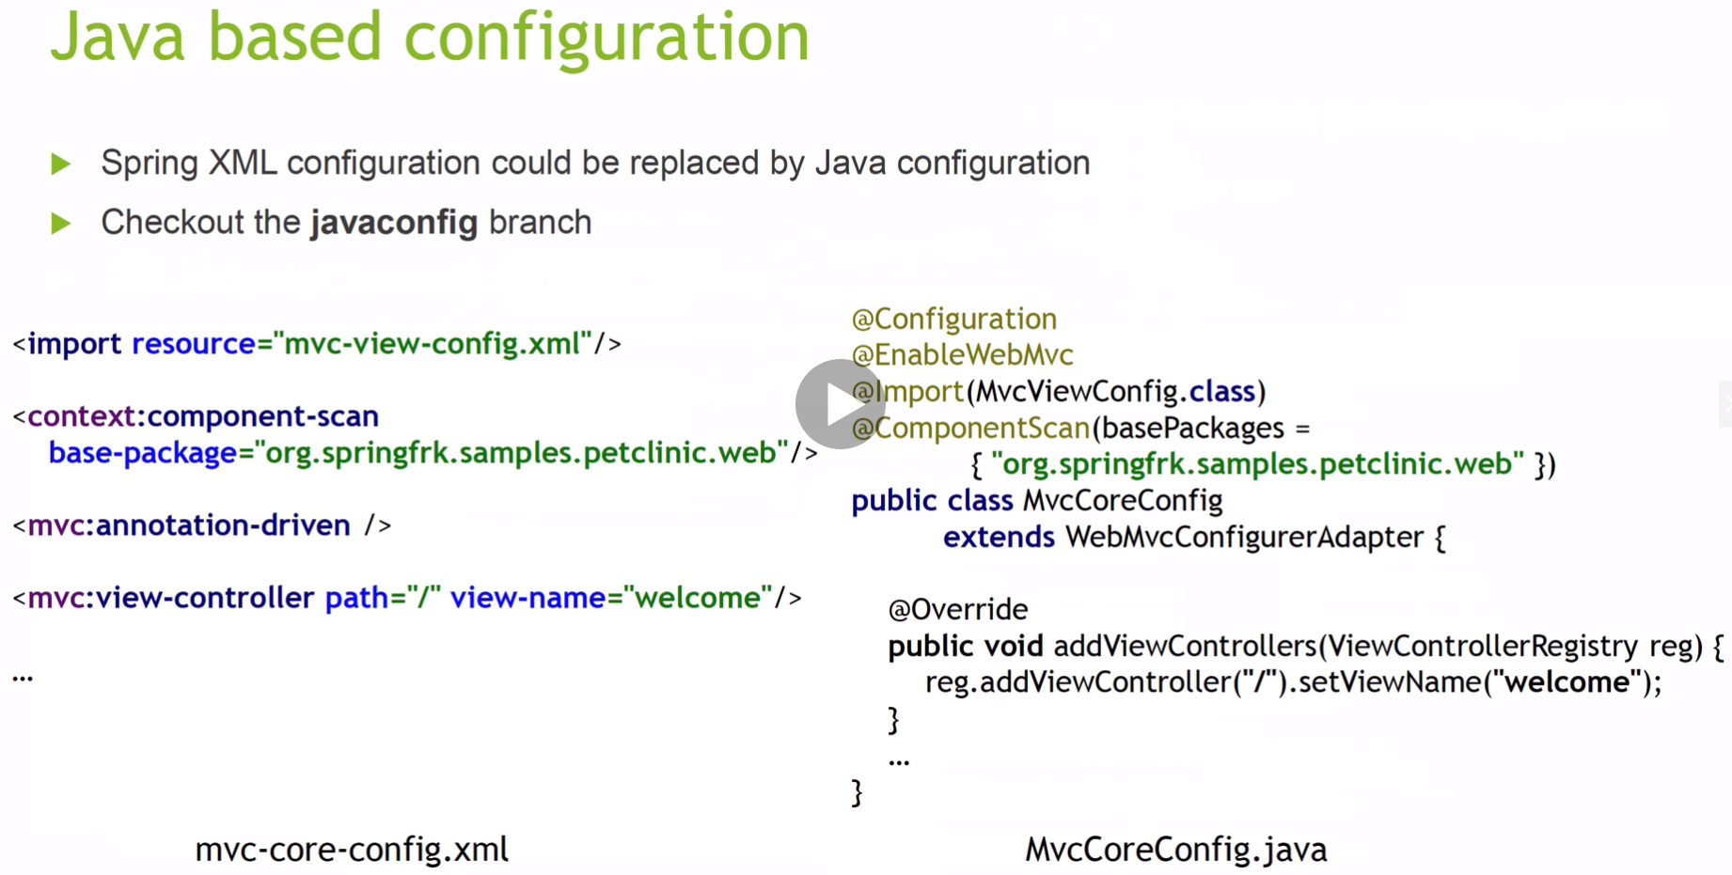

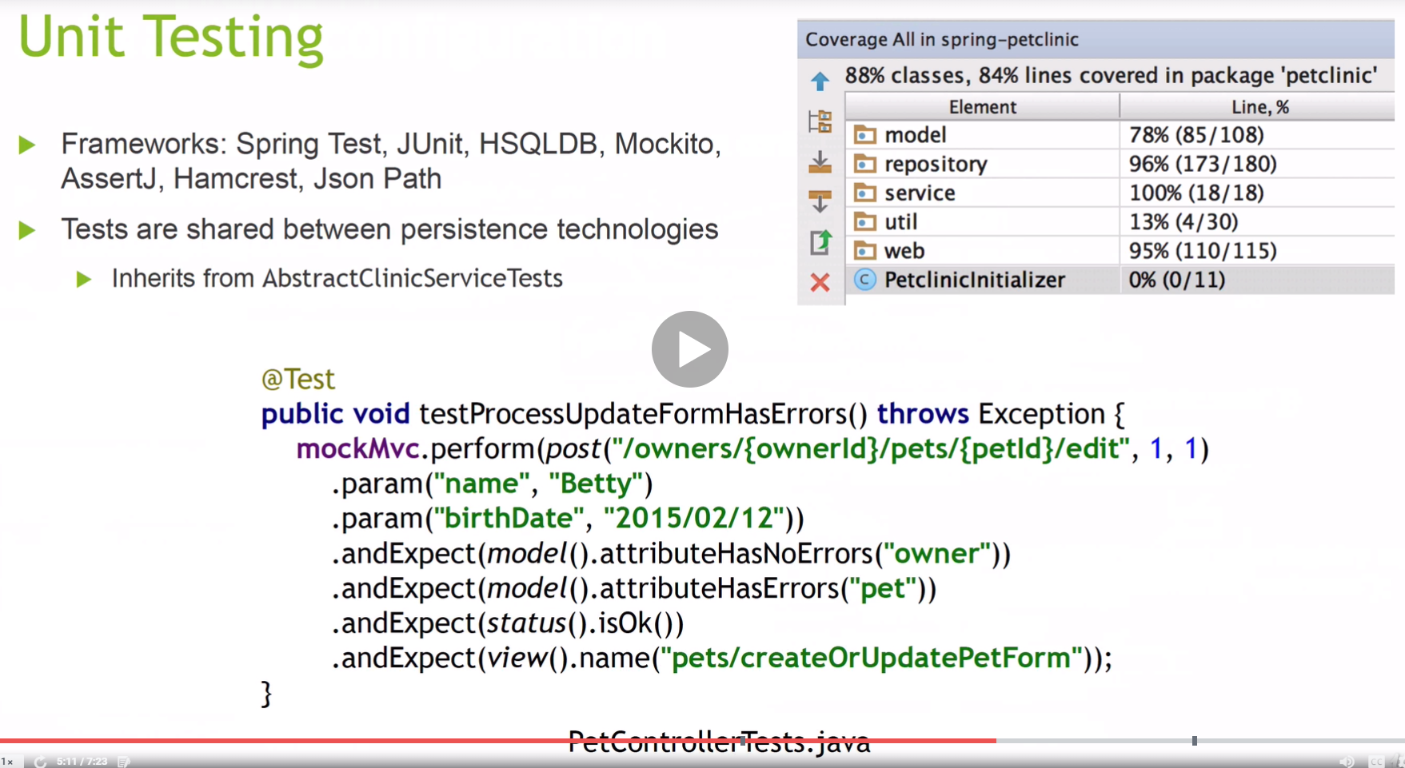

We will be using Junit5 which is the latest version.

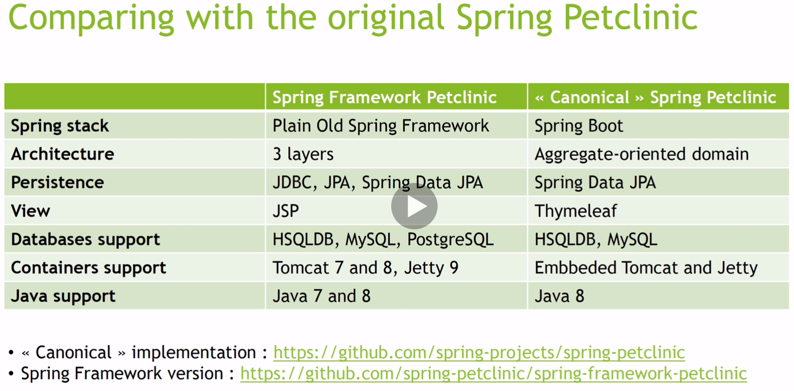

We will be using the Canonical Spring Boot and Spring Framework 5, and not the Plain Old Spring Framework.

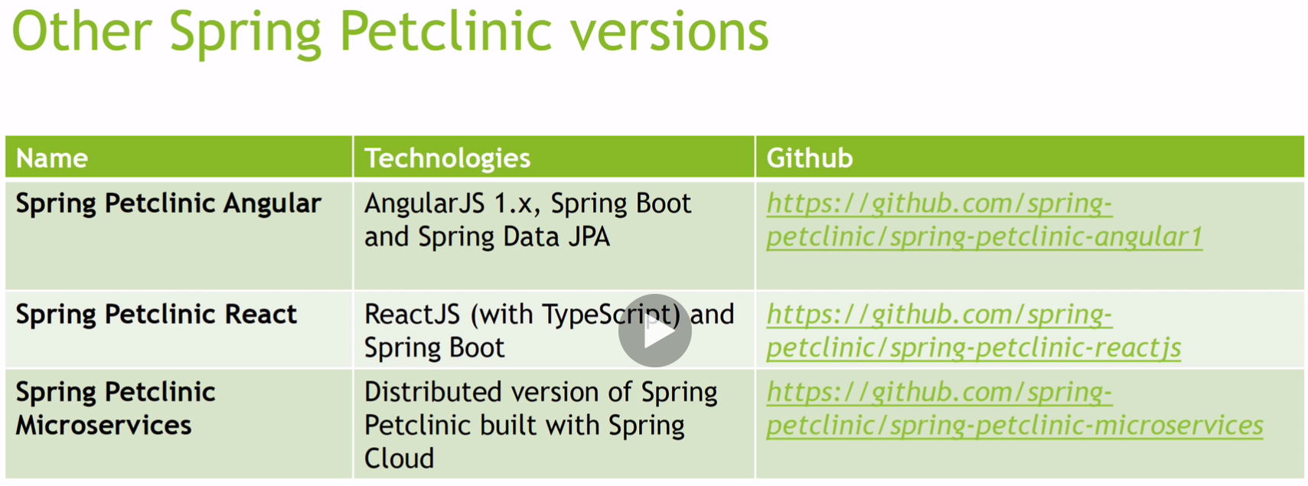



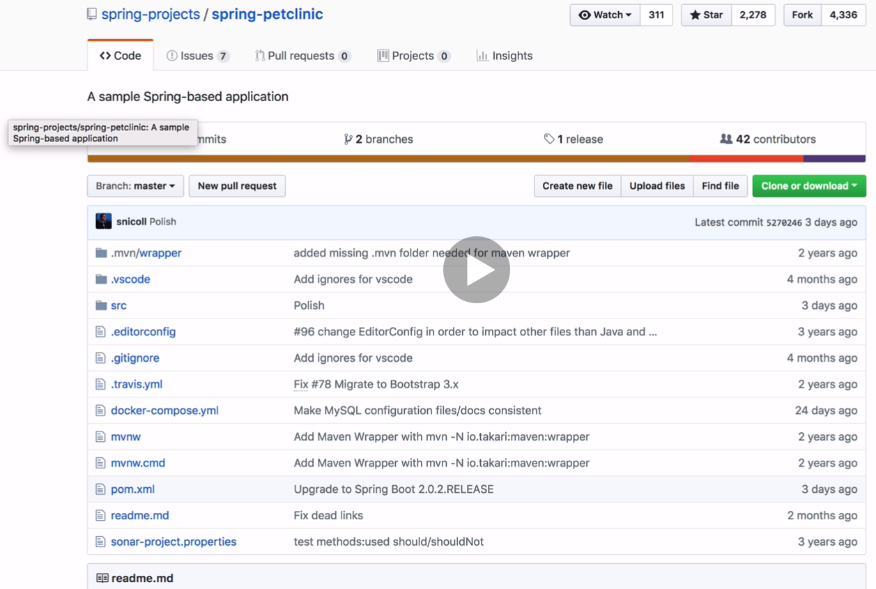

I have forked this down to my GitHub





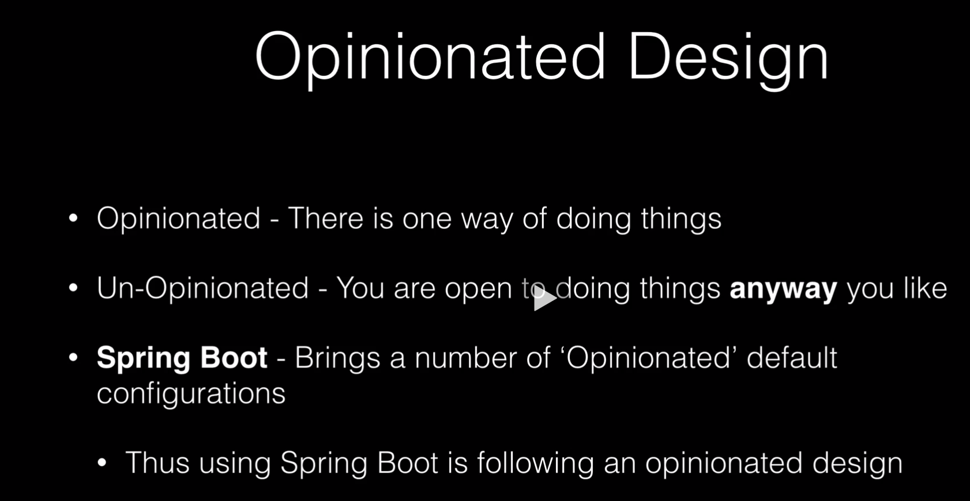

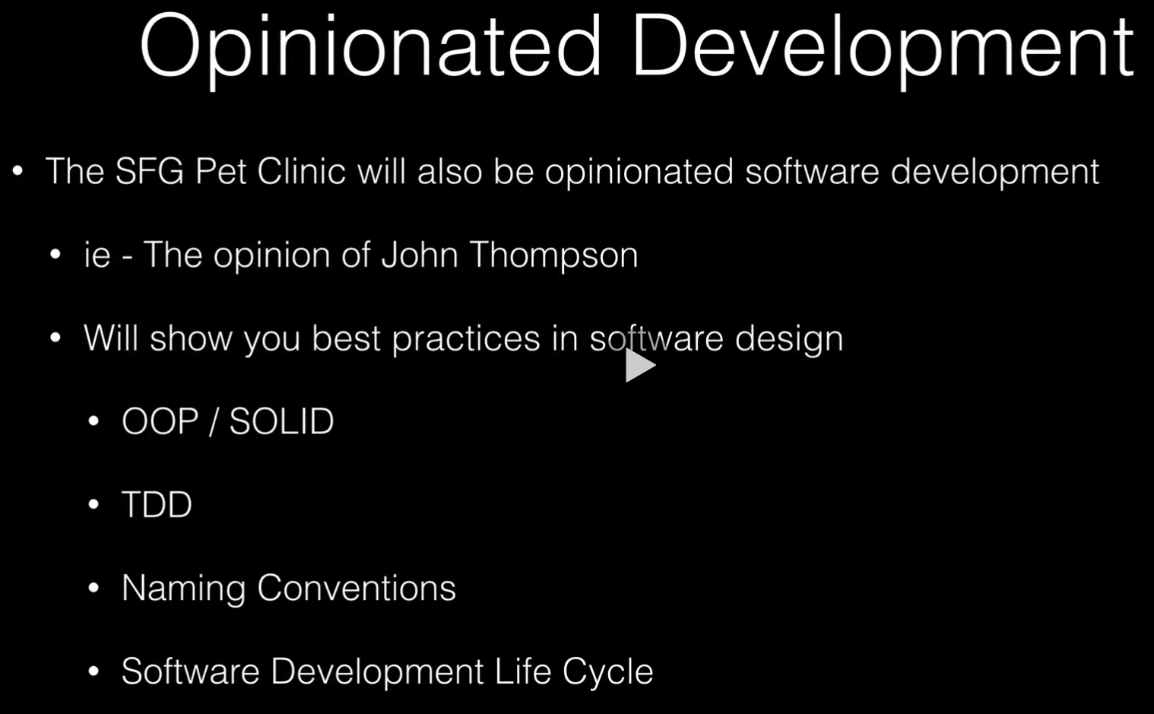

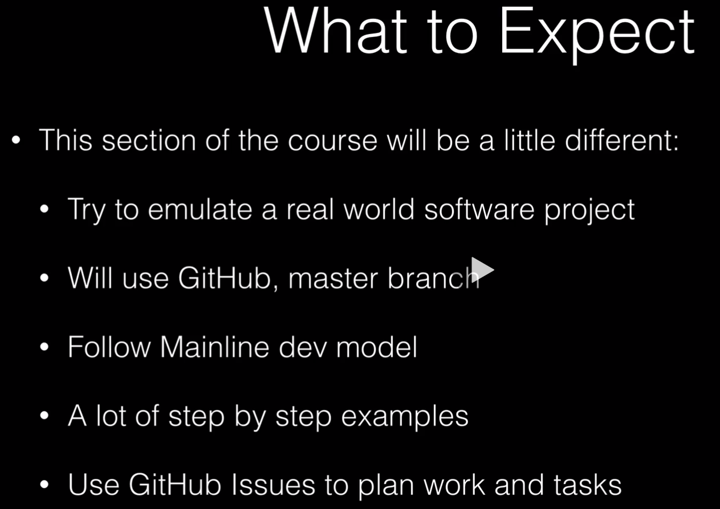

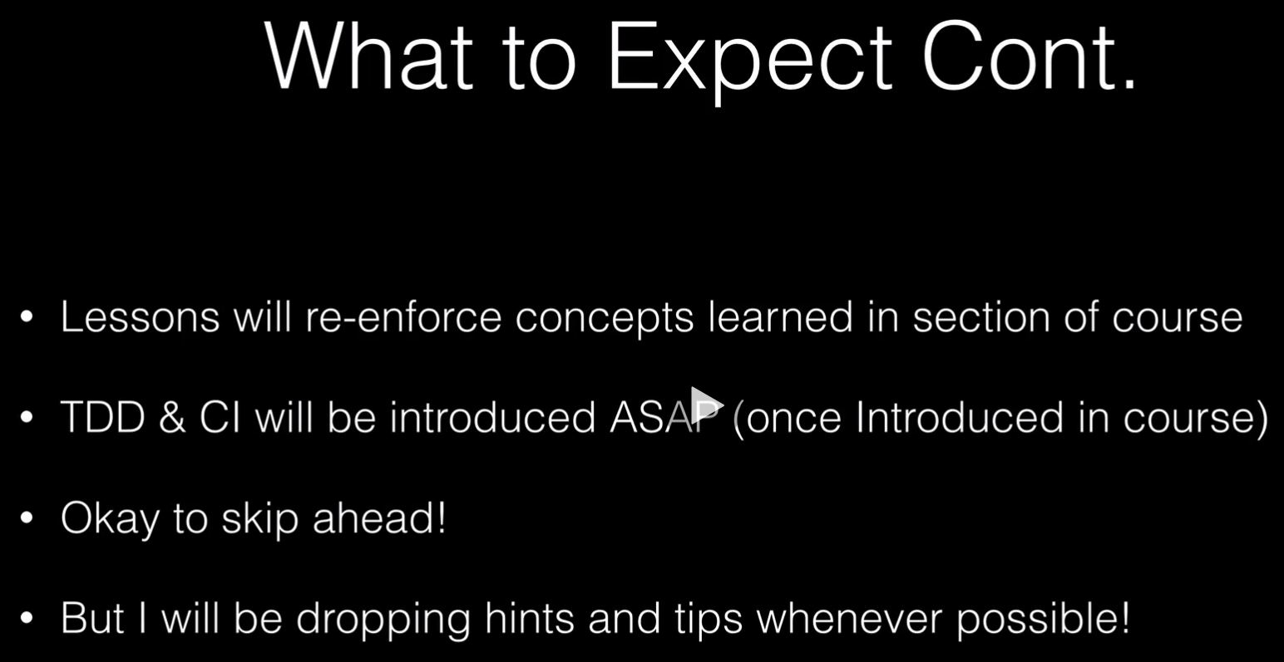



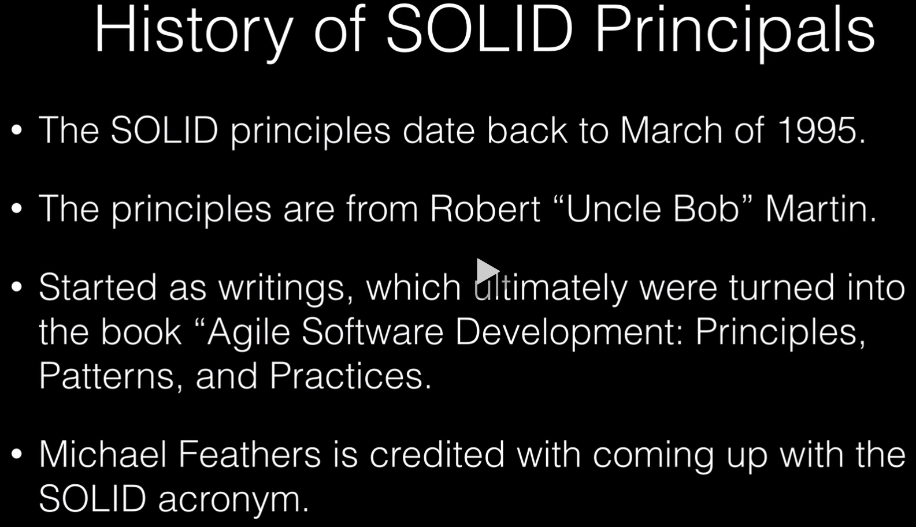

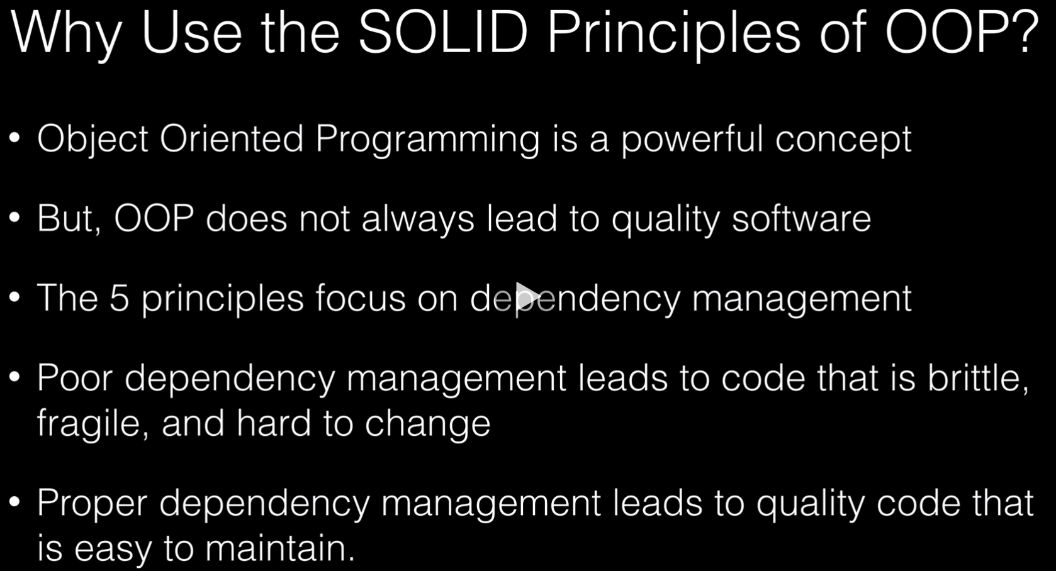

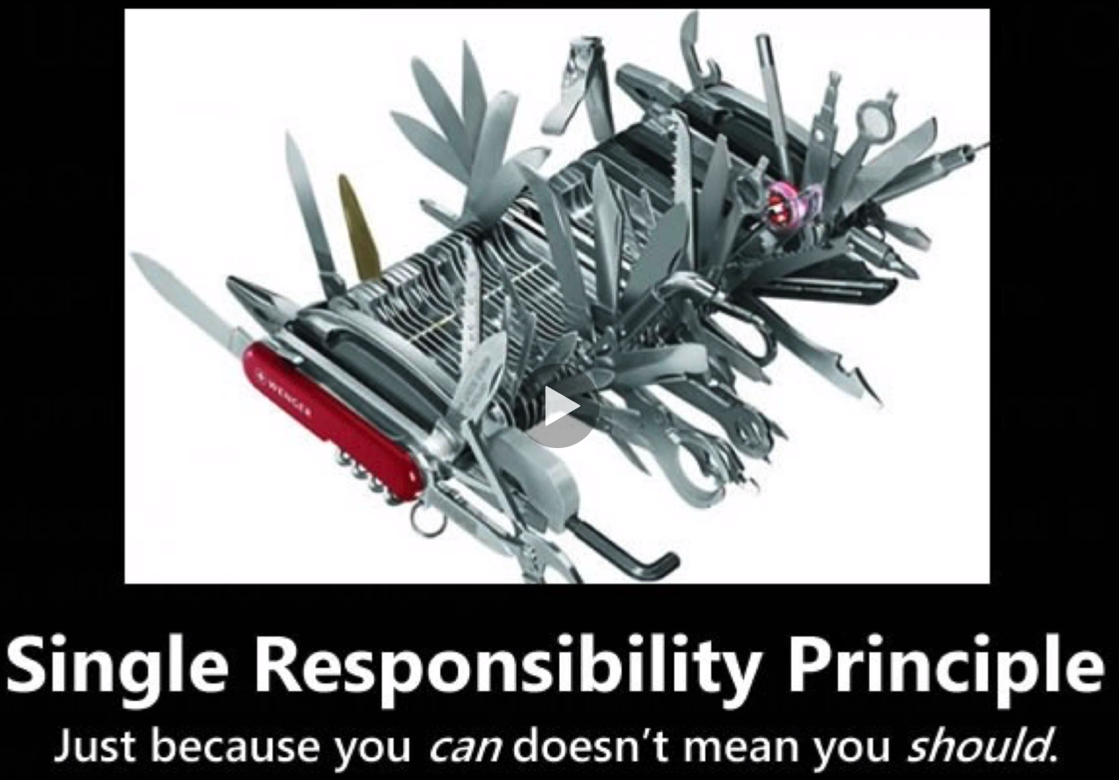

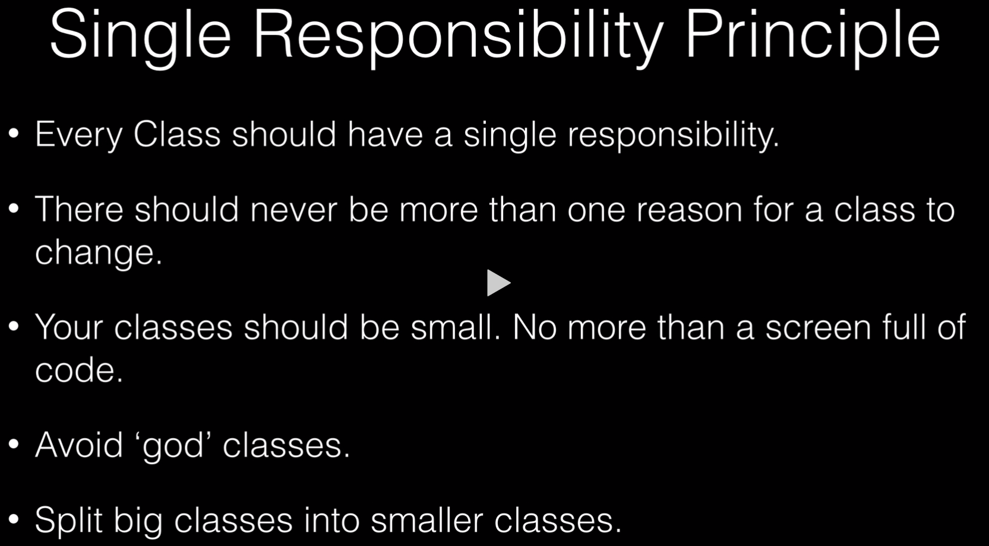



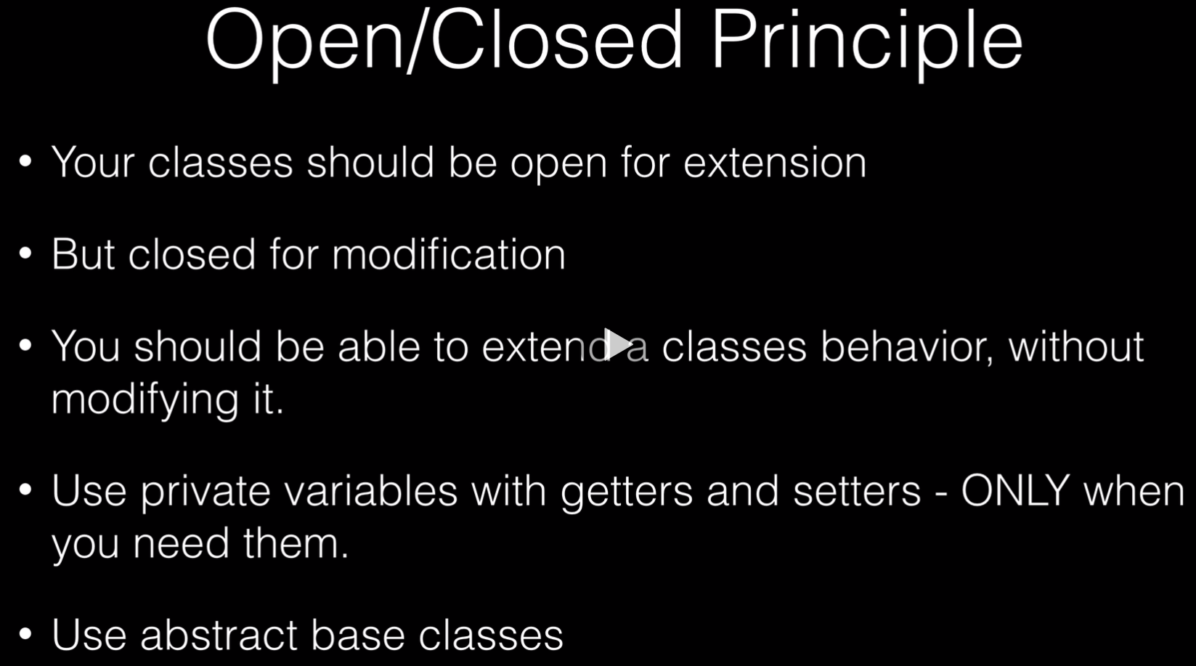



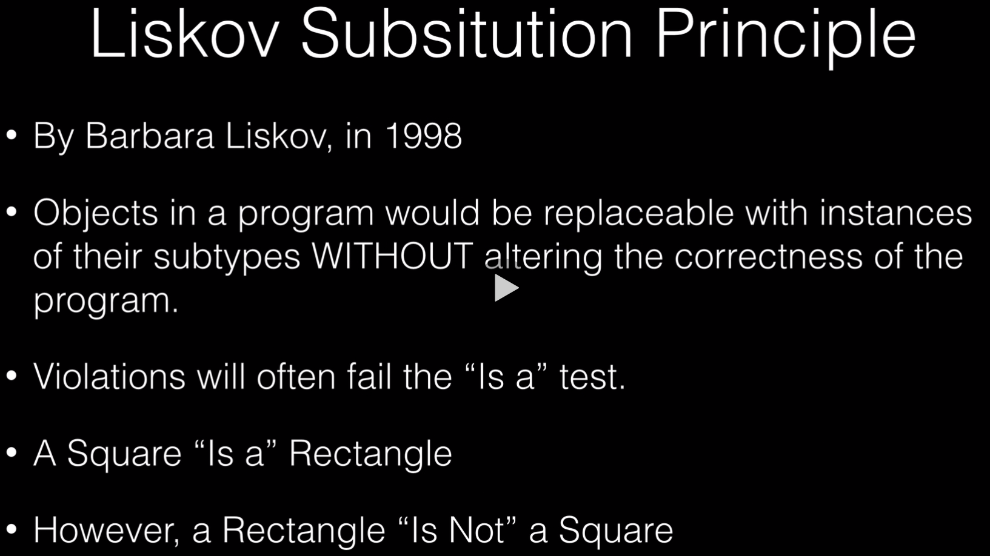

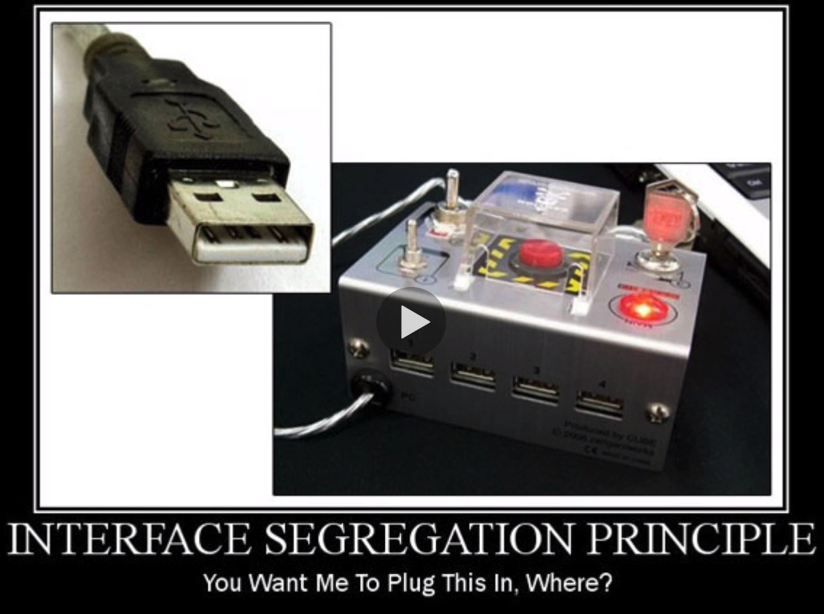

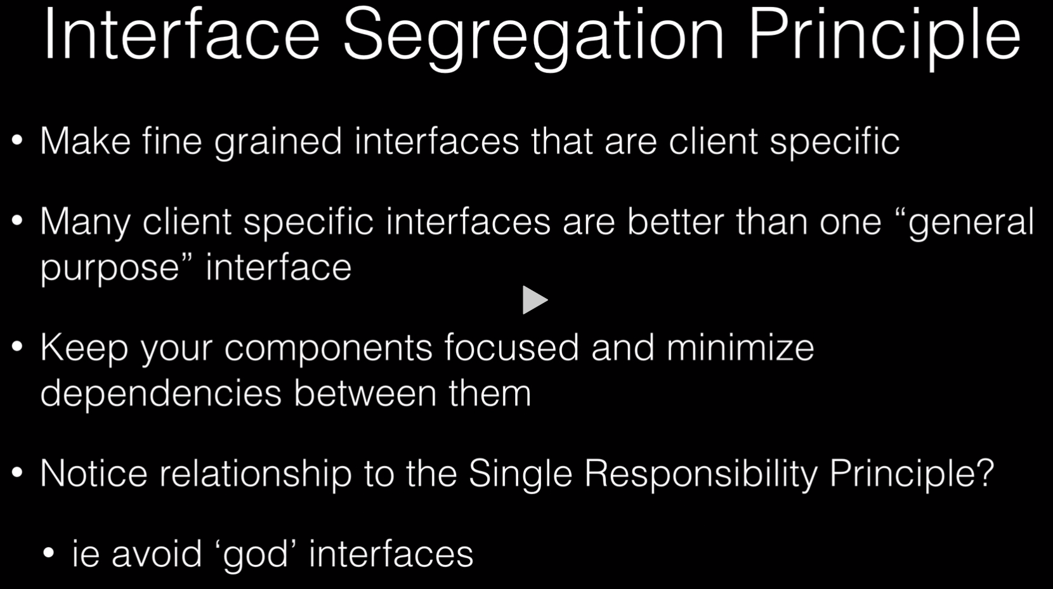



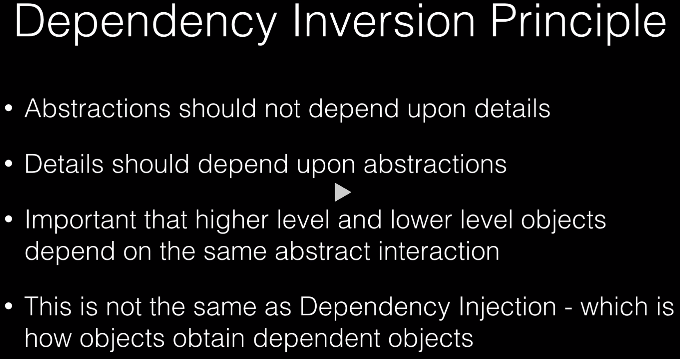

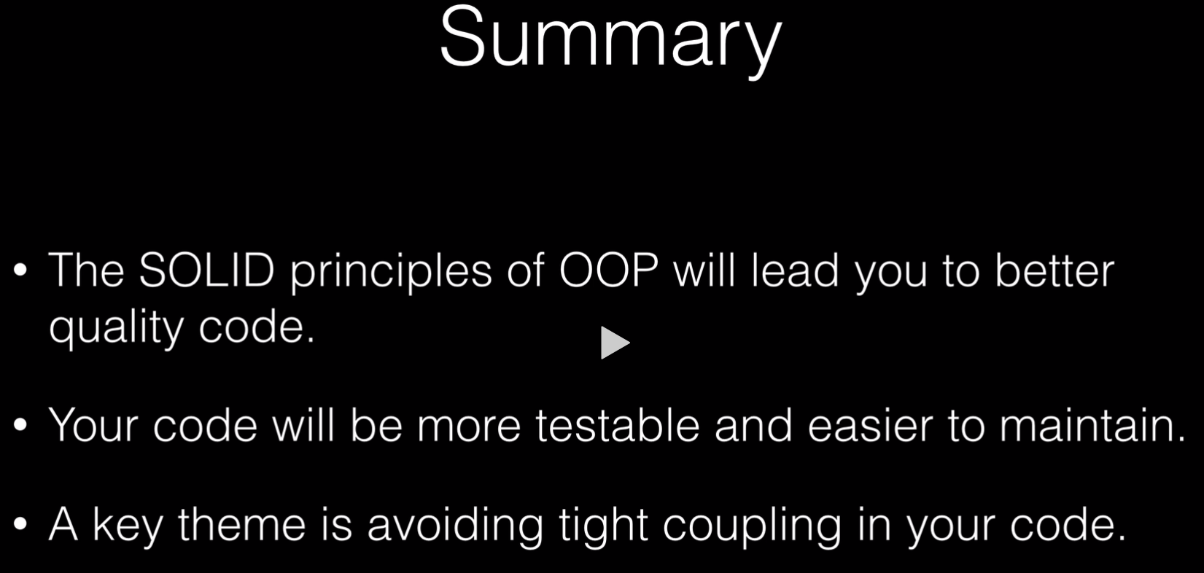

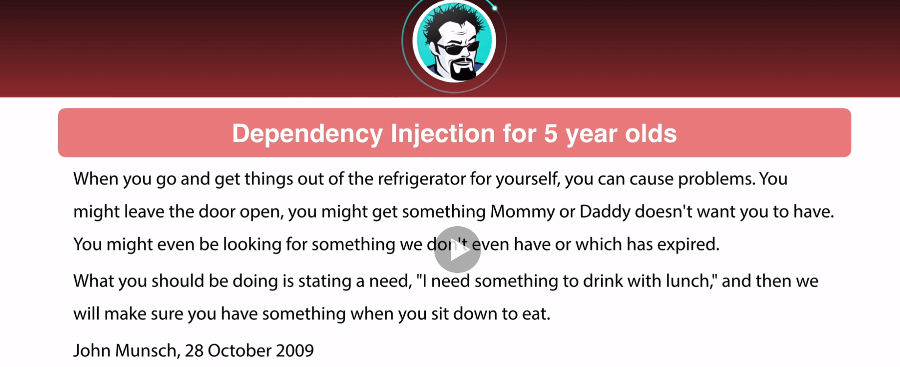

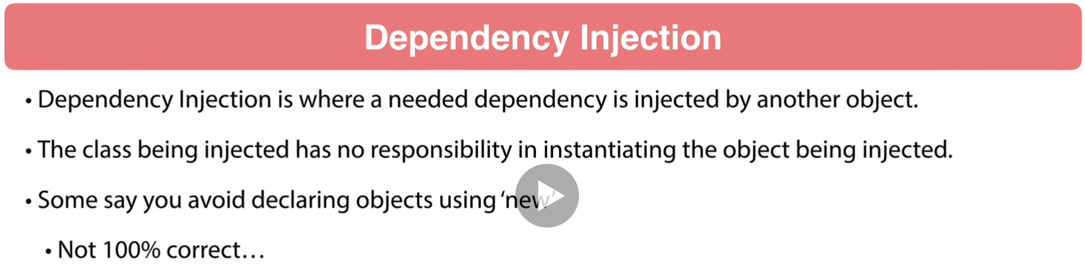

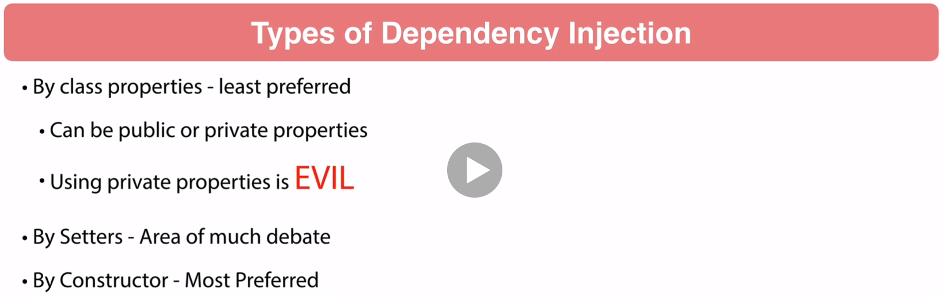

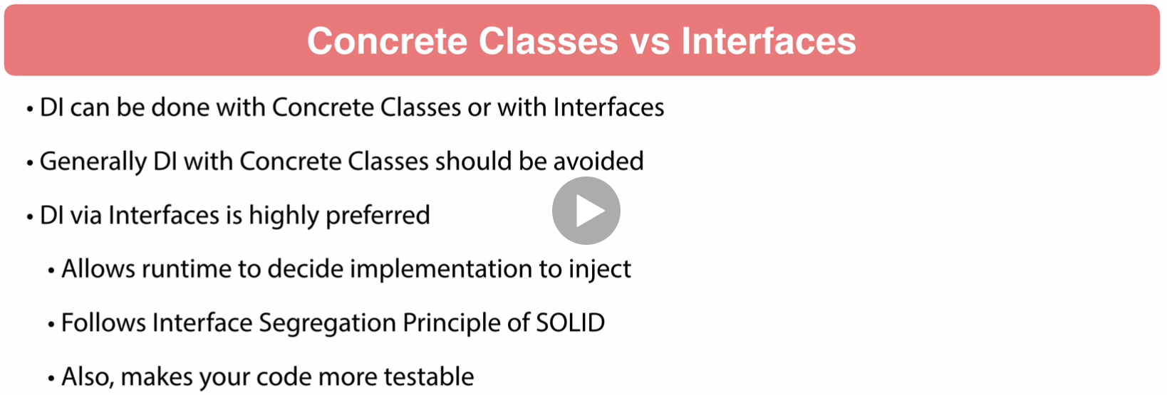

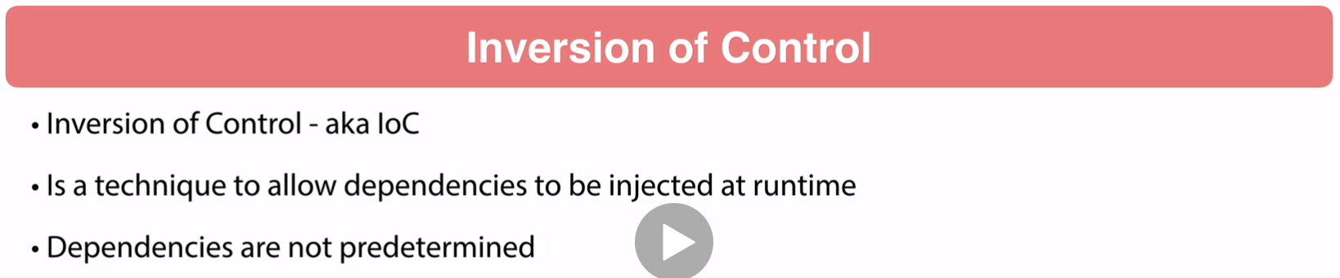

What you must remember is your class is in a runtime environment and it is

not your class that is controlling the injection it is Spring Framework

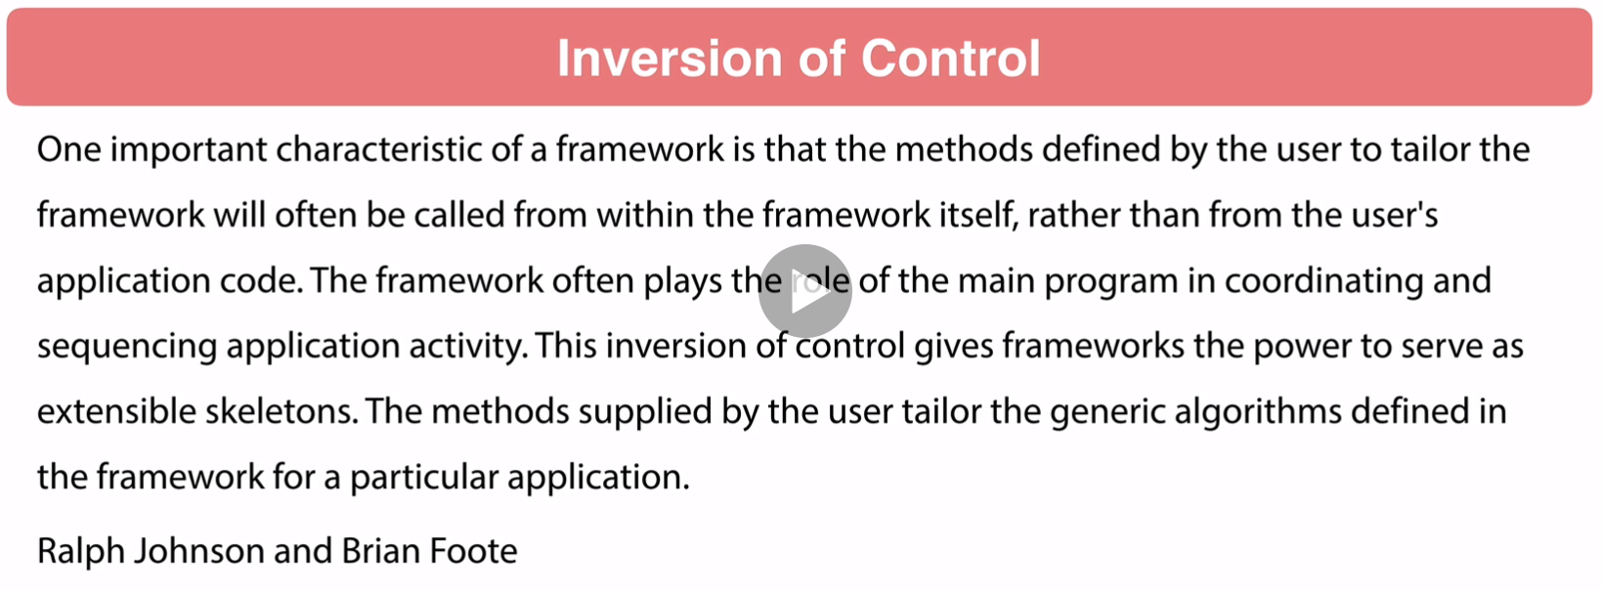

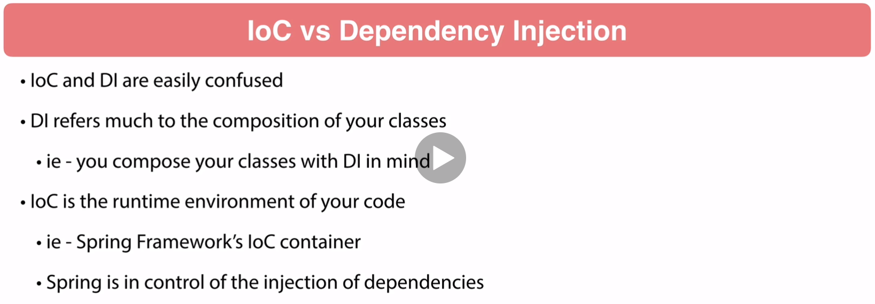

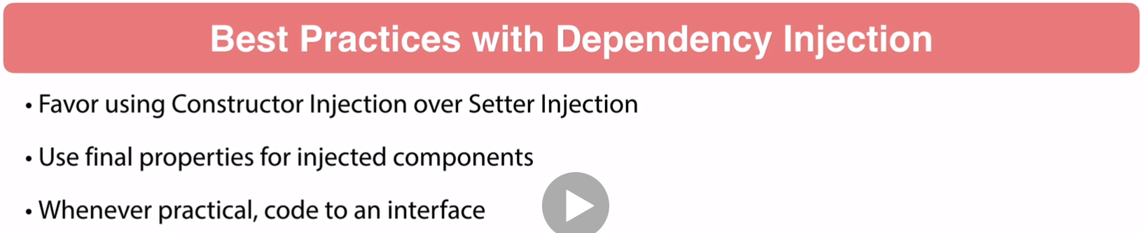

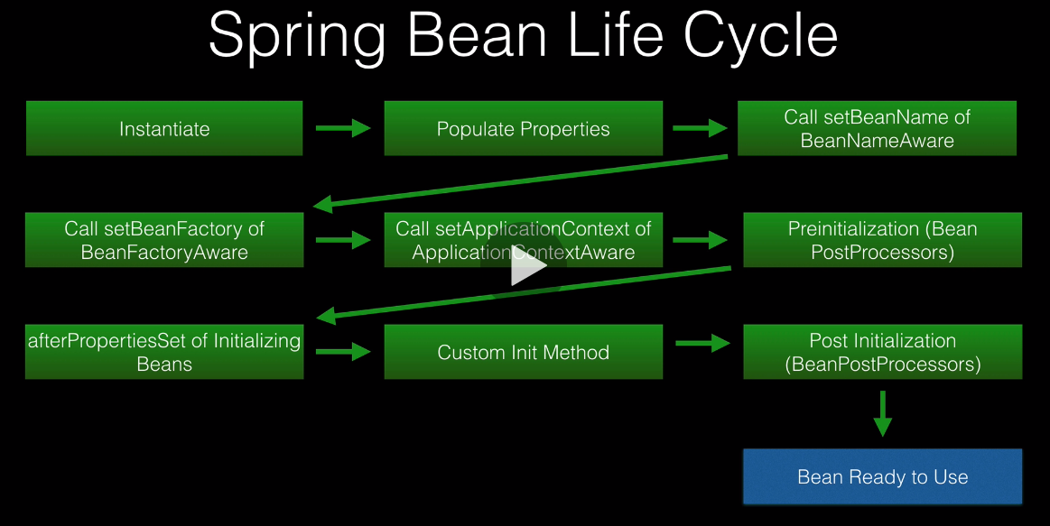

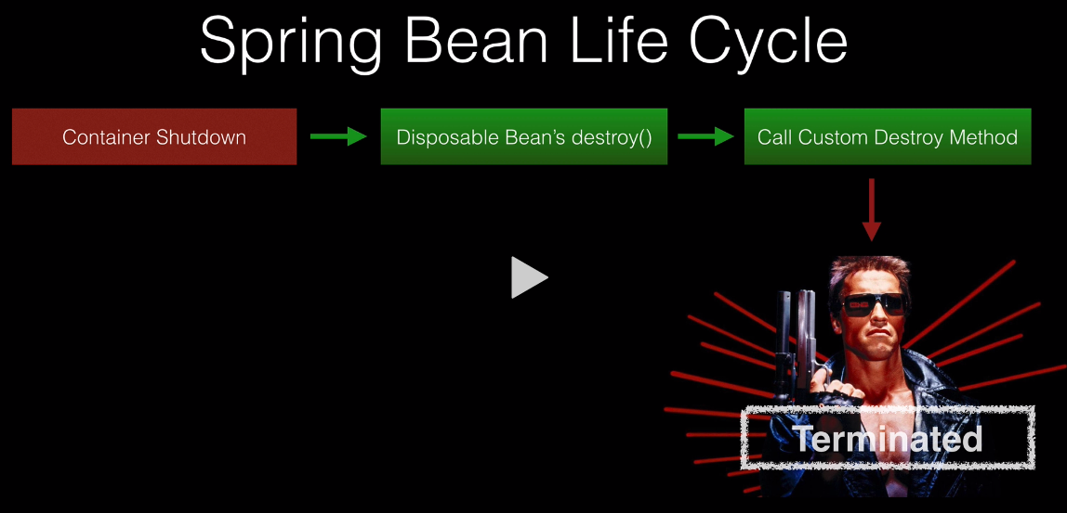

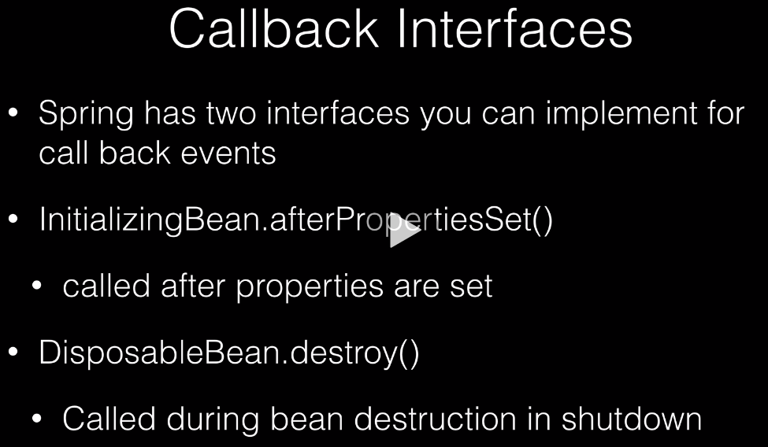

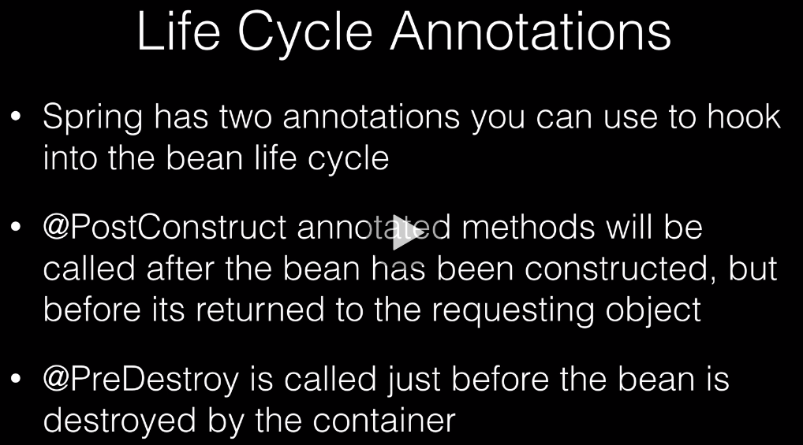

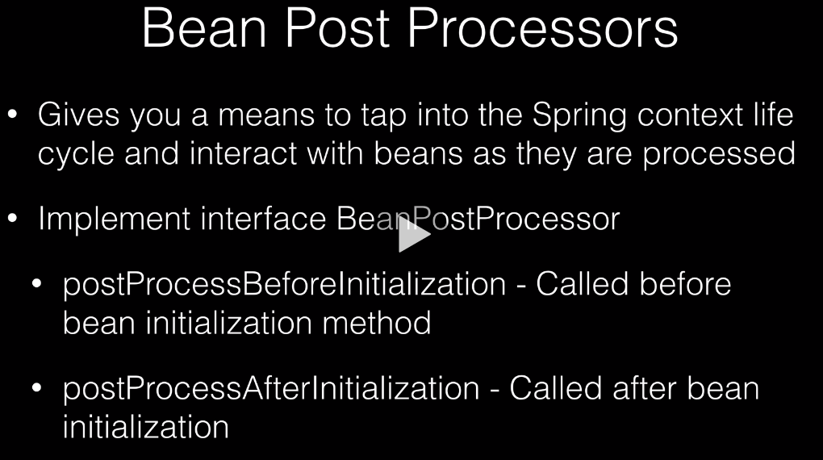

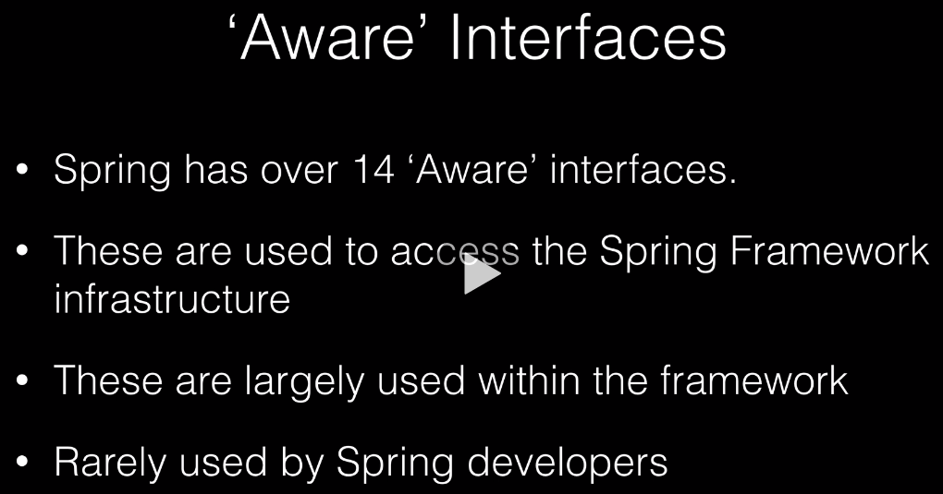

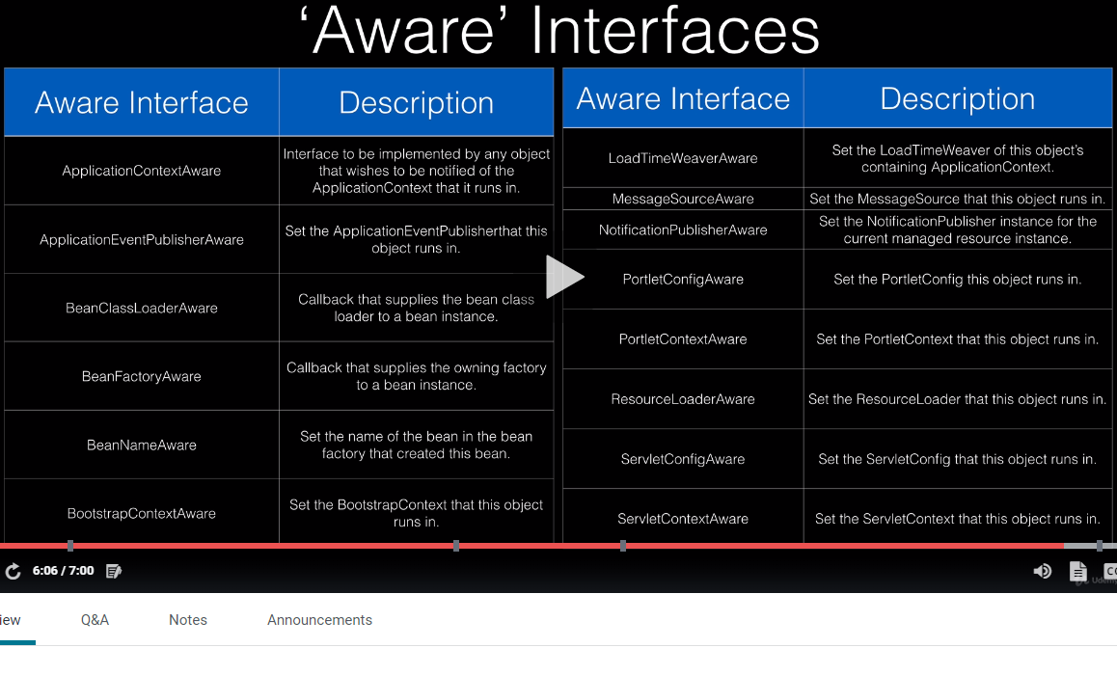

Open Closed Principle

Open Closed Principle

As applications evolve, changes are required. Changes are required when a new functionality is added, or an existing functionality is updated in the application. Often in both situations, you need to modify the existing code, and that carries the risk of breaking the application’s functionality. For good application design and the code writing part, you should avoid change in the existing code when requirements change. Instead, you should extend the existing functionality by adding new code to meet the new requirements. You can achieve this by following the Open Closed Principle.

The Open Closed Principle represents the “O” of the five [SOLID](http://springframework.guru/solid-principles-object-oriented-programming/) software engineering principles to write well-designed code that are more readable, maintainable, and easier to upgrade and modify. [Bertrand Meyer](https://en.wikipedia.org/wiki/Bertrand_Meyer) coined the term Open Closed Principle, which first appeared in his book [Object-Oriented Software Construction](https://www.amazon.com/Object-Oriented-Software-Construction-CD-ROM-Edition/dp/0136291554), release in 1988. This was about eight years before the initial release of Java.

This principle states: “software entities (classes, modules, functions, etc.) should be open for extension, but closed for modification “. Let us zero in on the two key phrases of the statement:

1. “Open for extension “: This means that the behaviour of a software module, say a class can be extended to make it behave in new and different ways. It is important to note here that the term “extended ” is not limited to inheritance using the Java extend keyword. As mentioned earlier, Java did not exist at that time. What it means here is that a module should provide extension points to alter its behaviour. One way is to make use of [polymorphism](http://springframework.guru/polymorphism-java/) to invoke extended behaviours of an object at run time.
2. “Closed for modification “: This means that the source code of such a module remains unchanged.

It might initially appear that the phrases are conflicting- How can we change the behaviour of a module without making changes to it? The answer in Java is abstraction. You can create abstractions (Java interfaces and abstract classes) that are fixed and yet represent an unbounded group of possible behaviours through concrete subclasses.

Open Closed Principle

Open Closed Principle

Before we write code, which follows the Open Closed Principle, let us look at the consequences of violating the Open Closed principle.

**Open Closed Principle Violation (Bad Example)**

Consider an insurance system that validates health insurance claims before approving one. We can follow the complementary [Single Responsibility Principle](http://springframework.guru/single-responsibility-principle/) to model this requirement by creating two separate classes. A HealthInsuranceSurveyor class responsible to validate claims and a ClaimApprovalManager class responsible to approve claims.

HealthInsuranceSurveyor.java

1. package guru.springframework.blog.openclosedprinciple;
2. public class HealthInsuranceSurveyor{
3. public boolean isValidClaim(){
4. System.out.println("HealthInsuranceSurveyor: Validating health insurance claim...");
5. /*Logic to validate health insurance claims*/
6. return true;
7. }
8. }

ClaimApprovalManager.java

1. package guru.springframework.blog.openclosedprinciple;
2. public class ClaimApprovalManager {
3. public void processHealthClaim (HealthInsuranceSurveyor surveyor)    {
4. if(surveyor.isValidClaim()){
5. System.out.println("ClaimApprovalManager: Valid claim. Currently processing claim for approval....");
6. }
7. }
8. }

Both the HealthInsuranceSurveyor and ClaimApprovalManager classes work fine and the design for the insurance system appears perfect until a new requirement to process vehicle insurance claims arises. We now need to include a new VehicleInsuranceSurveyor class, and this should not create any problems. But what we also need is to modify the ClaimApprovalManager class to process vehicle insurance claims. This is how the modified ClaimApprovalManager will be:

Open Closed Principle

Open Closed Principle

Modified ClaimApprovalManager.java

1. package guru.springframework.blog.openclosedprinciple;
2. public class ClaimApprovalManager {
3. public void processHealthClaim (HealthInsuranceSurveyor surveyor)    {
4. if(surveyor.isValidClaim()){
5. System.out.println("ClaimApprovalManager: Valid claim. Currently processing claim for approval....");
6. }
7. }
8. public void processVehicleClaim (VehicleInsuranceSurveyor surveyor)    {
9. if(surveyor.isValidClaim()){
10. System.out.println("ClaimApprovalManager: Valid claim. Currently processing claim for approval....");
11. }
12. }
13. }

In the example above, we modified the ClaimApprovalManager class by adding a new processVehicleClaim( ) method to incorporate a new functionality (claim approval of vehicle insurance).

As apparent, this is a clear violation of the Open Closed Principle. We need to modify the class to add support for a new functionality. In fact, we violated the Open Closed Principle at the very first instance we wrote the ClaimApprovalManager class. This may appear innocuous in the current example but consider the consequences in an enterprise application that needs to keep pace with fast changing business demands. For each change, you need to modify, test, and deploy the entire application. That not only makes the application fragile and expensive to extend but also makes it prone to software bugs.

Coding to the Open Closed Principle

The ideal approach for the insurance claim example would have been to design the ClaimApprovalManager class in a way that it remains:

* **Open** to support more types of insurance claims.
* **Closed** for any modifications whenever support for a new type of claim is added.
* Open Closed Principle
* Open Closed Principle

To achieve this, let us introduce a layer of abstraction by creating an abstract class to represent different claim validation behaviours. We will name the class InsuranceSurveyor.

InsuranceSurveyor.java

1. package guru.springframework.blog.openclosedprinciple;
2. public abstract class InsuranceSurveyor {
3. public abstract boolean isValidClaim();
4. }

Next, we will write the specific classes for each type of claim validation.

HealthInsuranceSurveyor.java

1. package guru.springframework.blog.openclosedprinciple;
2. public class HealthInsuranceSurveyor extends InsuranceSurveyor{
3. public boolean isValidClaim(){
4. System.out.println("HealthInsuranceSurveyor: Validating health insurance claim...");
5. /*Logic to validate health insurance claims*/
6. return true;
7. }
8. }

VehicleInsuranceSurveyor.java

1. package guru.springframework.blog.openclosedprinciple;
2. public class VehicleInsuranceSurveyor extends InsuranceSurveyor{
3. public boolean isValidClaim(){
4. System.out.println("VehicleInsuranceSurveyor: Validating vehicle insurance claim...");
5. /*Logic to validate vehicle insurance claims*/
6. return true;
7. }
8. }

In the examples above, we wrote the HealthInsuranceSurveyor and VehicleInsuranceSurveyor classes that extend the abstract InsuranceSurveyor class. Both classes provide different implementations of the isValidClaim( ) method. We will now write the ClaimApprovalManager class to follow the Open/Closed Principle.

Open Closed Principle

Open Closed Principle

ClaimApprovalManager.java

1. package guru.springframework.blog.openclosedprinciple;
2. public class ClaimApprovalManager {
3. public void processClaim(InsuranceSurveyor surveyor){
4. if(surveyor.isValidClaim()){
5. System.out.println("ClaimApprovalManager: Valid claim. Currently processing claim for approval....");
6. }
7. }
8. }

In the example above, we wrote a processClaim( ) method to accept a InsuranceSurveyor type instead of specifying a concrete type. In this way, any further addition of InsuranceSurveyor implementations will not affect the ClaimApprovalManager class. Our insurance system is now **open** to support more types of insurance claims and **closed** for any modifications whenever a new claim type is added. To test our example, let us write this unit test.

ClaimApprovalManagerTest.java

1. package guru.springframework.blog.openclosedprinciple;
3. import org.junit.Test;
4. import static org.junit.Assert.*;
6. public class ClaimApprovalManagerTest {
8. @Test
9. public void testProcessClaim() throws Exception {
10. HealthInsuranceSurveyor = new HealthInsuranceSurveyor();
12. ClaimApprovalManager claim1 = new ClaimApprovalManager();
14. claim1.processClaim(healthInsuranceSurveyor);
16. VehicleInsuranceSurveyor = new VehicleInsuranceSurveyor();
18. ClaimApprovalManager claim2 = new ClaimApprovalManager();
20. claim2.processClaim(vehicleInsuranceSurveyor);
21. }
22. }

Open Closed Principle

Open Closed Principle

The output is:

1. . ____ _ __ _ _
2. /\\ / ___'_ __ _ _(_)_ __ __ _ \ \ \ \
3. ( ( )\___ | '_ | '_| | '_ \/ _` | \ \ \ \
4. \\/ ___)| |_)| | | | | || (_| | ) ) ) )
5. ' |____| .__|_| |_|_| |_\__, | / / / /
6. =========|_|==============|___/=/_/_/_/
7. :: Spring Boot :: (v1.2.3.RELEASE)
9. Running guru.springframework.blog.openclosedprinciple.ClaimApprovalManagerTest
10. HealthInsuranceSurveyor: Validating health insurance claim...
11. ClaimApprovalManager: Valid claim. Currently processing claim for approval....
12. VehicleInsuranceSurveyor: Validating vehicle insurance claim...
13. ClaimApprovalManager: Valid claim. Currently processing claim for approval....
14. Tests run: 1, Failures: 0, Errors: 0, Skipped: 0, Time elapsed: 0.001 sec - in guru.springframework.blog.openclosedprinciple.ClaimApprovalManagerTest

Summary

Most of the times real closure of a software entity is practically not possible because there is always a chance that a change will violate the closure. For example, in our insurance example a change in the business rule to process a specific type of claim will require modifying the ClaimApprovalManager class. So, during enterprise application development, even if you might not always manage to write code that satisfies the Open Closed Principle in every aspect, taking the steps towards it will be beneficial as the application evolves.

Get the Code

I have committed the source code for this post to GitHub. It is a Maven project which you can download and build.

Interface Segregation Principle

Interface Segregation Principle

Interfaces form a core part of the Java programming language and they are extensively used in enterprise applications to achieve abstraction and to support multiple inheritance of type- the ability of a class to implement more than one interfaces. From coding perspective, writing an interface is simple. You use the **interface** keyword to create an interface and declare methods in it. Other classes can use that interface with the **implements** keyword, and then provide implementations of the declared methods. As a Java programmer, you must have written many interfaces, but the critical question is- have you written them while keeping design principles in mind? A design principle to follow while writing interfaces is the Interface Segregation Principle.

The Interface Segregation Principle represents the “I” of the five [SOLID](http://springframework.guru/solid-principles-object-oriented-programming/) principles of object-oriented programming to write well-designed code that are more readable, maintainable, and easier to upgrade and modify. This principle was first used by Robert C. Martin while consulting for Xerox, which he mentioned in his 2002 book, [Agile Software Development: Principles, Patterns and Practices](https://amzn.to/1GJg6on). This principle states that “Clients should not be forced to depend on methods that they do not use”. Here, the term “Clients” refers to the implementing classes of an interface.

What the Interface Segregation Principle says is that your interface should not be bloated with methods that implementing classes do not require. For such interfaces, also called “fat interfaces”, implementing classes are unnecessarily forced to provide implementations (dummy/empty) even for those methods that they do not need. In addition, the implementing classes are subject to change when the interface changes. An addition of a method or change to a method signature requires modifying all the implementation classes even if some of them do not use the method.

The Interface Segregation Principle advocates segregating a “fat interface” into smaller and [highly cohesive](https://en.wikipedia.org/wiki/Cohesion_%28computer_science%29) interfaces, known as “role interfaces”. Each “role interface” declares one or more methods for a specific behaviour. Thus clients, instead of implementing a “fat interface”, can implement only those “role interfaces” whose methods are relevant to them.

Interface Segregation Principle

Interface Segregation Principle Violation (Bad Example)

Consider the requirements of an application that builds different types of toys. Each toy will have a price and color. Some toys, such as a toy car or toy train can additionally move, while some toys, such as a toy plane can both move and fly. An interface to define the behaviours of toys is this.

Toy.java

1. public interface Toy {
2. void setPrice(double price);
3. void setColor(String color);
4. void move();
5. void fly();
6. }

A class that represents a toy plane can implement the Toy interface and provide implementations of all the interface methods. But imagine a class that represents a toy house. This is how the ToyHouse class will look.

ToyHouse.java

1. public class ToyHouse implements Toy {
2. double price;
3. String color;
4. @Override
5. public void setPrice(double price) {
6. this.price = price;
7. }
8. @Override
9. public void setColor(String color) {
10. this.color=color;
11. }
12. @Override
13. public void move(){}
14. @Override
15. public void fly(){}
16. }

As you can see in the code, ToyHouse needs to provide implementation of the move() and fly() methods, even though it does not require them. This is a violation of the Interface Segregation Principle. Such violations affect code readability and confuse programmers. Imagine that you are writing the ToyHouse class and the intellisense feature of your IDE pops up the fly() method for auto complete. Not exactly the behaviour you want for a toy house, is it?

Interface Segregation Principle

Violation of the Interface Segregation Principle also leads to violation of the complementary [Open Closed Principle](http://springframework.guru/open-closed-principle/). As an example, consider that the Toy interface is modified to include a walk( ) method to accommodate toy robots. As a result, you now need to modify all existing Toy implementation classes to include a walk method even if the toys do not walk. In fact, the Toy implementation classes will never be closed for modifications, which will lead to a fragile application that is difficult and expensive to maintain.

Following the Interface Segregation Principle

By following the Interface Segregation Principle, you can address the main problem of the toy building application- *The Toy interface forces clients (implementation classes) to depend on methods that they do not use*.

The solution is- *Segregate the Toy interface into multiple role interfaces each for a specific behaviour*. Let us segregate the Toy interface, so that our application now has three interfaces:Toy, Movable, and Flyable.

Toy.java

1. package guru.springframework.blog.interfacesegregationprinciple;
3. public interface Toy {
4. void setPrice(double price);
5. void setColor(String color);
6. }

Movable.java

1. package guru.springframework.blog.interfacesegregationprinciple;
3. public interface Movable {
4. void move();
5. }

Flyable.java

1. package guru.springframework.blog.interfacesegregationprinciple;
3. public interface Flyable {
4. void fly();
5. }

Interface Segregation Principle

In the examples above, we first wrote the Toy interface with the setPrice() and setColor() methods. As all toys will have a price and color, all Toy implementation classes can implement this interface. Then, we wrote the Movable and Flyable interfaces to represent moving and flying behaviours in toys. Let us write the implementation classes.

ToyHouse.java

1. package guru.springframework.blog.interfacesegregationprinciple;
3. public class ToyHouse implements Toy {
4. double price;
5. String color;
7. @Override
8. public void setPrice(double price) {
10. this.price = price;
11. }
12. @Override
13. public void setColor(String color) {
15. this.color=color;
16. }
17. @Override
18. public String toString(){
19. return "ToyHouse: Toy house- Price: "+price+" Color: "+color;
20. }
21. }

ToyCar.java

1. package guru.springframework.blog.interfacesegregationprinciple;
3. public class ToyCar implements Toy, Movable {
4. double price;
5. String color;
7. @Override
8. public void setPrice(double price) {
10. this.price = price;
11. }
12. @Override
13. public void setColor(String color) {
14. this.color=color;
15. }
16. @Override
17. public void move(){
18. System.out.println("ToyCar: Start moving car.");
19. }
20. @Override
21. public String toString(){
22. return "ToyCar: Moveable Toy car- Price: "+price+" Color: "+color;
23. }
24. }

Interface Segregation Principle

ToyPlane.java

1. package guru.springframework.blog.interfacesegregationprinciple;
3. public class ToyPlane implements Toy, Movable, Flyable {
4. double price;
5. String color;
7. @Override
8. public void setPrice(double price) {
9. this.price = price;
10. }
12. @Override
13. public void setColor(String color) {
14. this.color=color;
15. }
16. @Override
17. public void move(){
19. System.out.println("ToyPlane: Start moving plane.");
20. }
21. @Override
22. public void fly(){
24. System.out.println("ToyPlane: Start flying plane.");
25. }
26. @Override
27. public String toString(){
28. return "ToyPlane: Moveable and flyable toy plane- Price: "+price+" Color: "+color;
29. }
30. }

As you can see, the implementation classes now implement only those interfaces they are interested in. Our classes do not have unnecessary code clutters, are more readable, and lesser prone to modifications due to changes in interface methods.

Interface Segregation Principle

Next, let us write a class to create objects of the implementation classes.

ToyBuilder.java

1. package guru.springframework.blog.interfacesegregationprinciple;
3. public class ToyBuilder {
4. public static ToyHouse buildToyHouse(){
5. ToyHouse toyHouse=new ToyHouse();
6. toyHouse.setPrice(15.00);
7. toyHouse.setColor("green");
8. return toyHouse;
9. }
10. public static ToyCar buildToyCar(){
11. ToyCar toyCar=new ToyCar();
12. toyCar.setPrice(25.00);
13. toyCar.setColor("red");
14. toyCar.move();
15. return toyCar;
16. }
17. public static ToyPlane buildToyPlane(){
18. ToyPlane toyPlane=new ToyPlane();
19. toyPlane.setPrice(125.00);
20. toyPlane.setColor("white");
21. toyPlane.move();
22. toyPlane.fly();
23. return toyPlane;
24. }
25. }

In the code example above, we wrote the ToyBuilder class with three static methods to create objects of the ToyHouse, ToyCar, and ToyPlane classes.

Interface Segregation Principle

Finally, let us write this unit test to test our example.

ToyBuilderTest.java

1. package guru.springframework.blog.interfacesegregationprinciple;
3. import org.junit.Test;
5. public class ToyBuilderTest {
7. @Test
8. public void testBuildToyHouse() throws Exception {
9. ToyHouse toyHouse=ToyBuilder.buildToyHouse();
10. System.out.println(toyHouse);
11. }
13. @Test
14. public void testBuildToyCar() throws Exception {
15. ToyCar toyCar=ToyBuilder.buildToyCar();;
16. System.out.println(toyCar);
17. }
19. @Test
20. public void testBuildToyPlane() throws Exception {
21. ToyPlane toyPlane=ToyBuilder.buildToyPlane();
22. System.out.println(toyPlane);
23. }
24. }

The output is:

1. . ____ _ __ _ _
2. /\\ / ___'_ __ _ _(_)_ __ __ _ \ \ \ \
3. ( ( )\___ | '_ | '_| | '_ \/ _` | \ \ \ \
4. \\/ ___)| |_)| | | | | || (_| | ) ) ) )
5. ' |____| .__|_| |_|_| |_\__, | / / / /
6. =========|_|==============|___/=/_/_/_/
7. :: Spring Boot :: (v1.2.3.RELEASE)
9. Running guru.springframework.blog.interfacesegregationprinciple.ToyBuilderTest
10. ToyHouse: Toy house- Price: 15.0 Color: green
11. ToyPlane: Start moving plane.
12. ToyPlane: Start flying plane.
13. ToyPlane: Moveable and flyable toy plane- Price: 125.0 Color: white
14. ToyCar: Start moving car.
15. ToyCar: Moveable Toy car- Price: 25.0 Color: red
16. Tests run: 3, Failures: 0, Errors: 0, Skipped: 0, Time elapsed: 0.001 sec - in guru.springframework.blog.interfacesegregationprinciple.ToyBuilderTest

Interface Segregation Principle

Summary of Interface Segregation Principle

Both the Interface Segregation Principle and [Single Responsibility Principle](http://springframework.guru/single-responsibility-principle/) have the same goal: ensuring small, focused, and highly cohesive software components. The difference is that Single Responsibility Principle is concerned with classes, while Interface Segregation Principle is concerned with interfaces.Interface Segregation Principle is easy to understand and simple to follow. But identifying the distinct interfaces can sometimes be a challenge as careful considerations are required to avoid proliferation of interfaces. Therefore, while writing an interface, consider the possibility of implementation classes having different sets of behaviours, and if so, segregate the interface into multiple interfaces, each having a specific role.

Interface Segregation Principle in the Spring Framework

A number of times on this blog I’ve written about programming for [Dependency Injection](http://springframework.guru/dependency-injection-example-using-spring/) when programming using the Spring Framework. The Interface Segregation Principle becomes especially important when doing [Enterprise Application Development](http://springframework.guru/using-the-spring-framework-for-enterprise-application-development/) with the Spring Framework.

As the size and scope of the application you are building grows, you are going to need pluggable components. Even when just for unit testing your classes, the Interface Segregation Principle has a role. If you’re testing a class which you’ve written for dependency injection, as I’ve [written before](http://springframework.guru/dependency-injection-example-using-spring/), it is ideal that you write to an interface. By designing your classes to use dependency injection against an interface, any class implementing the specified interface can be injected into your class. In [testing](http://springframework.guru/testing-software/) your classes, you may wish to inject a mock object to fulfil the needs of your unit test. But when the class you wrote is running in production, the Spring Framework would inject the real full featured implementation of the interface into your class.

The Interface Segregation Principle and Dependency Injection are two very powerful concepts to master when developing enterprise class applications using the Spring Framework.

Dependency Inversion Principle

Dependency Inversion Principle

As a Java programmer, you have likely heard about code coupling and have been told to avoid tightly coupled code. Ignorance of writing “*good code*” is the main reason of tightly coupled code existing in applications. As an example, creating an object of a class using the **new** operator results in a class being tightly coupled to another class. Such coupling appears harmless and does not disrupt small programs. But, as you move into [enterprise application development](https://springframework.guru/using-the-spring-framework-for-enterprise-application-development/), tightly coupled code can lead to serious adverse consequences.

When one class knows explicitly about the design and implementation of another class, changes to one class raise the risk of breaking the other class. Such changes can have rippling effects across the application making the application fragile. To avoid such problems, you should write “*good code*” that is loosely coupled, and to support this you can turn to the Dependency Inversion Principle.

The Dependency Inversion Principle represents the last “D” of the five [SOLID](https://springframework.guru/solid-principles-object-oriented-programming/)principles of object-oriented programming. [Robert C. Martin](http://www.objectmentor.com/omTeam/martin_r.html) first postulated the Dependency Inversion Principle and published it in 1996. The principle states:

*“A. High-level modules should not depend on low-level modules. Both should depend on abstractions.  
B. Abstractions should not depend on details. Details should depend on abstractions.”*

Conventional application architecture follows a top-down design approach where a high-level problem is broken into smaller parts. In other words, the high-level design is described in terms of these smaller parts. As a result, high-level modules that gets written directly depends on the smaller (low-level) modules.

Dependency Inversion Principle

What Dependency Inversion Principle says is that instead of a high-level module depending on a low-level module, both should depend on an abstraction. Let us look at it in the context of Java through this figure.

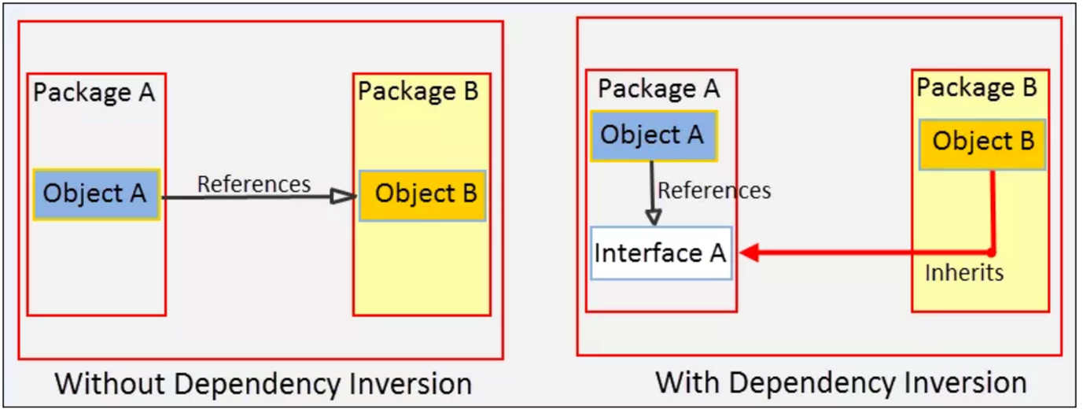

In the figure above, without Dependency Inversion Principle, Object A in Package A refers Object B in Package B. With Dependency Inversion Principle, an Interface A is introduced as an abstraction in Package A. Object A now refers Interface A and Object B inherits from Interface A. What the principle has done is:

1. Both Object A and Object B now depends on Interface A, the abstraction.
2. It inverted the dependency that existed from Object A to Object B into Object B being dependent on the abstraction (Interface A).

Before we write code that follows the Dependency Inversion Principle, let us examine a typical violating of the principle.

Dependency Inversion Principle

Dependency Inversion Principle Violation (Bad Example)

Consider the example of an electric switch that turns a light bulb on or off. We can model this requirement by creating two classes: ElectricPowerSwitch and LightBulb. Let us write the LightBulb class first.

LightBulb.java

1. public class LightBulb {
2. public void turnOn() {
3. System.out.println("LightBulb: Bulb turned on...");
4. }
5. public void turnOff() {
6. System.out.println("LightBulb: Bulb turned off...");
7. }
8. }

In the LightBulb class above, we wrote the turnOn() and turnOff() methods to turn a bulb on and off.

Dependency Inversion Principle

Next, we will write the ElectricPowerSwitch class.

ElectricPowerSwitch.java

1. public class ElectricPowerSwitch {
2. public LightBulb;
3. public boolean on;
4. public ElectricPowerSwitch(LightBulb lightBulb) {
5. this.lightBulb = lightBulb;
6. this.on = false;
7. }
8. public boolean isOn() {
9. return this.on;
10. }
11. public void press(){
12. boolean checkOn = isOn();
13. if (checkOn) {
14. lightBulb.turnOff();
15. this.on = false;
16. } else {
17. lightBulb.turnOn();
18. this.on = true;
19. }
21. }
22. }

In the example above, we wrote the ElectricPowerSwitch class with a field referencing LightBulb. In the constructor, we created a LightBulb object and assigned it to the field. We then wrote an isOn() method that returns the state of ElectricPowerSwitch as a boolean value. In the press() method, based on the state, we called the turnOn() and turnOff() methods.

Our switch is now ready for use to turn on and off the light bulb. But the mistake we did is apparent. Our high-level ElectricPowerSwitch class is directly dependent on the low-level LightBulb class. if you see in the code, the LightBulb class is hardcoded in ElectricPowerSwitch. But a switch should not be tied to a bulb. It should be able to turn on and off other appliances and devices too, say a fan, an AC, or the entire lightning system of an amusement park. Now, imagine the modifications we will require in the ElectricPowerSwitch class each time we add a new appliance or device. We can conclude that our design is flawed, and we need to revisit it by following the Dependency Inversion Principle.

Dependency Inversion Principle

Following the Dependency Inversion Principle

To follow the Dependency Inversion Principle in our example, we will need an abstraction that both the ElectricPowerSwitch and LightBulb classes will depend on. But, before creating it, let us create an interface for switches.

Switch.java

1. package guru.springframework.blog.dependencyinversionprinciple.highlevel;
3. public interface Switch {
4. boolean isOn();
5. void press();
6. }

We wrote an interface for switches with the isOn() and press() methods. This interface will give us the flexibility to plug in other types of switches, say a remote-control switch later, if required. Next, we will write the abstraction in the form of an interface, which we will call Switchable.

Switchable.java

1. package guru.springframework.blog.dependencyinversionprinciple.highlevel;
3. public interface Switchable {
4. void turnOn();
5. void turnOff();
6. }

In the example above, we wrote the Switchable interface with the turnOn() and turnoff() methods. From now on, any switchable devices in the application can implement this interface and provide their own functionality.

Dependency Inversion Principle

Our ElectricPowerSwitch class will also depend on this interface, as shown below:

ElectricPowerSwitch.java

1. package guru.springframework.blog.dependencyinversionprinciple.highlevel;

4. public class ElectricPowerSwitch implements Switch {
5. public Switchable client;
6. public boolean on;
7. public ElectricPowerSwitch(Switchable client) {
8. this.client = client;
9. this.on = false;
10. }
11. public boolean isOn() {
12. return this.on;
13. }
14. public void press(){
15. boolean checkOn = isOn();
16. if (checkOn) {
17. client.turnOff();
18. this.on = false;
19. } else {
20. client.turnOn();
21. this.on = true;
22. }
24. }
25. }

In the ElectricPowerSwitch class we implemented the Switch interface and referred the Switchable interface instead of any concrete class in a field. We then called the turnOn() and turnoff() methods on the interface, which at run time will get invoked on the object passed to the constructor. Now, we can add low-level switchable classes without worrying about modifying the ElectricPowerSwitch class.

Dependency Inversion Principle

We will add two such classes: LightBulb and Fan.

LightBulb.java

1. package guru.springframework.blog.dependencyinversionprinciple.lowlevel;
3. import guru.springframework.blog.dependencyinversionprinciple.highlevel.Switchable;
5. public class LightBulb implements Switchable {
6. @Override
7. public void turnOn() {
8. System.out.println("LightBulb: Bulb turned on...");
9. }
11. @Override
12. public void turnOff() {
13. System.out.println("LightBulb: Bulb turned off...");
14. }
15. }

Fan.java

1. package guru.springframework.blog.dependencyinversionprinciple.lowlevel;
3. import guru.springframework.blog.dependencyinversionprinciple.highlevel.Switchable;
5. public class Fan implements Switchable {
6. @Override
7. public void turnOn() {
8. System.out.println("Fan: Fan turned on...");
9. }
11. @Override
12. public void turnOff() {
13. System.out.println("Fan: Fan turned off...");
14. }
15. }

In both the LightBulb and Fan classes that we wrote, we implemented the Switchable interface to provide their own functionality for turning on and off. While writing the classes, if you have missed how we arranged them in packages, notice that we kept the Switchable interface in a different package from the low-level electric device classes. Although, this did not make any difference from coding perspective, except for an import statement, by doing so we have made our intentions clear- We want the low-level classes to depend (inversely) on our abstraction. This will also help us if we later decide to release the high-level package as a public API that other applications can use for their devices.

Dependency Inversion Principle

To test our example, let us write this unit test.

ElectricPowerSwitchTest.java

1. package guru.springframework.blog.dependencyinversionprinciple.highlevel;
3. import guru.springframework.blog.dependencyinversionprinciple.lowlevel.Fan;
4. import guru.springframework.blog.dependencyinversionprinciple.lowlevel.LightBulb;
5. import org.junit.Test;
7. public class ElectricPowerSwitchTest {
9. @Test
10. public void testPress() throws Exception {
11. Switchable switchableBulb=new LightBulb();
12. Switch bulbPowerSwitch=new ElectricPowerSwitch(switchableBulb);
13. bulbPowerSwitch.press();
14. bulbPowerSwitch.press();
16. Switchable switchableFan=new Fan();
17. Switch fanPowerSwitch=new ElectricPowerSwitch(switchableFan);
18. fanPowerSwitch.press();
19. fanPowerSwitch.press();
20. }
21. }

The output is:

1. . ____ _ __ _ _
2. /\\ / ___'_ __ _ _(_)_ __ __ _ \ \ \ \
3. ( ( )\___ | '_ | '_| | '_ \/ _` | \ \ \ \
4. \\/ ___)| |_)| | | | | || (_| | ) ) ) )
5. ' |____| .__|_| |_|_| |_\__, | / / / /
6. =========|_|==============|___/=/_/_/_/
7. :: Spring Boot :: (v1.2.3.RELEASE)
9. Running guru.springframework.blog.dependencyinversionprinciple.highlevel.ElectricPowerSwitchTest
10. LightBulb: Bulb turned on...
11. LightBulb: Bulb turned off...
12. Fan: Fan turned on...
13. Fan: Fan turned off...
14. Tests run: 1, Failures: 0, Errors: 0, Skipped: 0, Time elapsed: 0.016 sec - in guru.springframework.blog.dependencyinversionprinciple.highlevel.ElectricPowerSwitchTest

Dependency Inversion Principle

Summary of the Dependency Inversion Principle

Robert Martin equated the Dependency Inversion Principle, as a first-class combination of the [Open Closed Principle](https://springframework.guru/open-closed-principle/) and the [Liskov Substitution Principle](https://springframework.guru/?s=Liskov+Substitution+Principle), and found it important enough to give its own name. While using the Dependency Inversion Principle comes with the overhead of writing additional code, the advantages that it provides outweigh the extra effort. Therefore, from now whenever you start writing code, consider the possibility of dependencies breaking your code, and if so, add abstractions to make your code resilient to changes.

Dependency Inversion Principle and the Spring Framework

You may think the Dependency Inversion Principle is related to [Dependency Injection](https://springframework.guru/dependency-injection-example-using-spring/) as it applies to the Spring Framework, and you would be correct. Uncle Bob Martin coined this concept of Dependency Inversion before Martin Fowler coined the term Dependency Injection. The two concepts are [highly related](http://martinfowler.com/articles/dipInTheWild.html). Dependency Inversion is more focused on the structure of your code, its focus is keeping your code loosely coupled. On the other hand, Dependency Injection is how the code functionally works. When programming with the Spring Framework, Spring is using Dependency Injection to assemble your application. Dependency Inversion is what decouples your code so Spring can use Dependency Injection at run time.



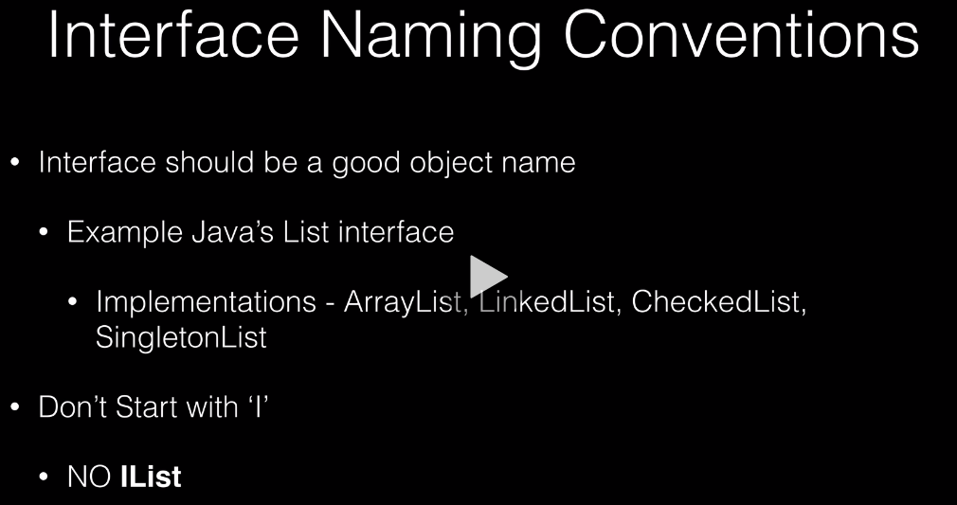

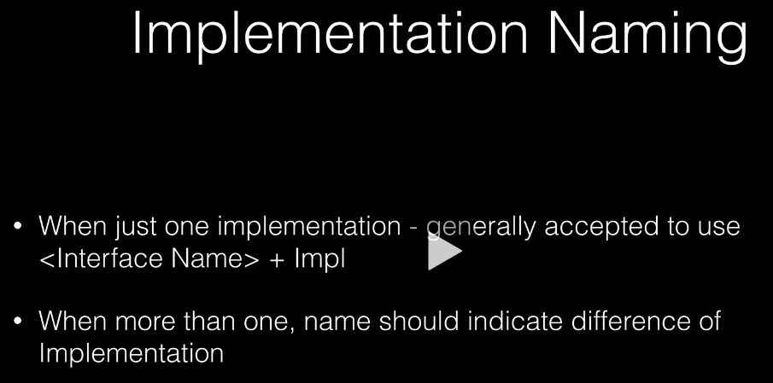

**General Notes**

**My Q&A Summary Collection after my many failures...**

**1**

[Chakotay](https://www.udemy.com/user/chakotaychou/) ·

Lecture 49 Using <scm></scm> in the main pom file.

 · 14 days ago

Check List:

1. make sure your clinic pom has

1. <scm>
2. <developerConnection>scm:git:[your git repo url/ssh]</developerConnection>
3. <tag>HEAD</tag>
4. </scm>

2. clinic pom: goals not goal

3. For the first time build, version number is very important, always the -SNAPSHOT:

clinic pom => <version>0.0.1-SNAPSHOT</version>

web pom => <version>0.0.1-SNAPSHOT</version>

data pom => <version>0.0.1-SNAPSHOT</version>

Problem and Fix:

1. mvn not found: copy your mvn.cmd and rename the copy to mvn.bat

2. I want to cleanly restart all the processes when I have errors:

   a. reset git, execute the command:  git reset --hard HEAD~1

   b. delete the tag if you have one (cannot tag error/tag exists error): git tag --delete sfg-pet-clinic-0.0.1

   c. delete the remote github tag if you have one (cannot tag error/tag exists error): git push --delete origin sfg-pet-clinic-0.0.1

   d. make sure you fix your pom and execute commands below:

      git add .

      git commit -m "update pom.xml to include SNAPSHOT"

   e. execute mvn clean package

   f. execute mvn release:clean

   g. execute mvn release:prepare

   h. execute mvn release:perform

1. The pom version is correct but IntelliJ still shows error: click the refresh button on Maven tab.

**Changing the Spring Banner**

1. Goto the website [www.patorjk.com](http://www.patorjk.com) and select ‘TEXT TO ASCII ART GENERATOR’
2. Enter your text and select your font etc.
3. Select and Copy
4. Back to Intellij
5. Under resources create a file call banner.txt
6. Paste into the file and make any further modifications.
7. Restart your app and you will get the new banner.

**Inserting an Image In to The Spring Banner**

1. Select a basic image (jpg), B&W outline and copy it
2. Go to Intellij and past the image in the resource folder
3. In the applications.properties file add the line:
   1. spring.banner.image.location=filename.jpg

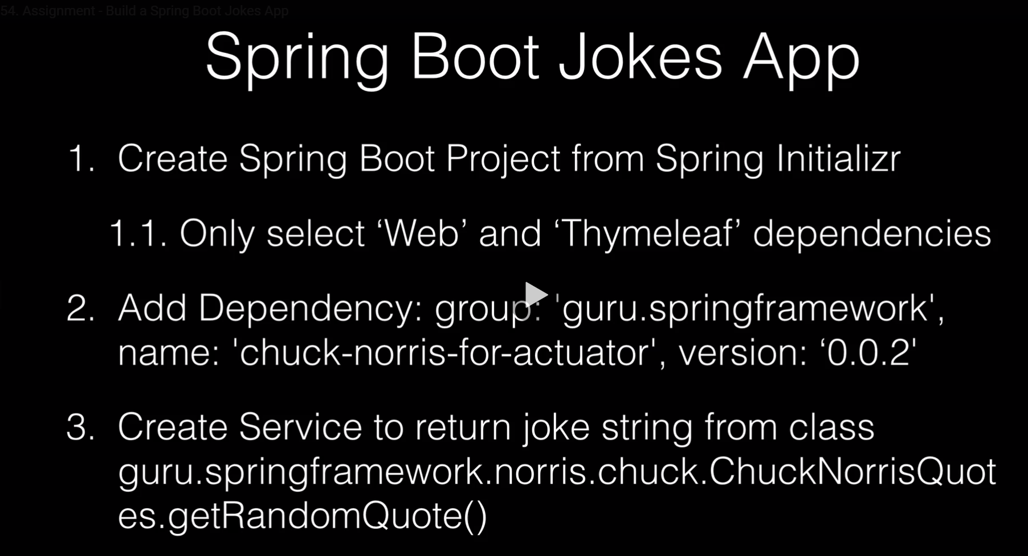

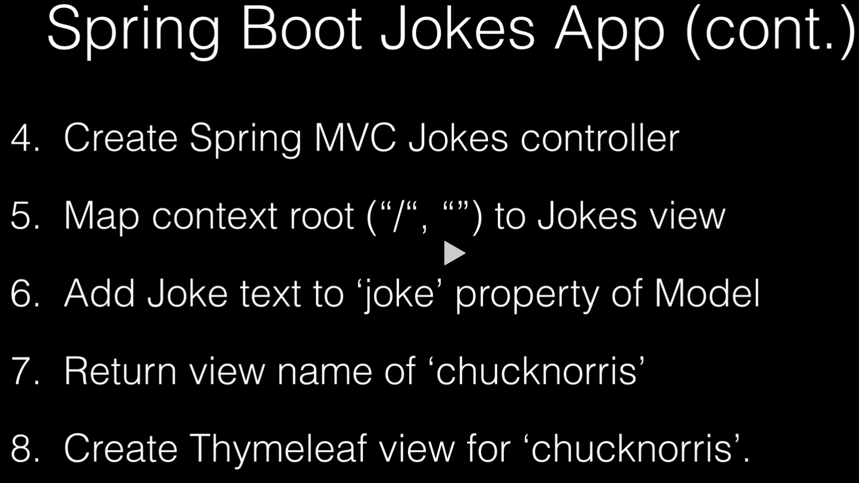

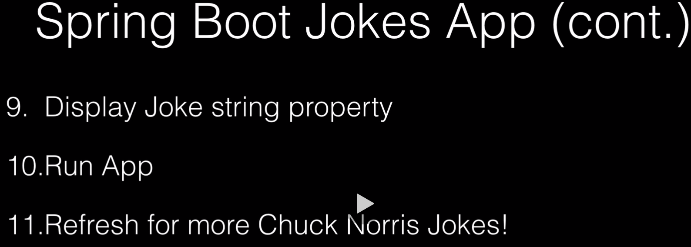



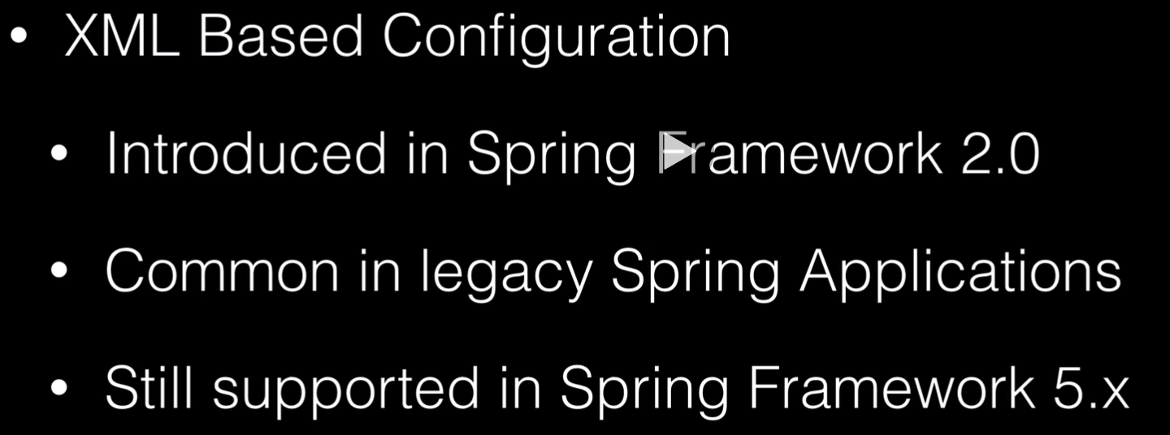

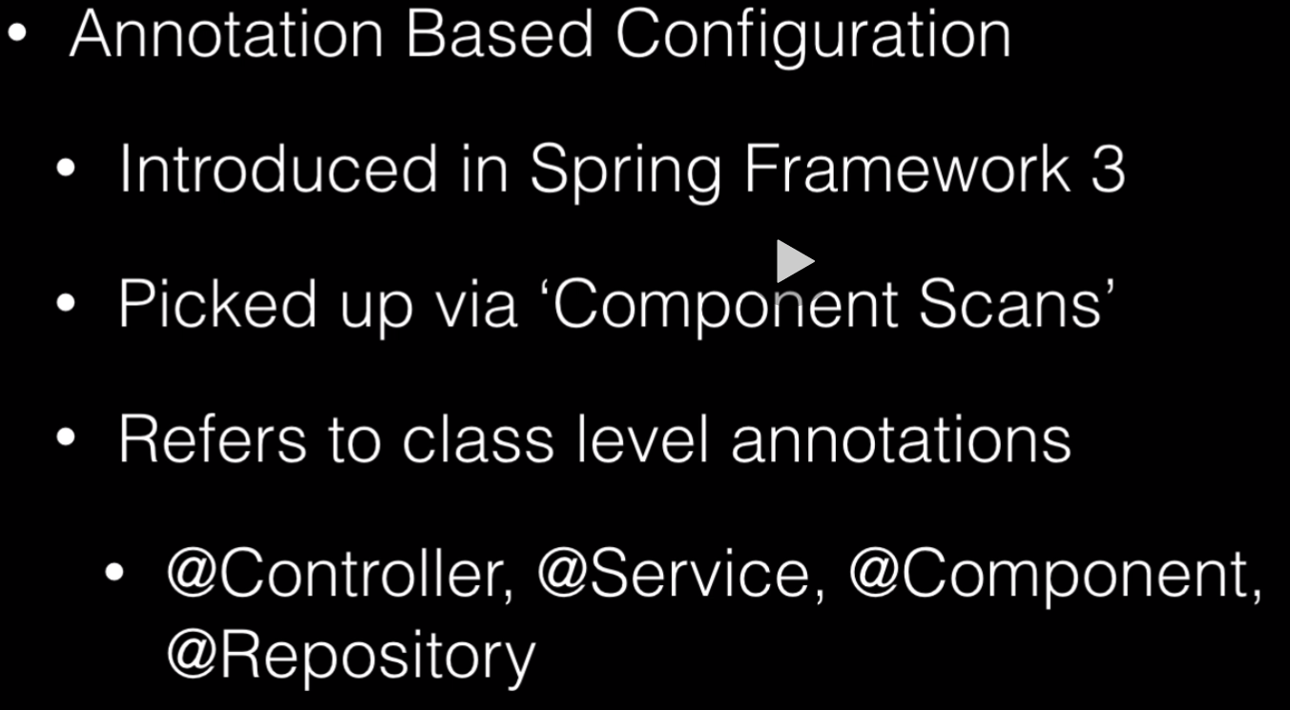

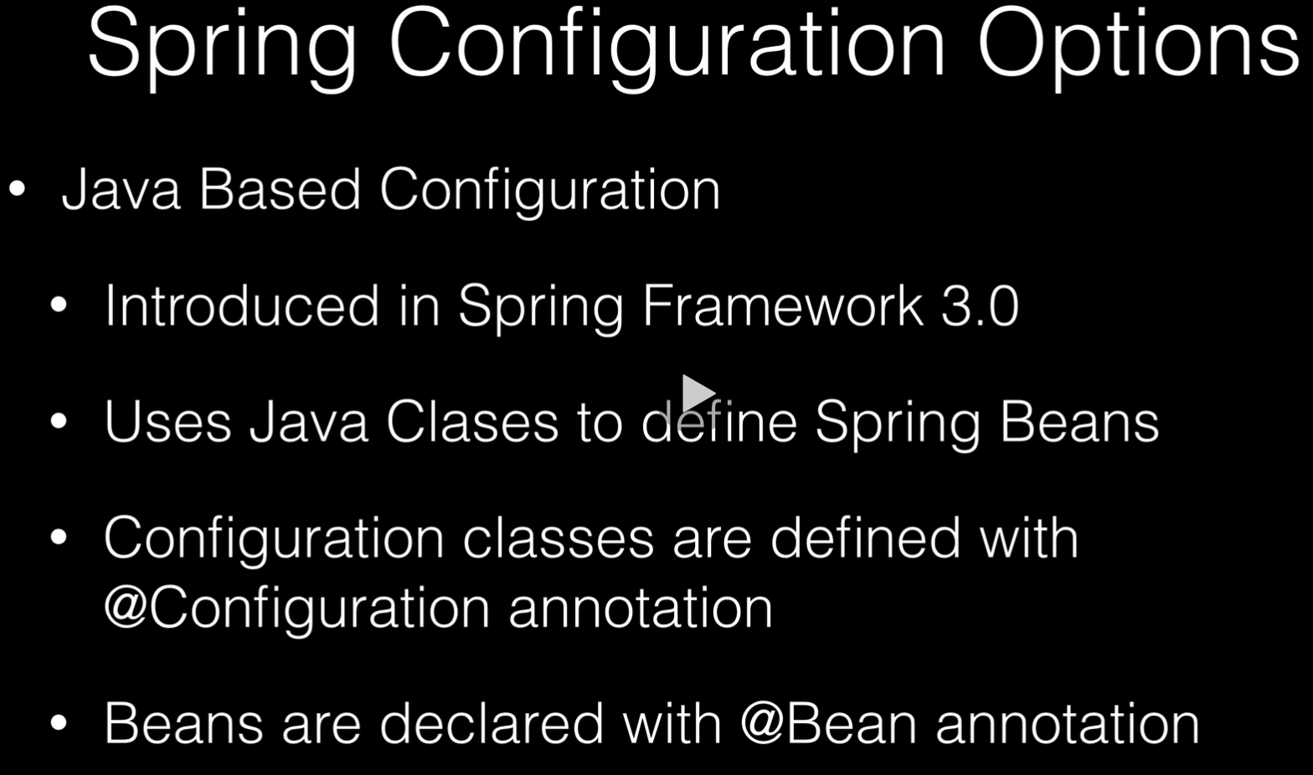

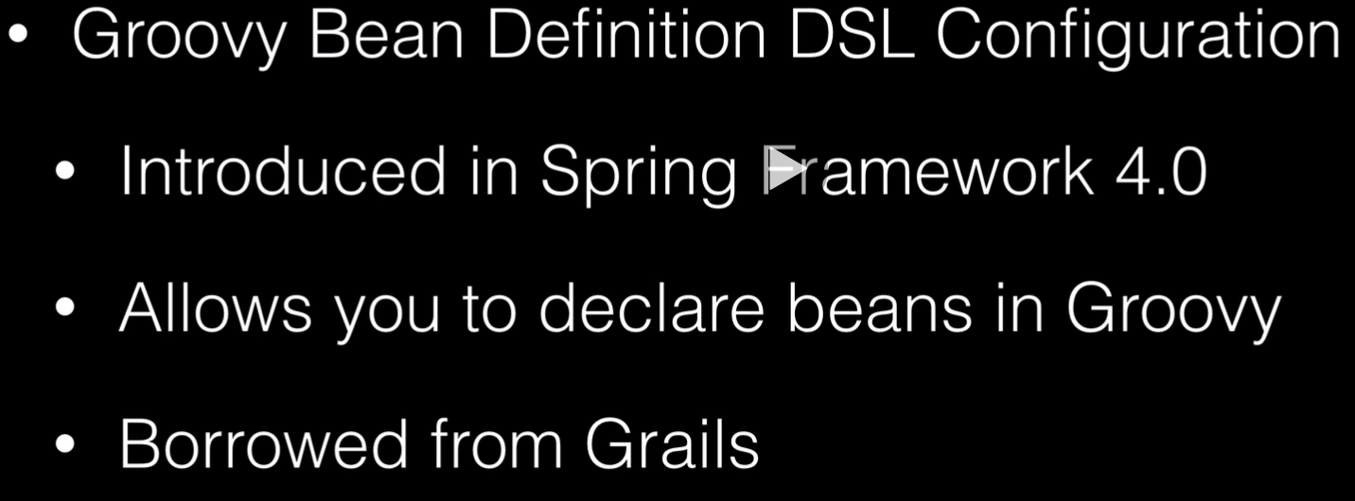

DSL: Domain Specific Language.

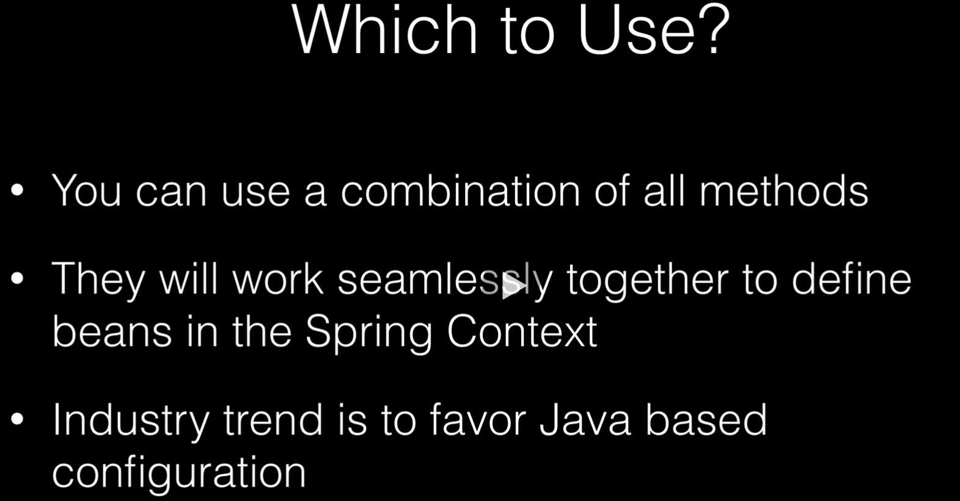

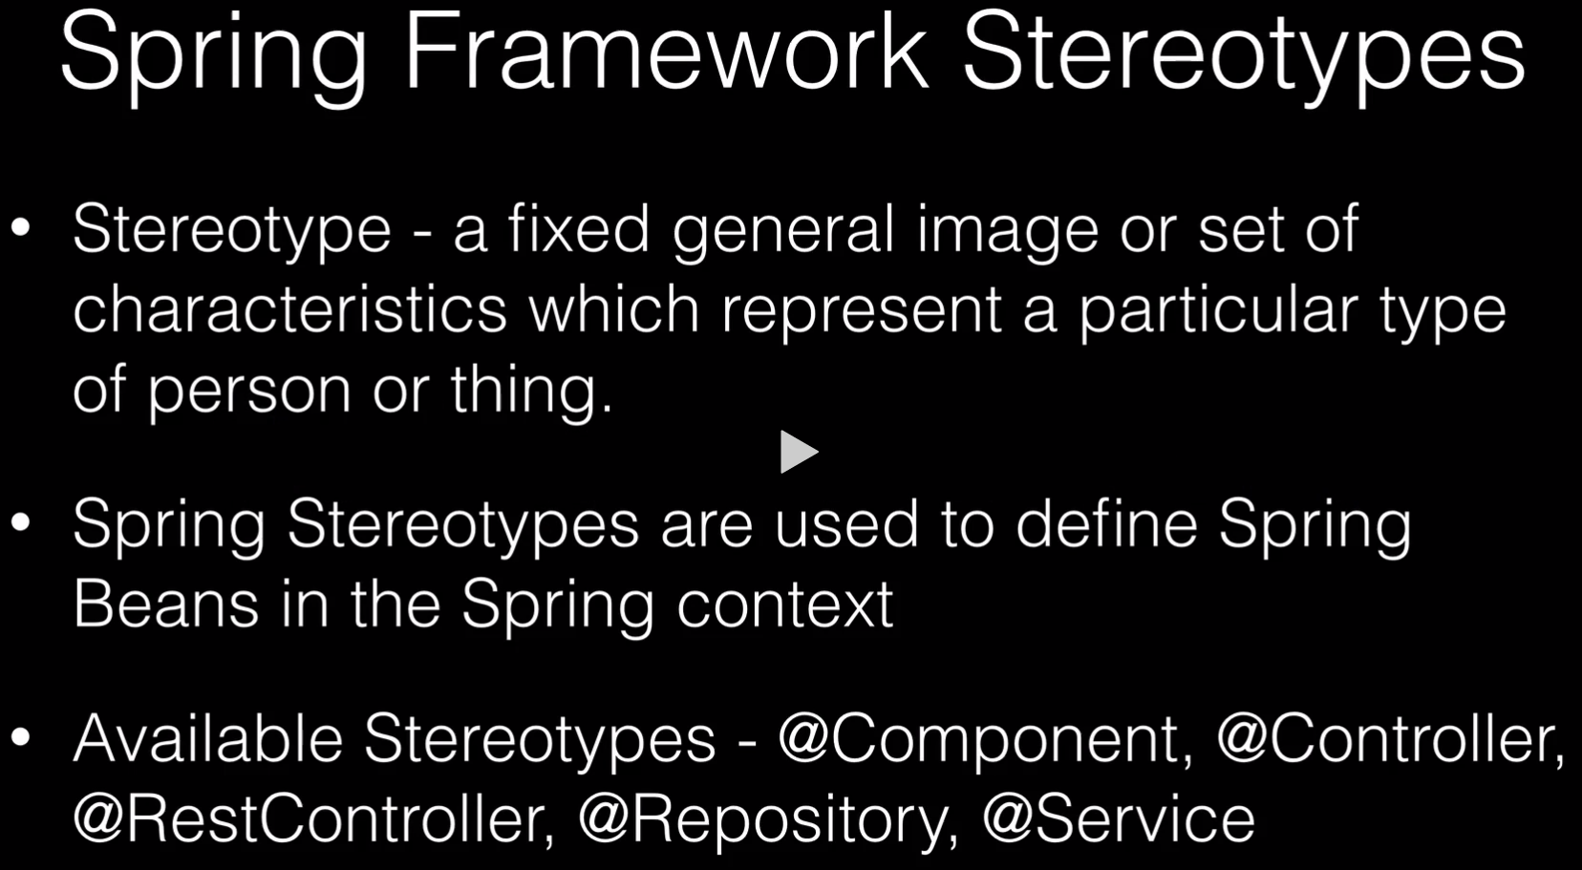

We will be focusing on the Thing and not Person, because focusing on a Person is a bad habit.

We are talking about Stereotyping software components (things).

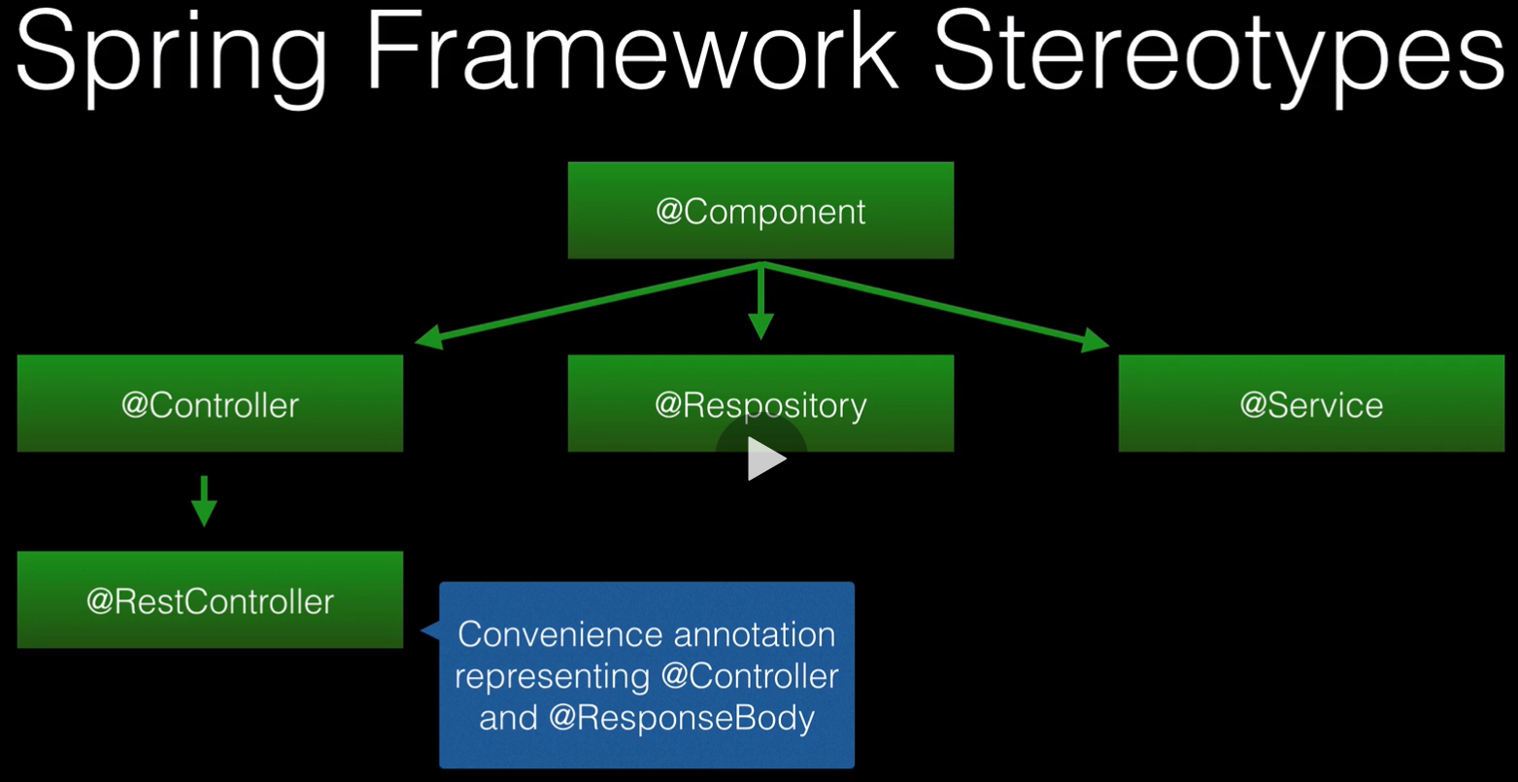

* @Component, everything inherits from the @Component
  + When Spring encounters the @Component annotation it is going to wire it up as a Spring Bean, this is also the case for all the other annotations.
* @Controller is used to indicate and MVC controller.
  + When you use @Controller you are going to be using @RequestMapping to map a method to a URL. That is really the meat and potatoes of that action.
* @Repository indicates that you are accessing the data layer.
* @Services is indicating the business logic and is backing up, usually, a Controller
* @RestController, not everybody recognises this a stereotype, because it is a convenience annotation, representing @Controller and @ResponseBody. If you look at the code of that you can see that it just extends controller and adds in a responsebody.
  + @ResponseBody is used by Spring MVC to render an object back to the response. It is saying render this back to the client as Json or xml.

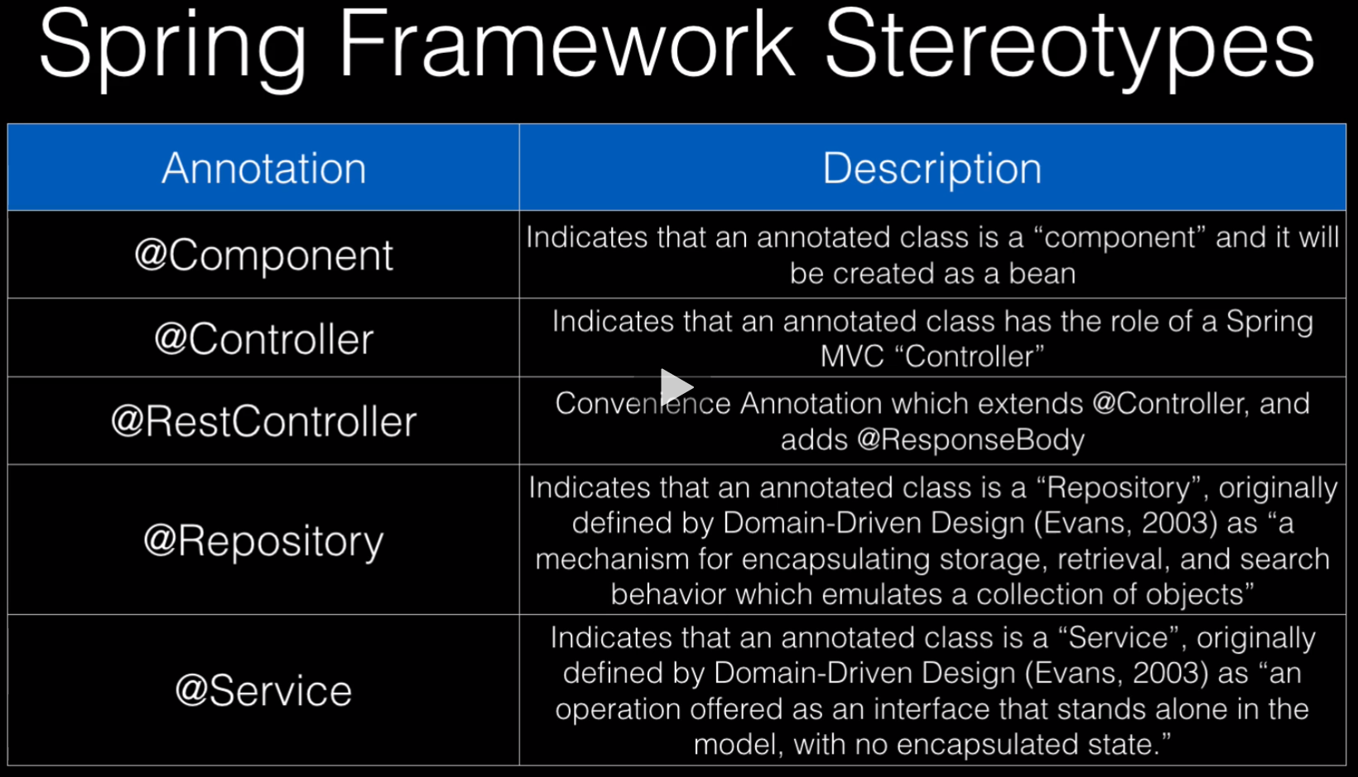

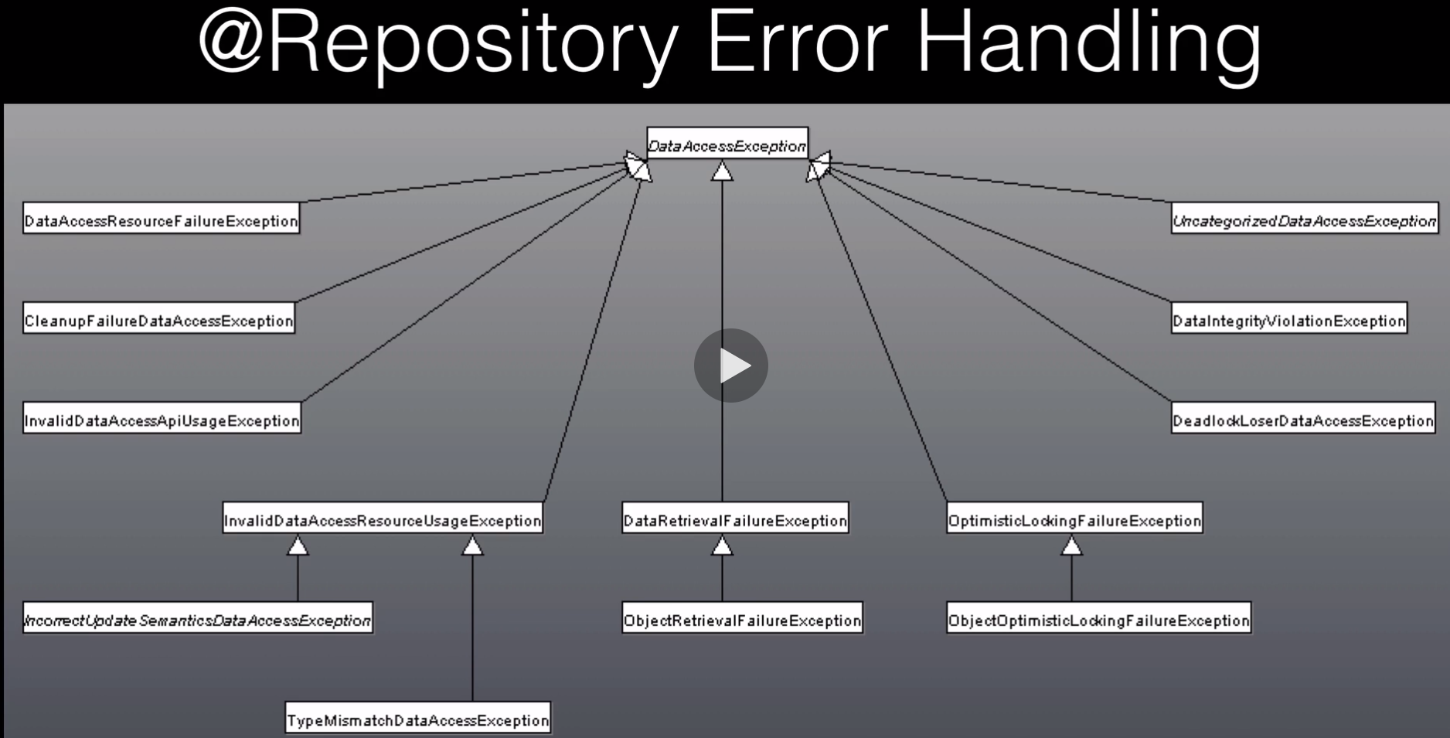

What Spring is going to do when you are using Hibernate or straight JDBC or different databases it is going to take those exceptions from that specific layer and make it into a Spring exception. So that the exception and error handling above your Repository is going to stay generic to the Spring Framework and not tied to the persistence application you have underneath. It is basically an abstraction layer; it is a good habit to do it this way.

**@ComponentScan**

@ComponentScan, is a way for Spring to look at your package structure and determine and find Spring Beans within the package.

It is going to be looking for classes with Spring annotations.

By default, Spring looks at its own packages and scans down, but it does not scan everything.

**Spring Boot Configuration**

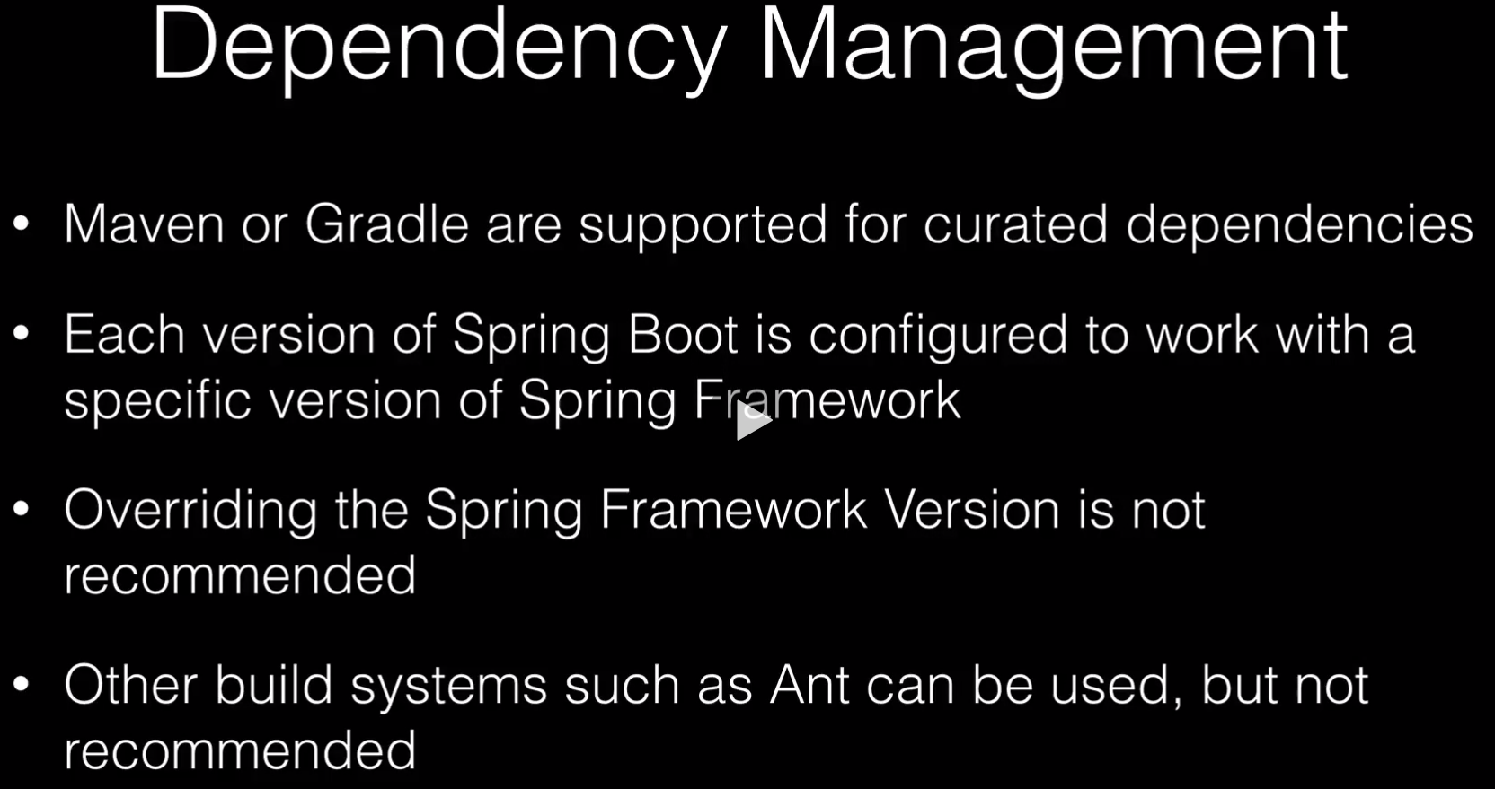

**Spring Boot Configuration**

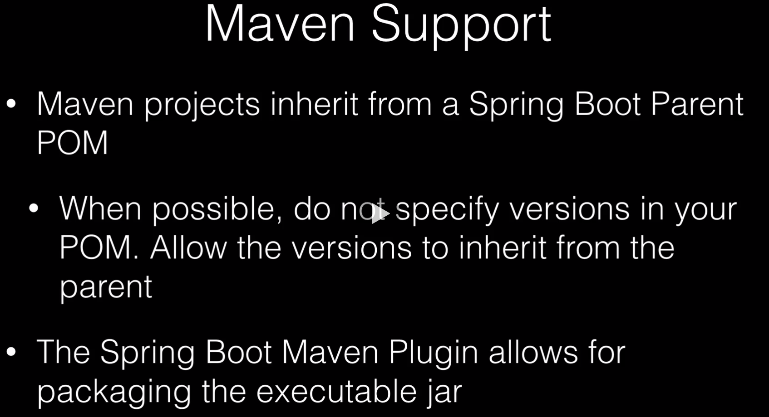

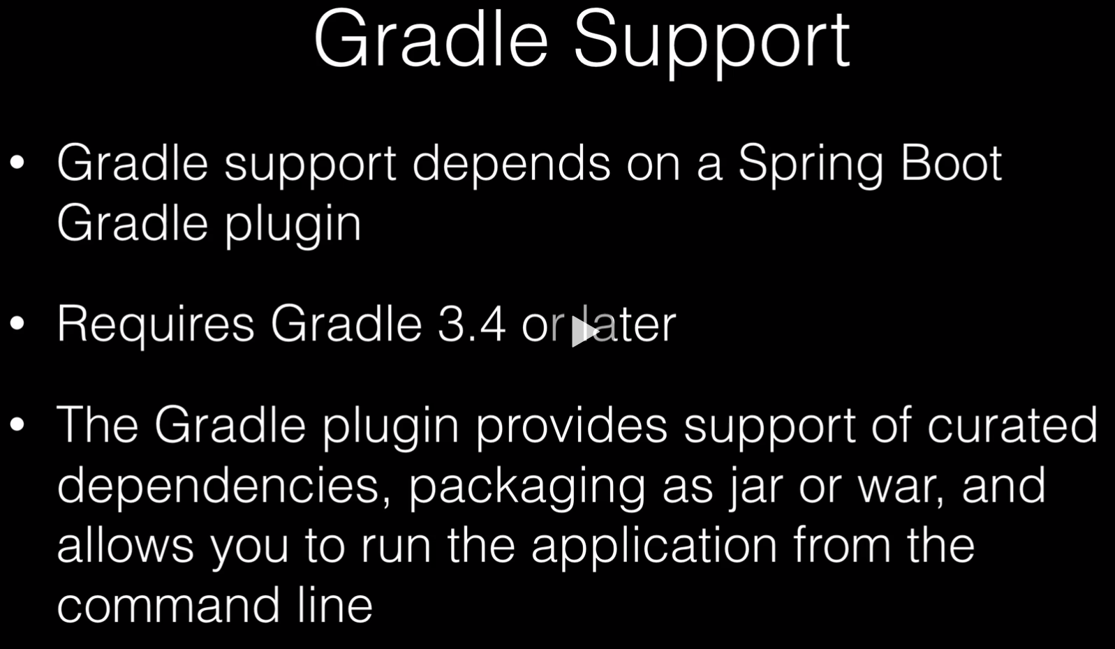

**Spring Boot Configuration**

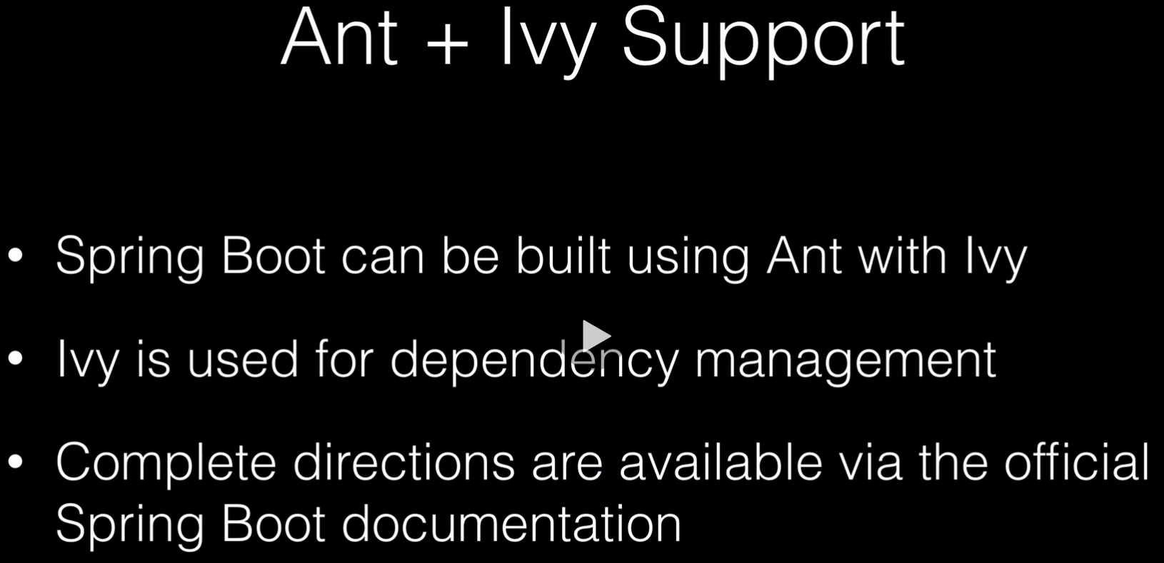

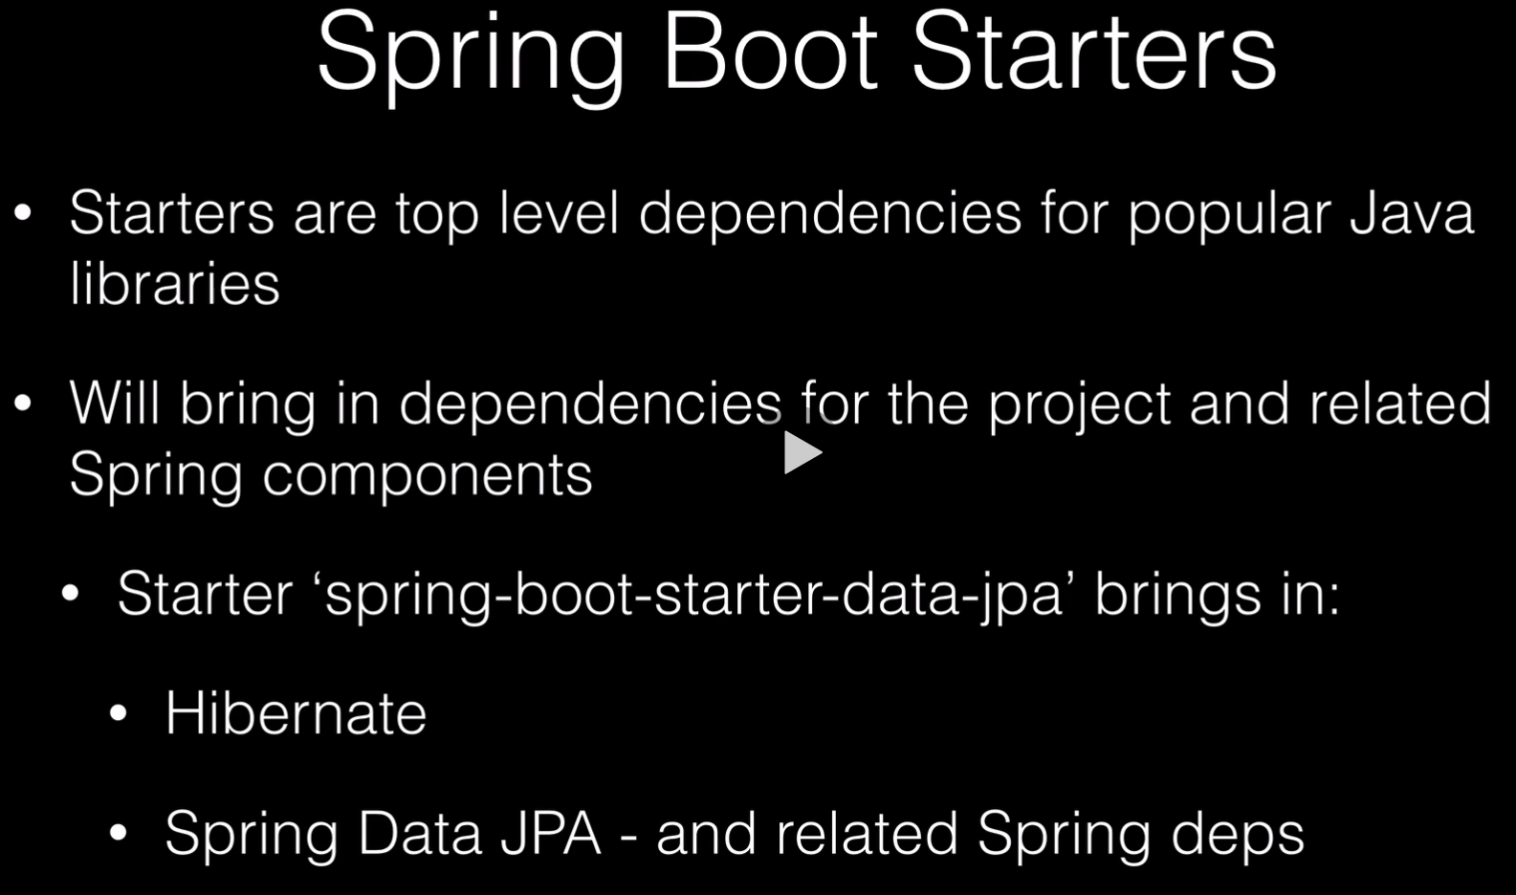

**Spring Boot Configuration**

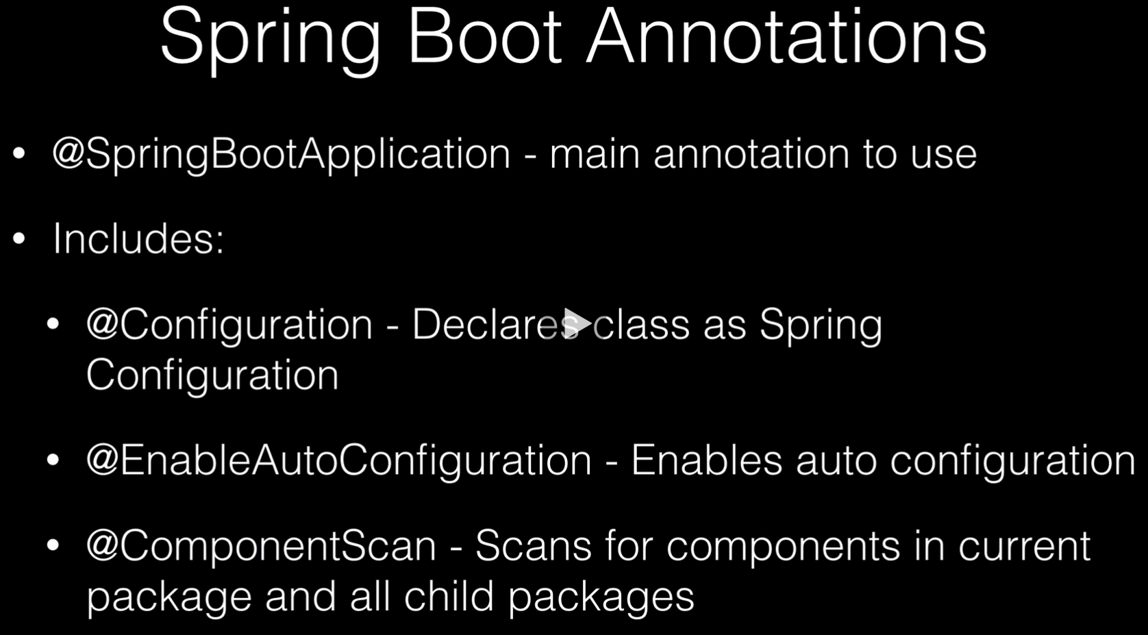

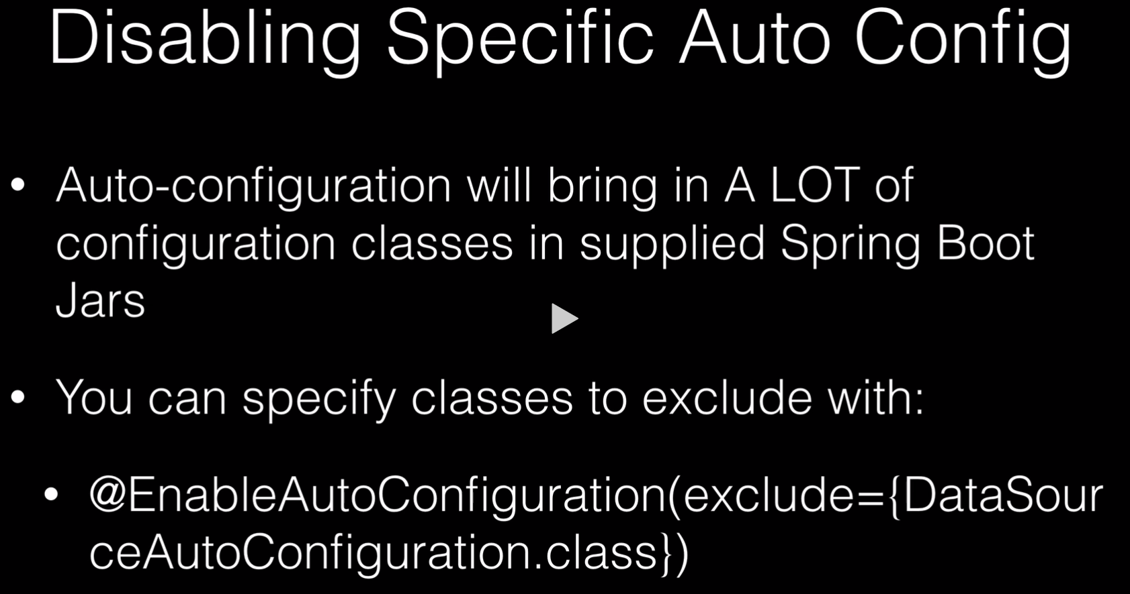

**Some Useful Maven Commands**

* + mvn spring-boot:help -Ddetail=true
    1. This will display a details of the help
  + mvn spring-boot:run -Drun arguments=--debug
    1. This will give us an auto configuration report
  + From within Intellij you can select from the main toolbar ‘Run’ and then ‘Edit Configurations’ then for Spring Boot you can select debug output, and you will get the configuration report when you run the application.
  + Spring Boot is really a configuration wrapper around the Spring Framework. Is essentially gives you all the defaults which you can override if you need to.
  + Spring MVC is the Web Wrapper
  + Security, goes through Spring Security

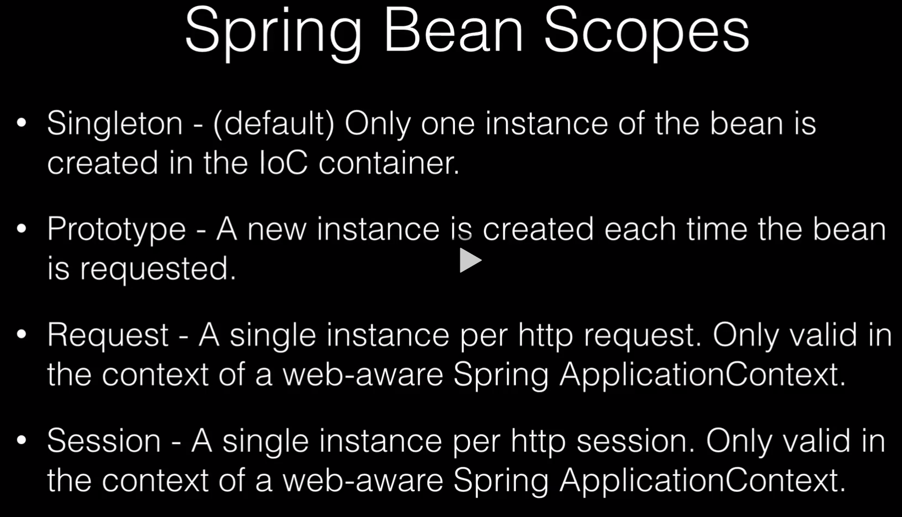

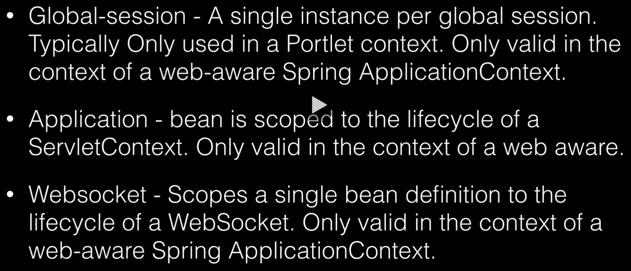

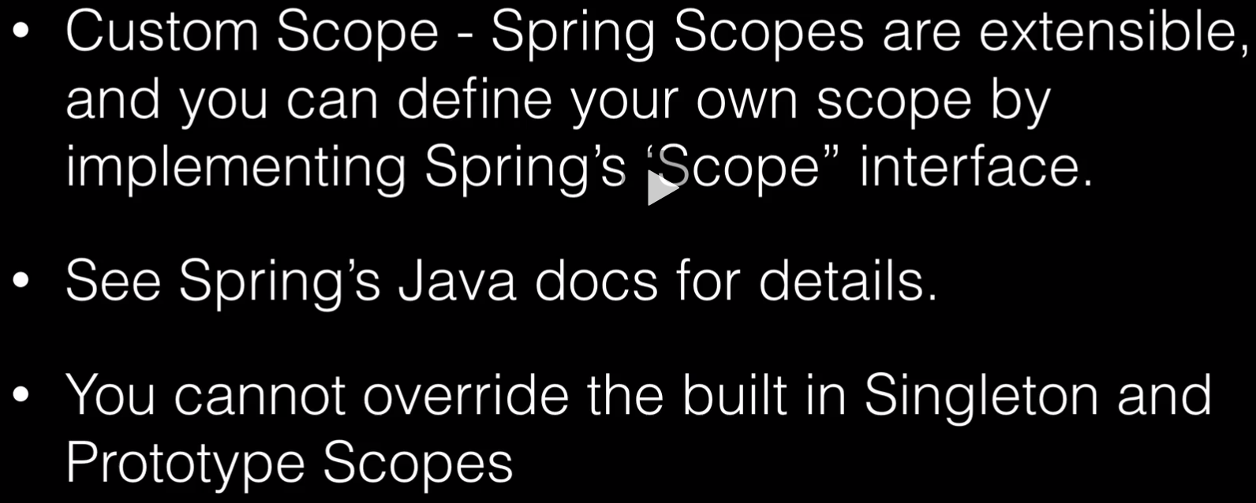

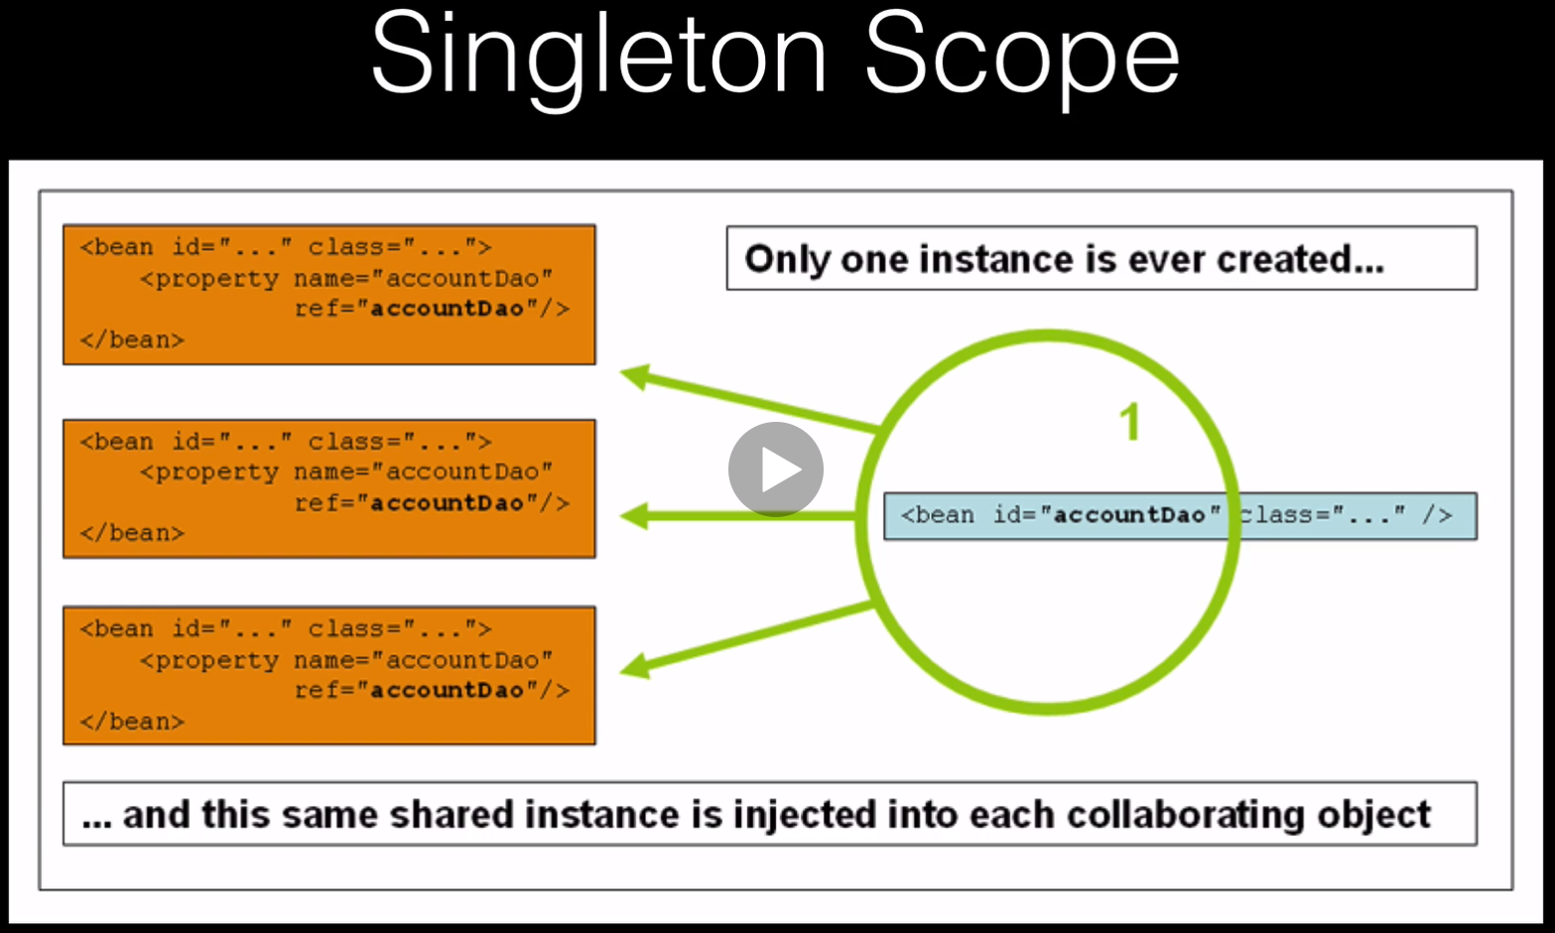

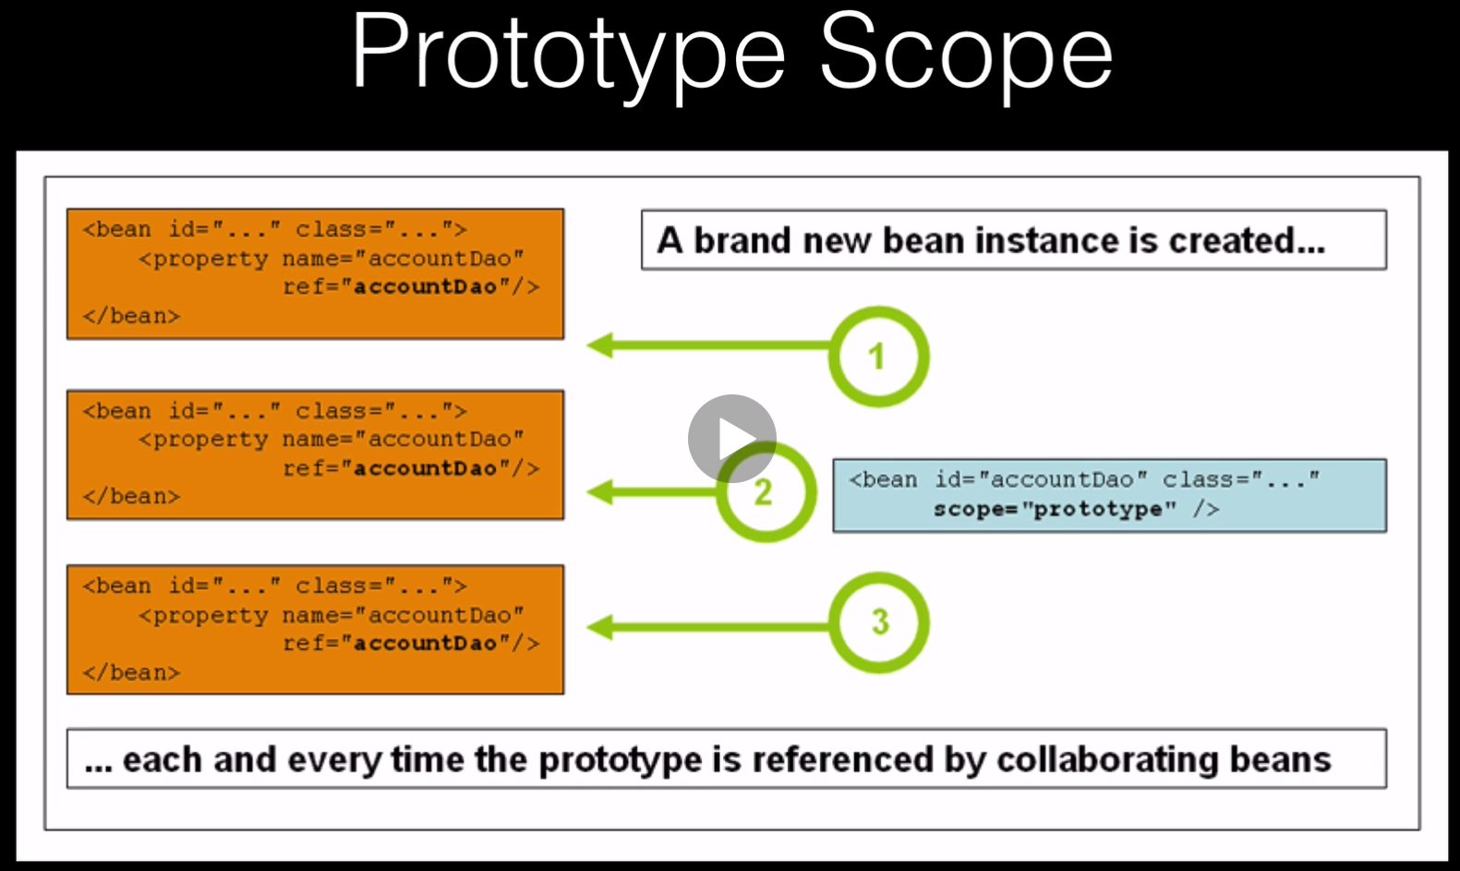

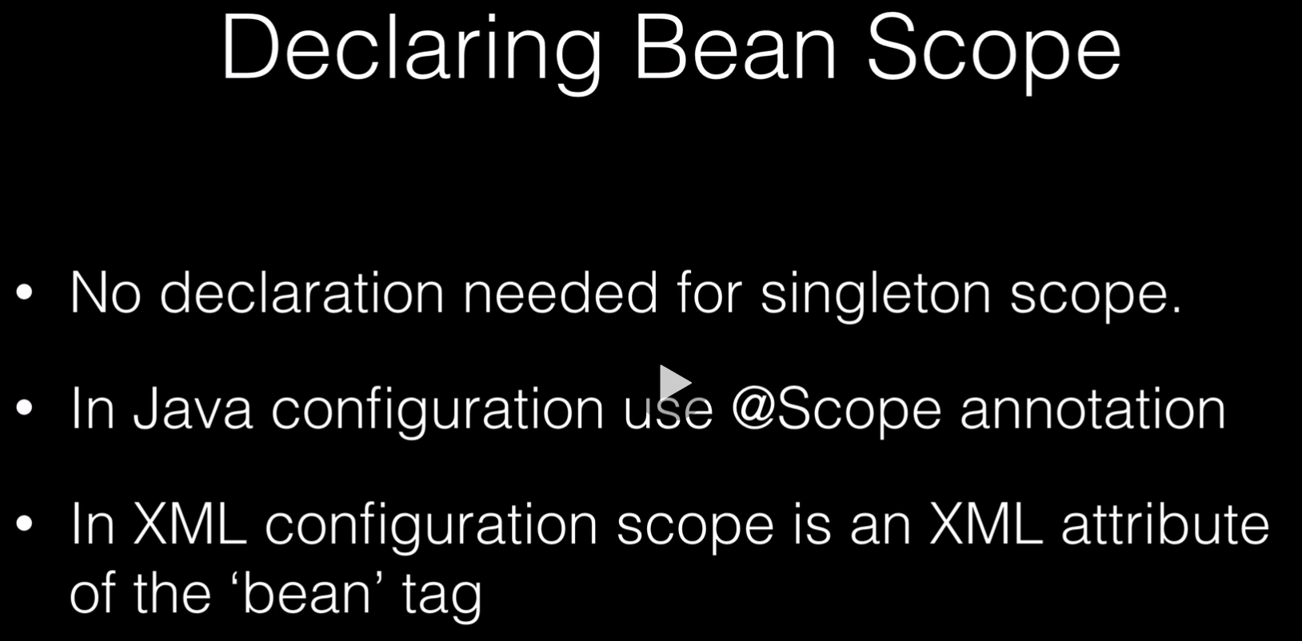

**Questions and Answers:**

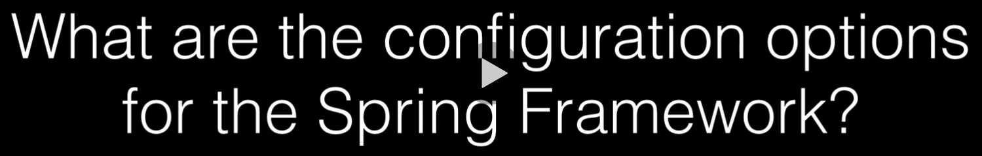









**Answer = YES**

**Questions and Answers:**

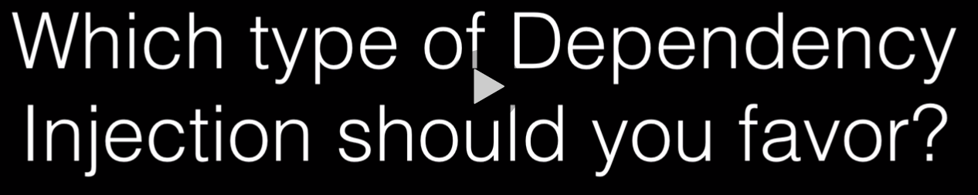

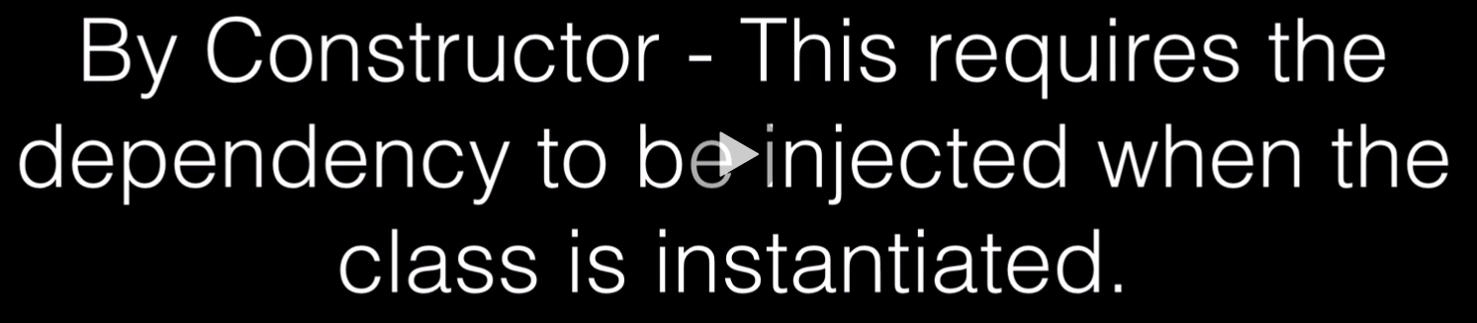

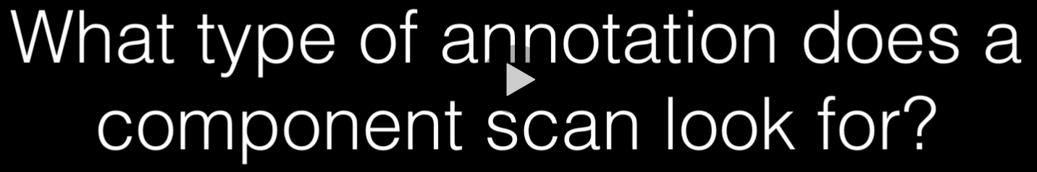



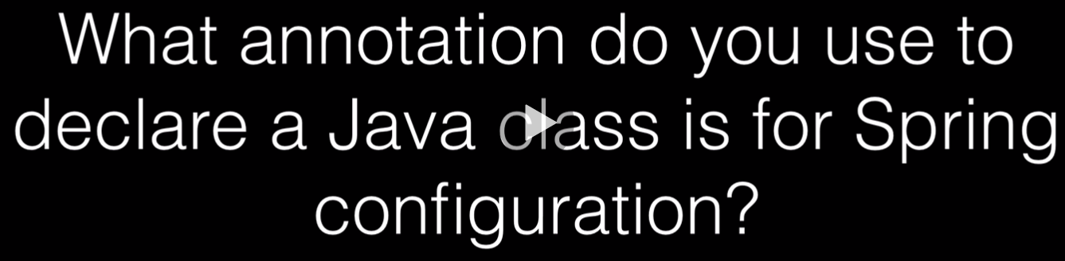

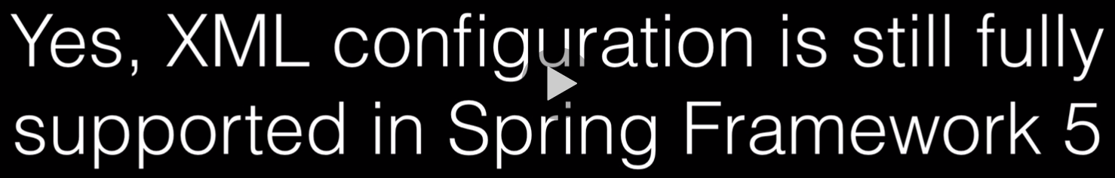



**Questions and Answers:**

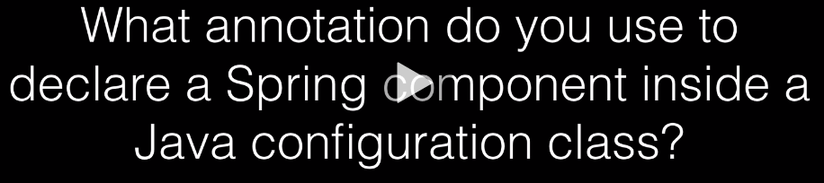



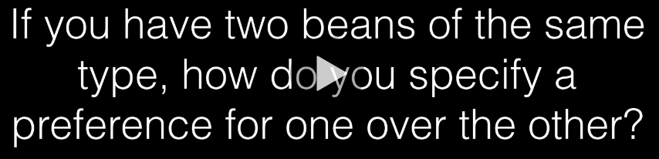



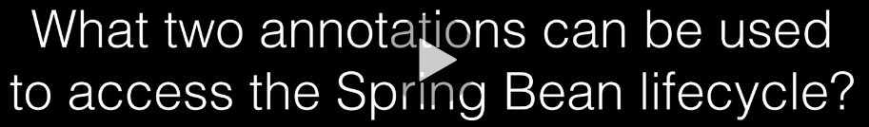



**Questions and Answers:**













**Questions and Answers:**



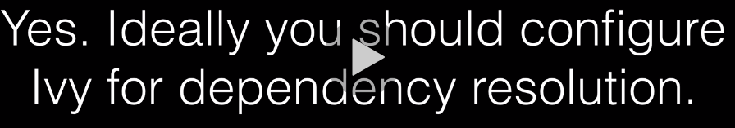





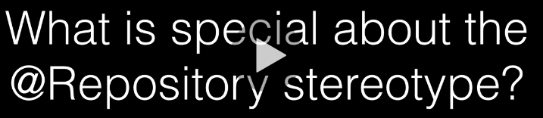

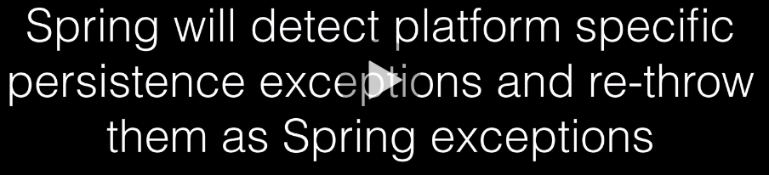

**Questions and Answers:**

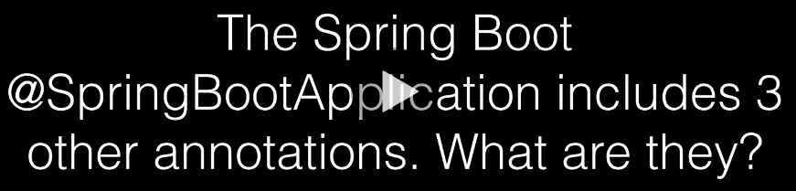

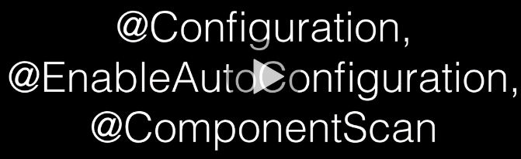

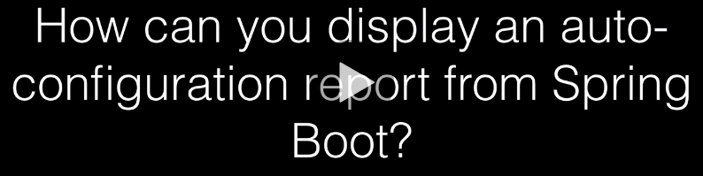

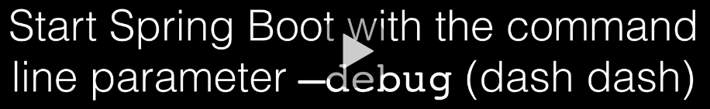



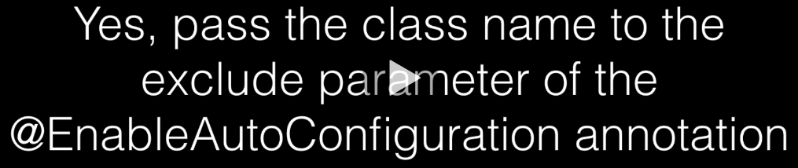

**Questions and Answers:**













**Spring Boot Properties**

<https://docs.spring.io/spring-boot/docs/current/reference/html/boot-features-external-config.html>

Spring Boot lets you externalize your configuration so that you can work with the same application code in different environments. You can use properties files, YAML files, environment variables, and command-line arguments to externalize configuration. Property values can be injected directly into your beans by using the @Value annotation, accessed through Spring’s Environment abstraction, or be [bound to structured objects](https://docs.spring.io/spring-boot/docs/current/reference/html/spring-boot-features.html#boot-features-external-config-typesafe-configuration-properties) through @ConfigurationProperties.

Spring Boot uses a very particular PropertySource order that is designed to allow sensible overriding of values. Properties are considered in the following order:

1. [Devtools global settings properties](https://docs.spring.io/spring-boot/docs/current/reference/html/using-spring-boot.html#using-boot-devtools-globalsettings) in the $HOME/.config/spring-boot directory when devtools is active.
2. [@TestPropertySource](https://docs.spring.io/spring/docs/5.2.8.RELEASE/javadoc-api/org/springframework/test/context/TestPropertySource.html) annotations on your tests.
3. properties attribute on your tests. Available on [@SpringBootTest](https://docs.spring.io/spring-boot/docs/2.3.3.RELEASE/api/org/springframework/boot/test/context/SpringBootTest.html) and the [test annotations for testing a particular slice of your application](https://docs.spring.io/spring-boot/docs/current/reference/html/spring-boot-features.html#boot-features-testing-spring-boot-applications-testing-autoconfigured-tests).
4. Command line arguments.
5. Properties from SPRING_APPLICATION_JSON (inline JSON embedded in an environment variable or system property).
6. ServletConfig init parameters.
7. ServletContext init parameters.
8. JNDI attributes from java:comp/env.
9. Java System properties (System.getProperties()).
10. OS environment variables.
11. A RandomValuePropertySource that has properties only in random.*.
12. [Profile-specific application properties](https://docs.spring.io/spring-boot/docs/current/reference/html/spring-boot-features.html#boot-features-external-config-profile-specific-properties) outside of your packaged jar (application-{profile}.properties and YAML variants).
13. [Profile-specific application properties](https://docs.spring.io/spring-boot/docs/current/reference/html/spring-boot-features.html#boot-features-external-config-profile-specific-properties) packaged inside your jar (application-{profile}.properties and YAML variants).
14. [Application properties](https://docs.spring.io/spring-boot/docs/current/reference/html/spring-boot-features.html#boot-features-external-config-application-property-files) outside of your packaged jar (application.properties and YAML variants).
15. [Application properties](https://docs.spring.io/spring-boot/docs/current/reference/html/spring-boot-features.html#boot-features-external-config-application-property-files) packaged inside your jar (application.properties and YAML variants).
16. [@PropertySource](https://docs.spring.io/spring/docs/5.2.8.RELEASE/javadoc-api/org/springframework/context/annotation/PropertySource.html) annotations on your @Configuration classes. Please note that such property sources are not added to the Environment until the application context is being refreshed. This is too late to configure certain properties such as logging.* and spring.main.* which are read before refresh begins.
17. Default properties (specified by setting SpringApplication.setDefaultProperties).

**HTTP Protocol**

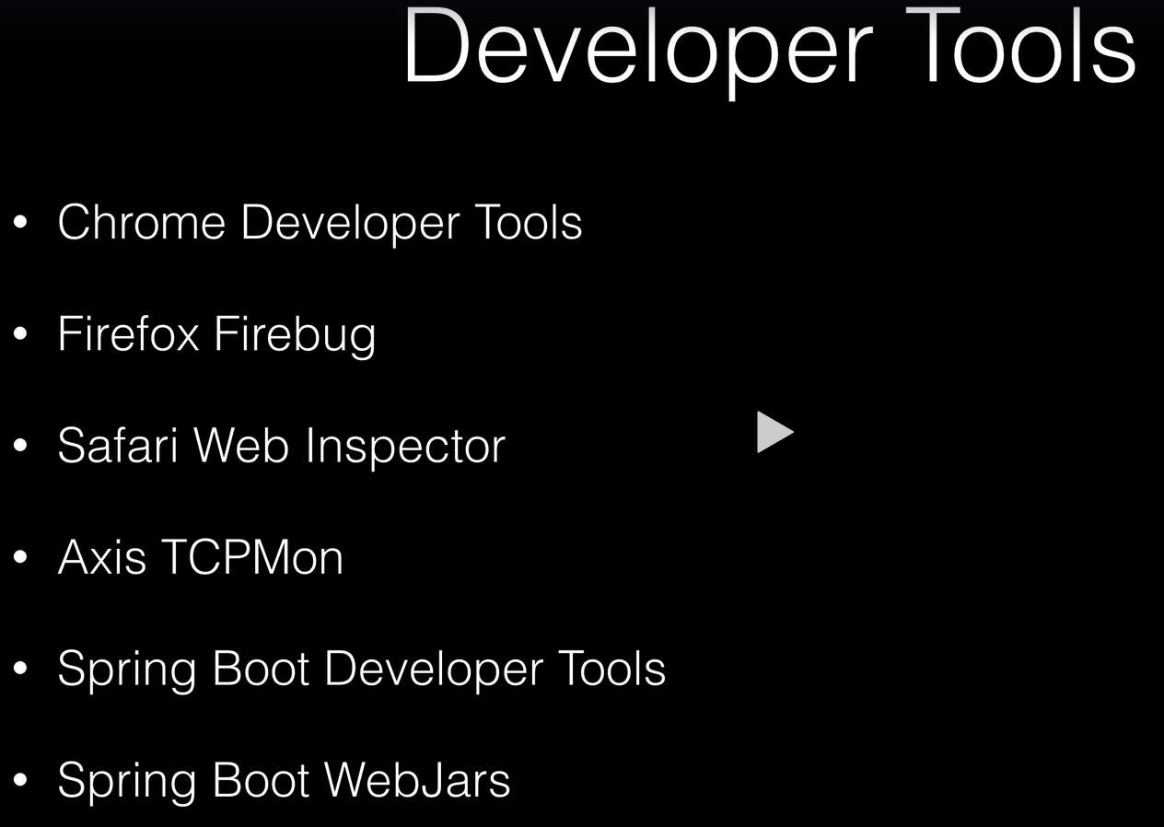

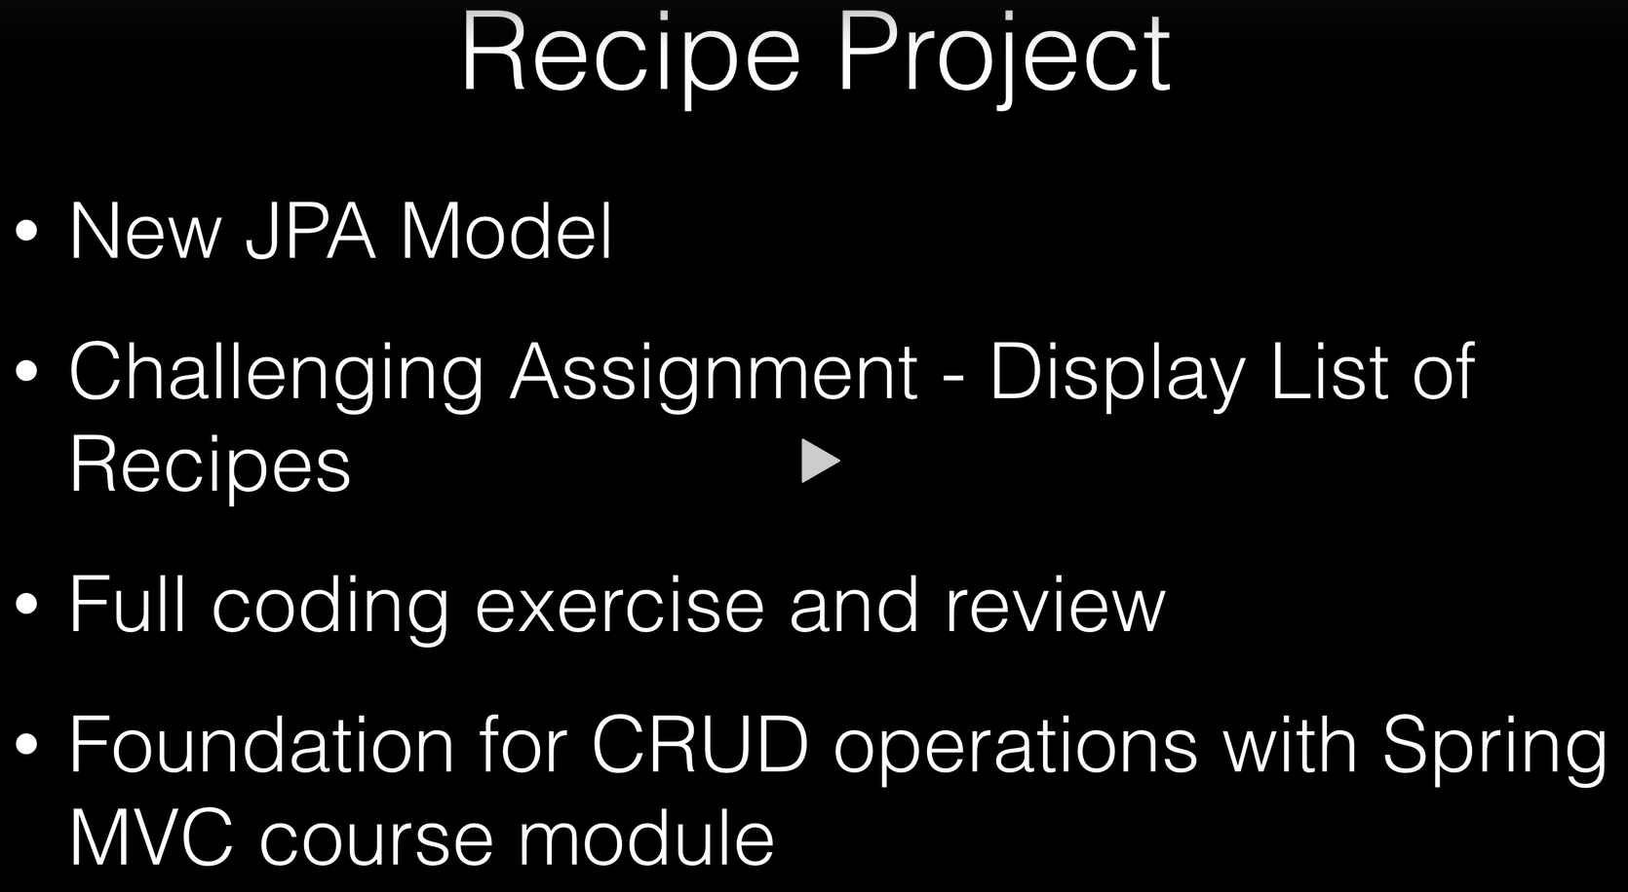

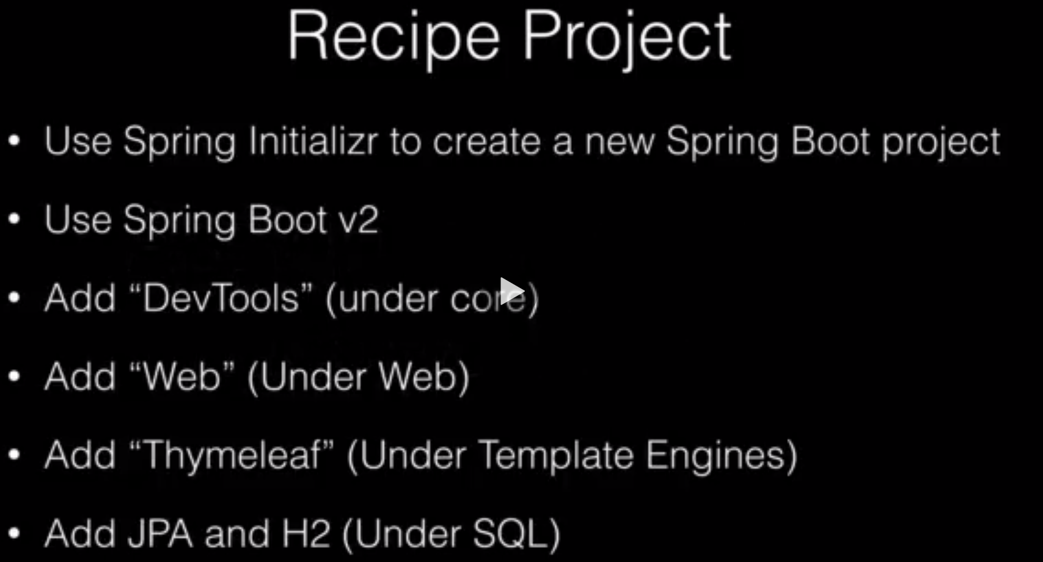

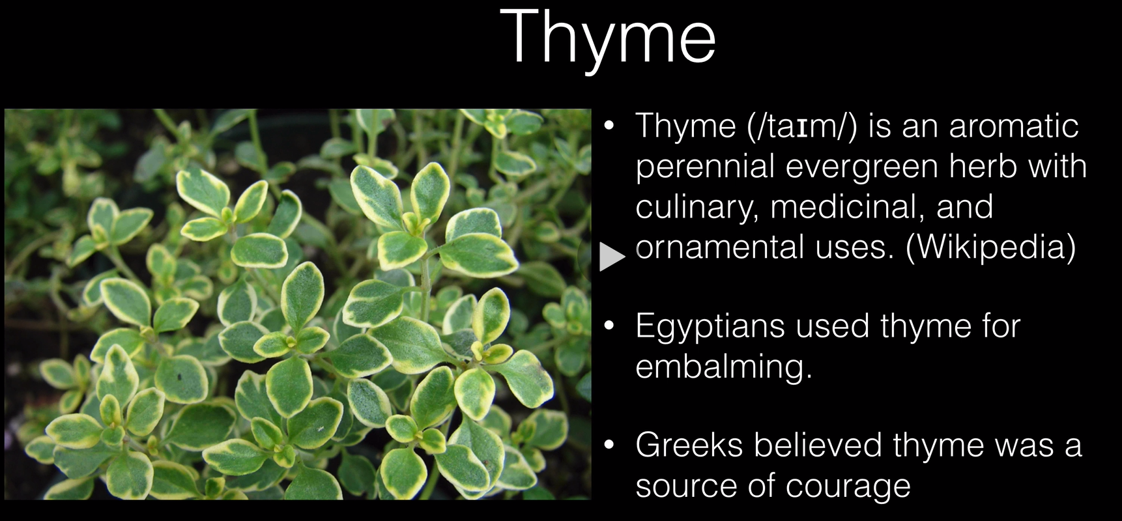

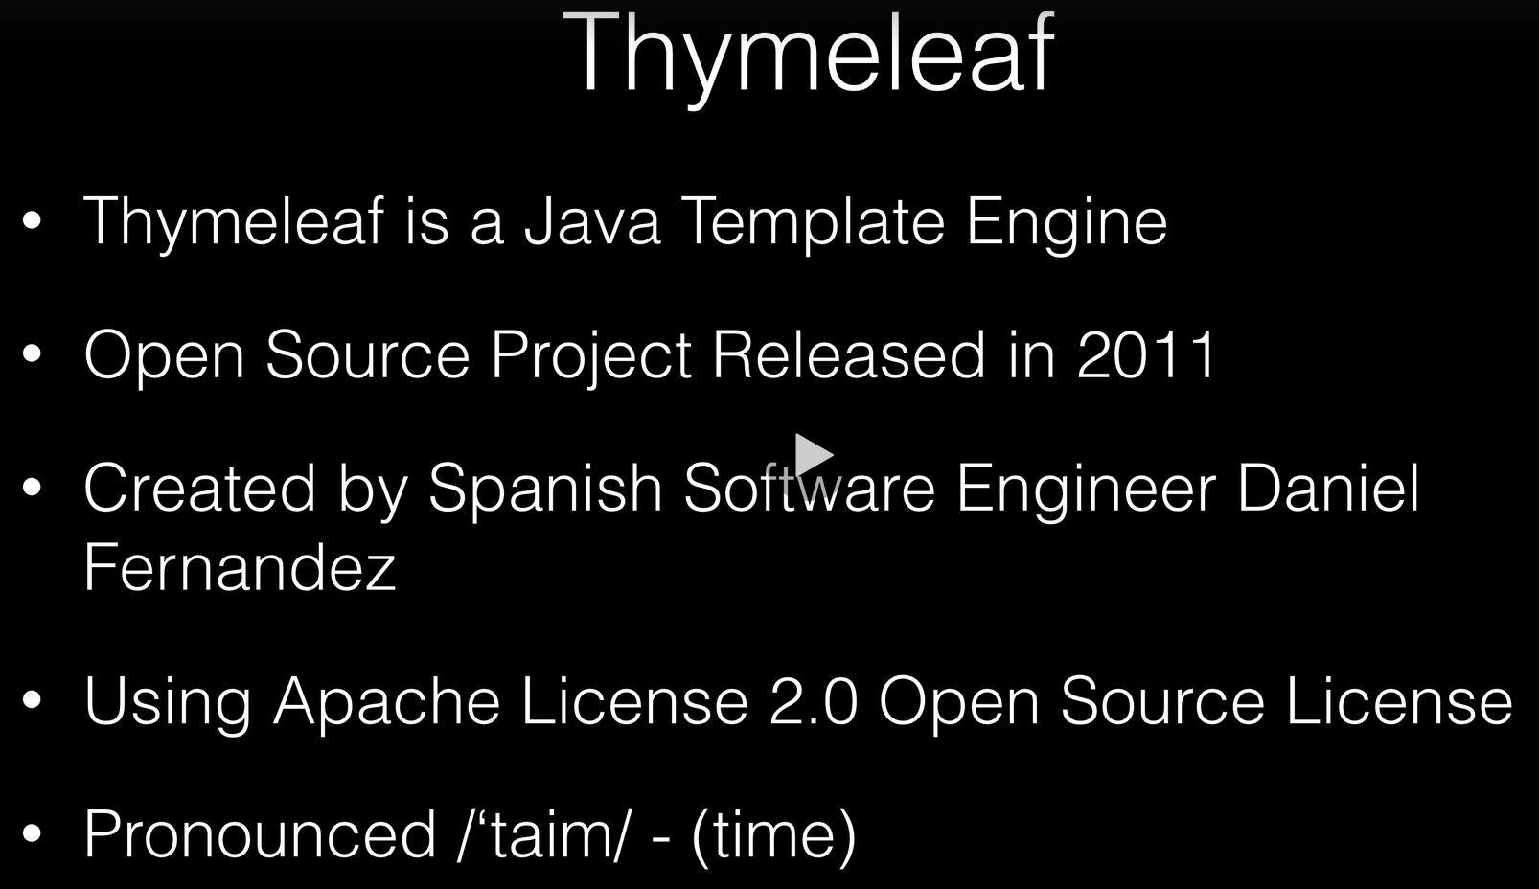

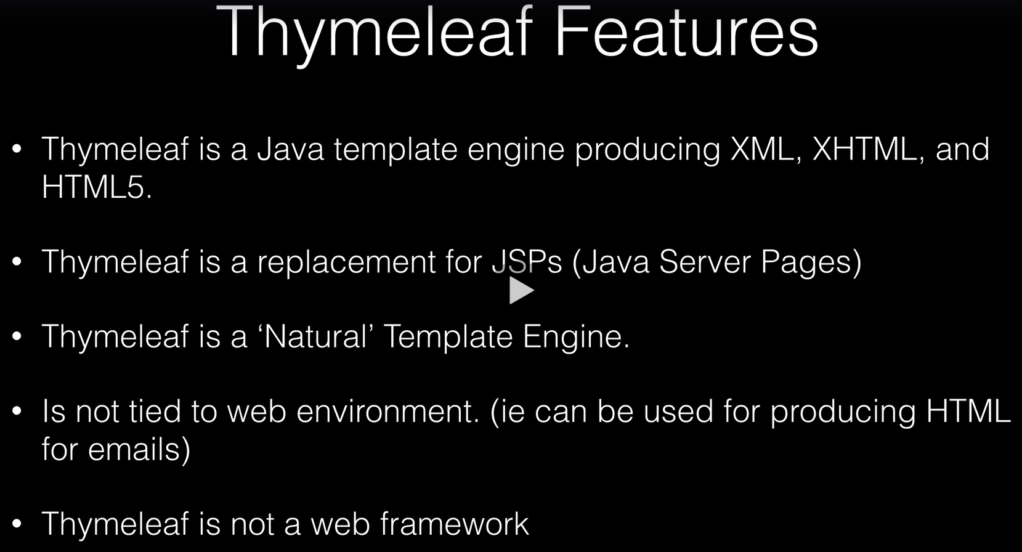

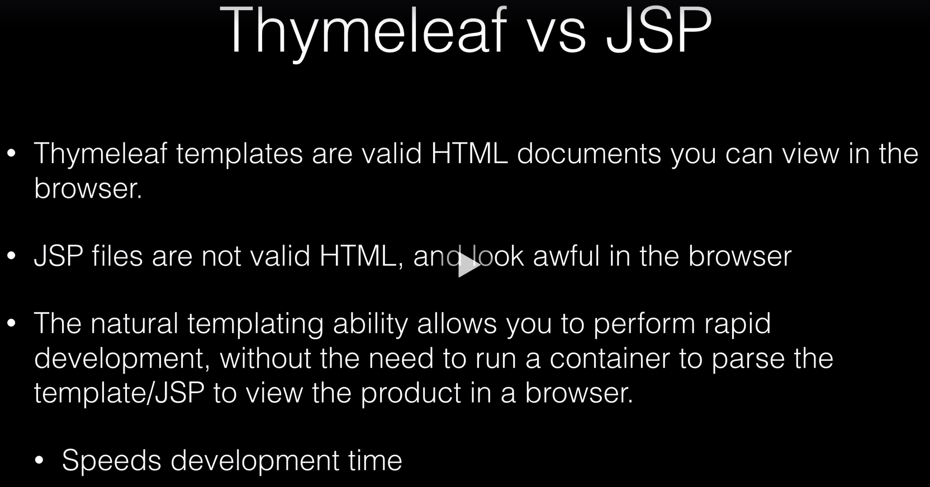

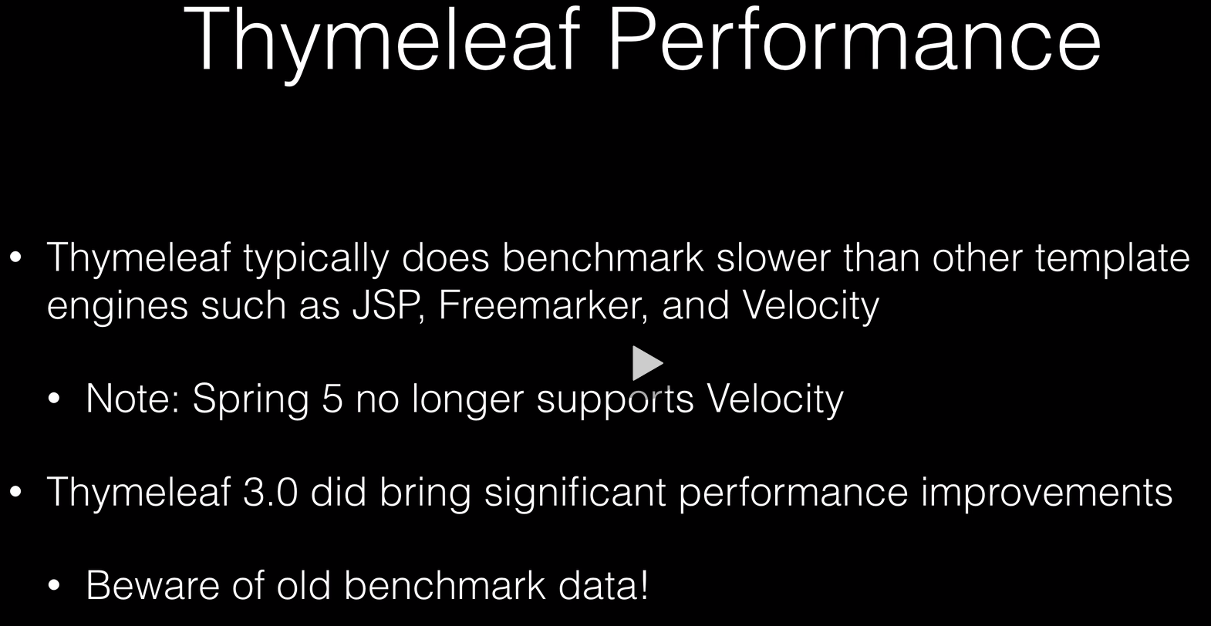

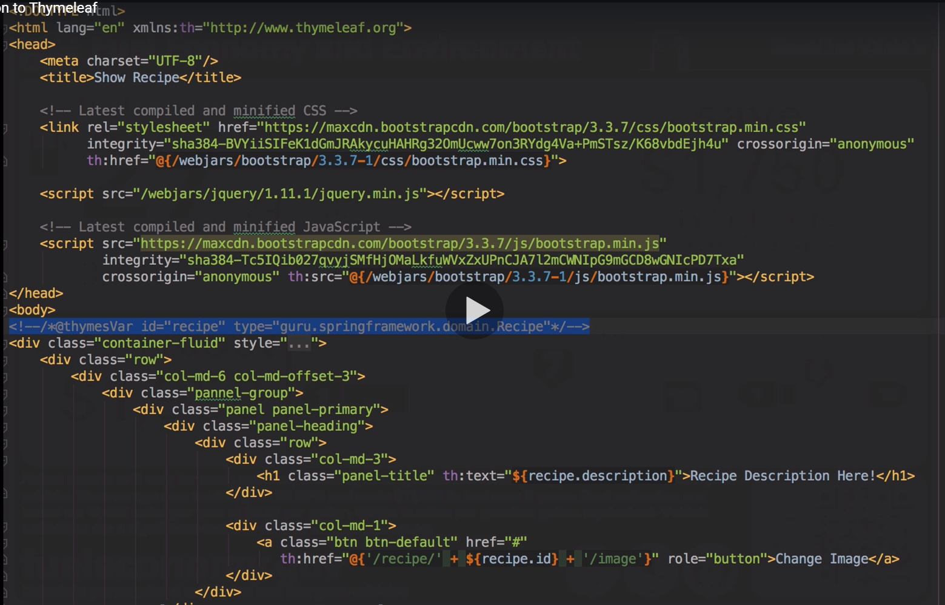



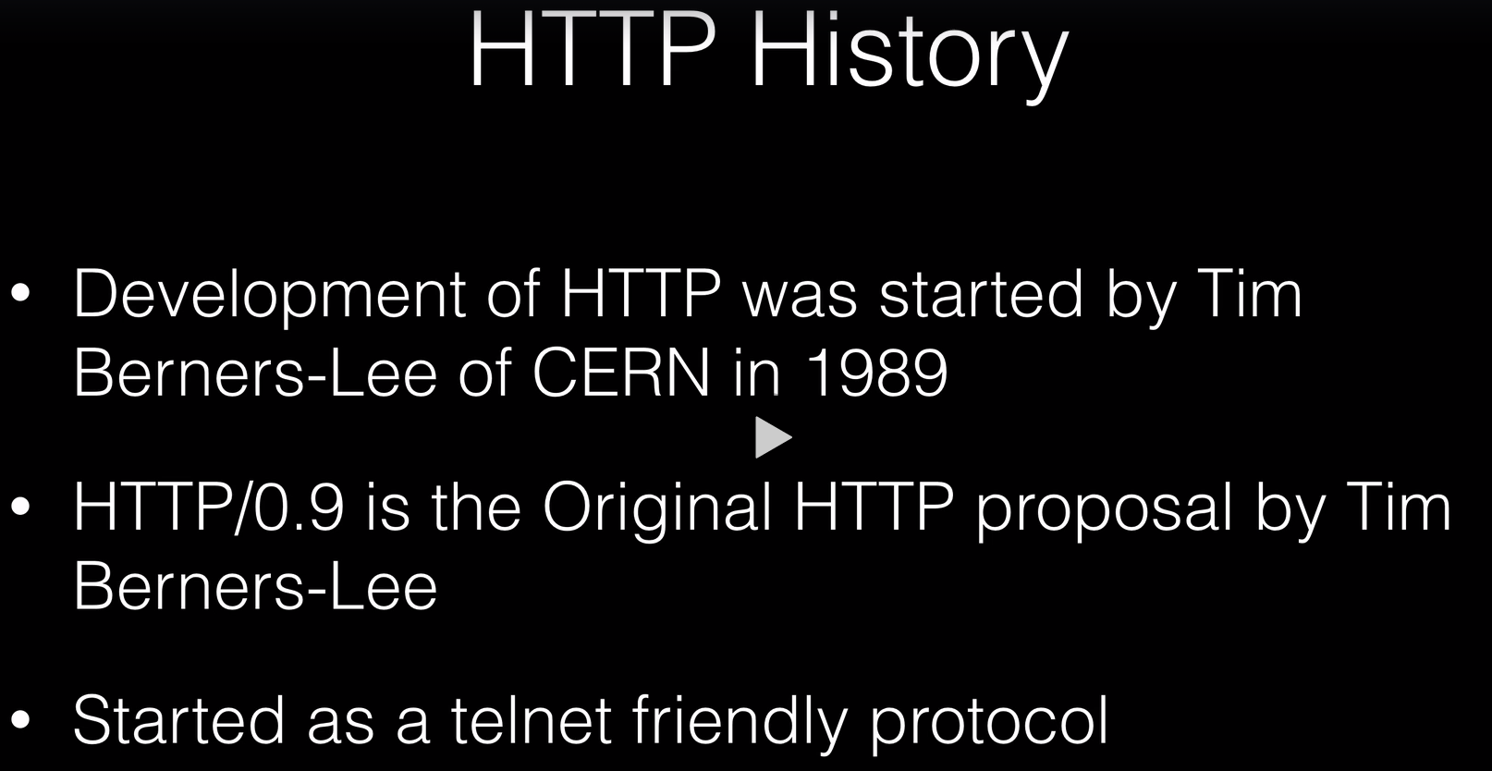

Telnet is no longer used, it’s a free text protocol, which as many security issues.

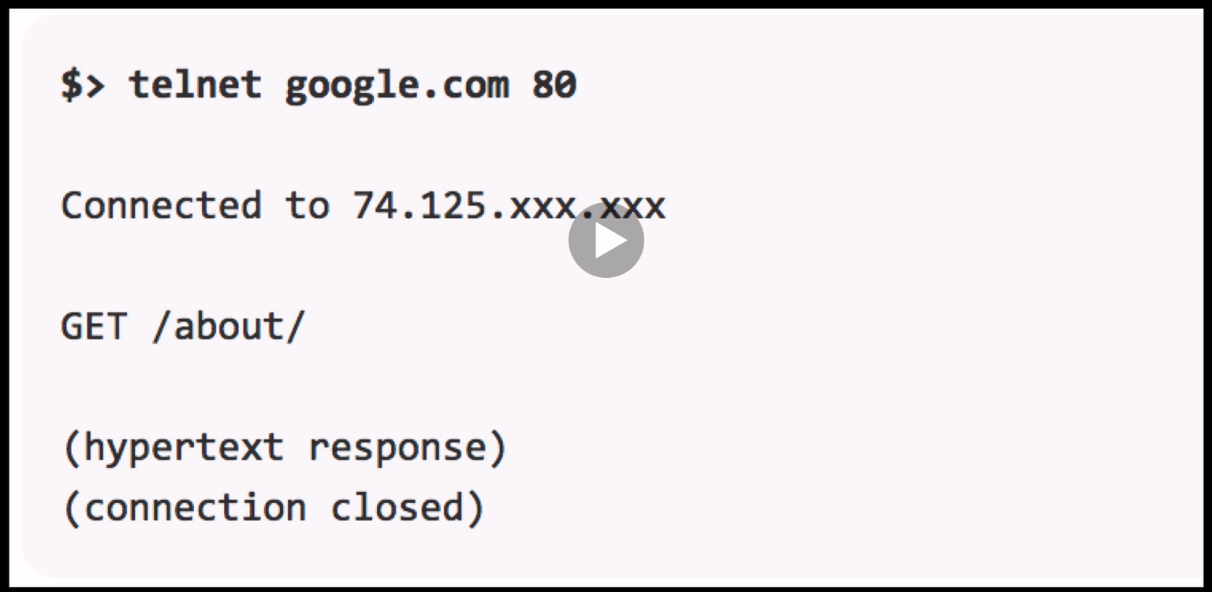

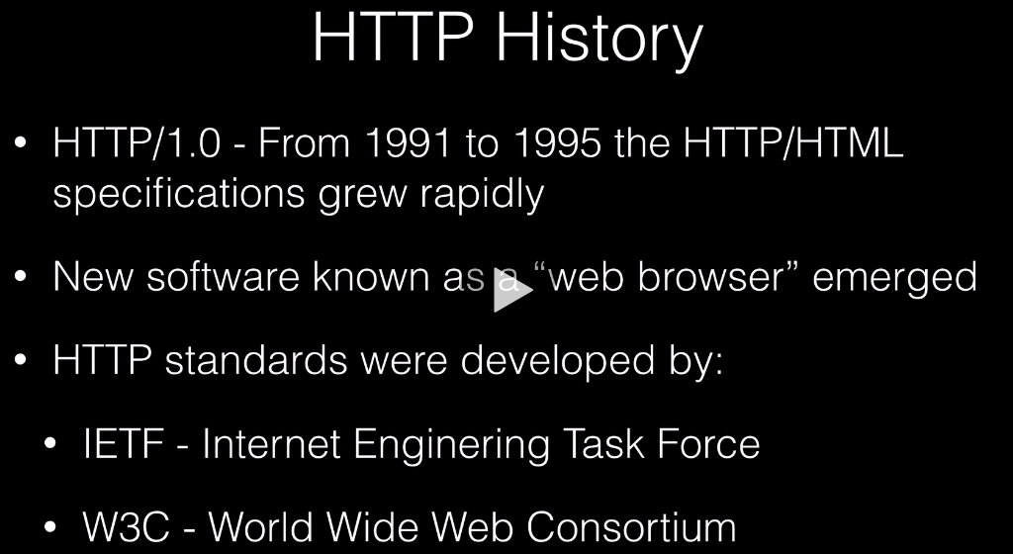

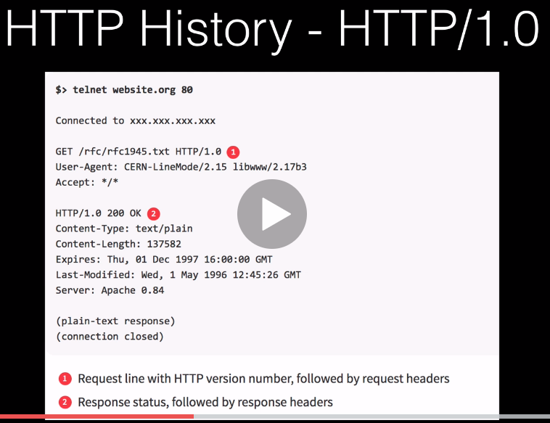

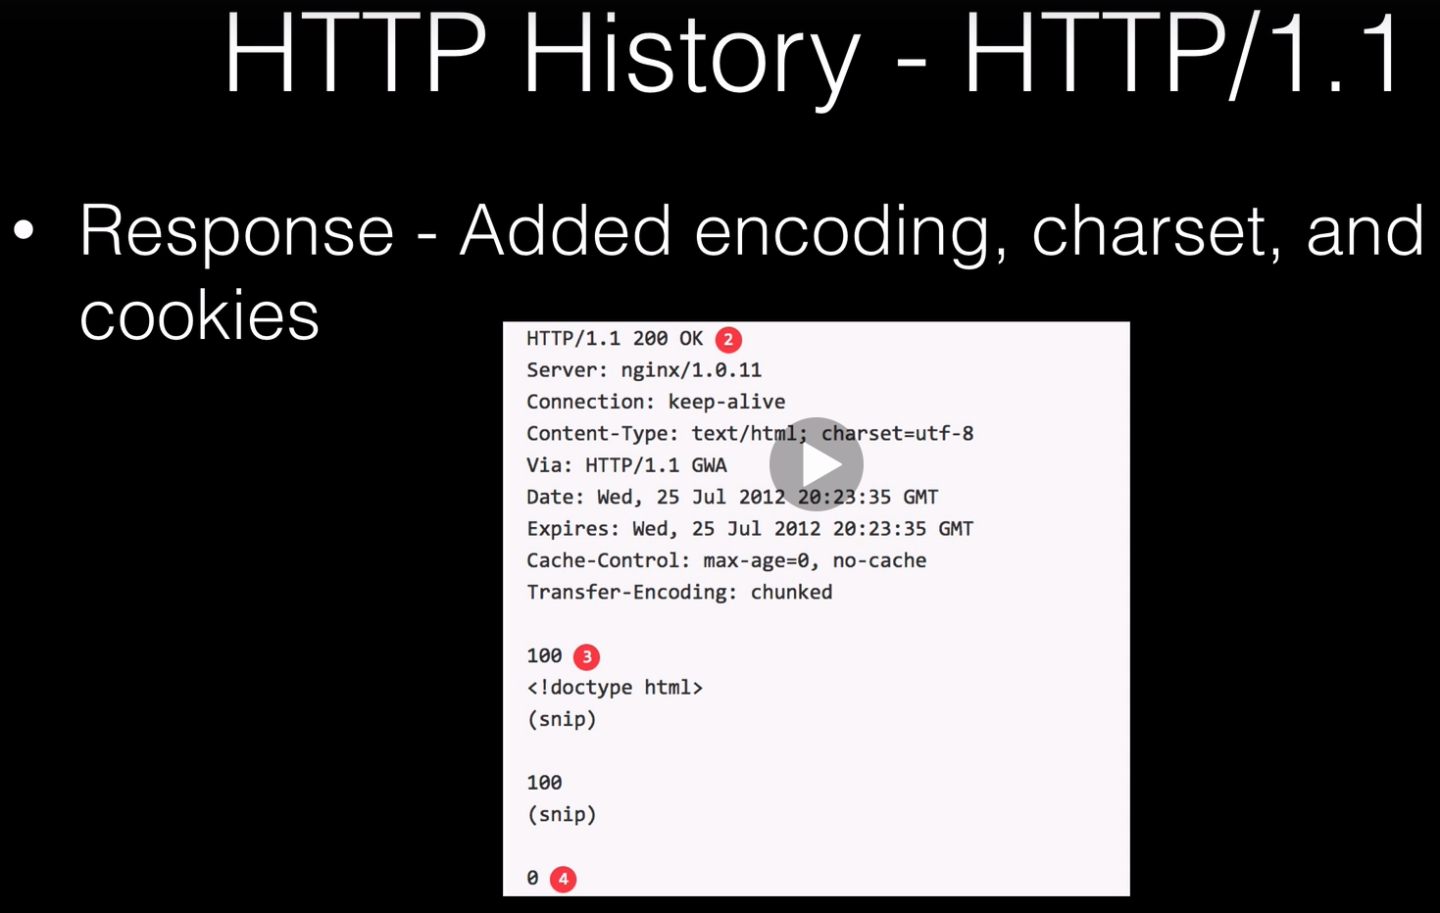



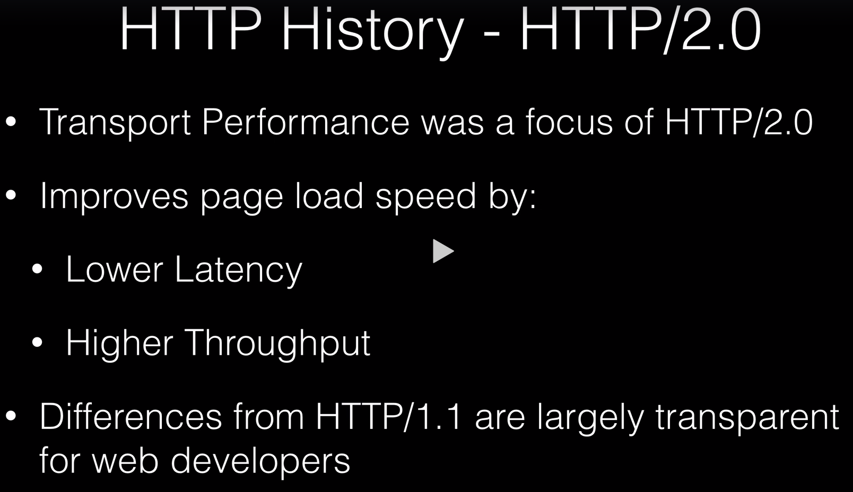



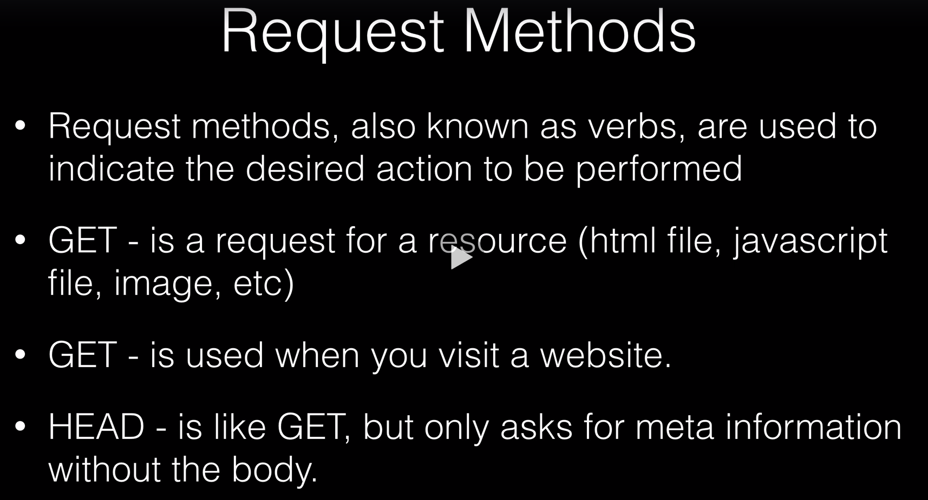

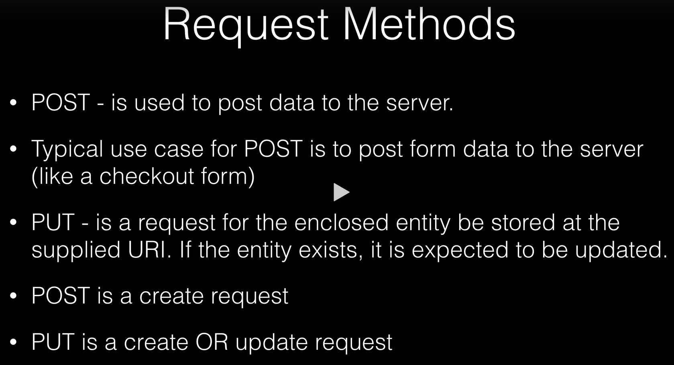

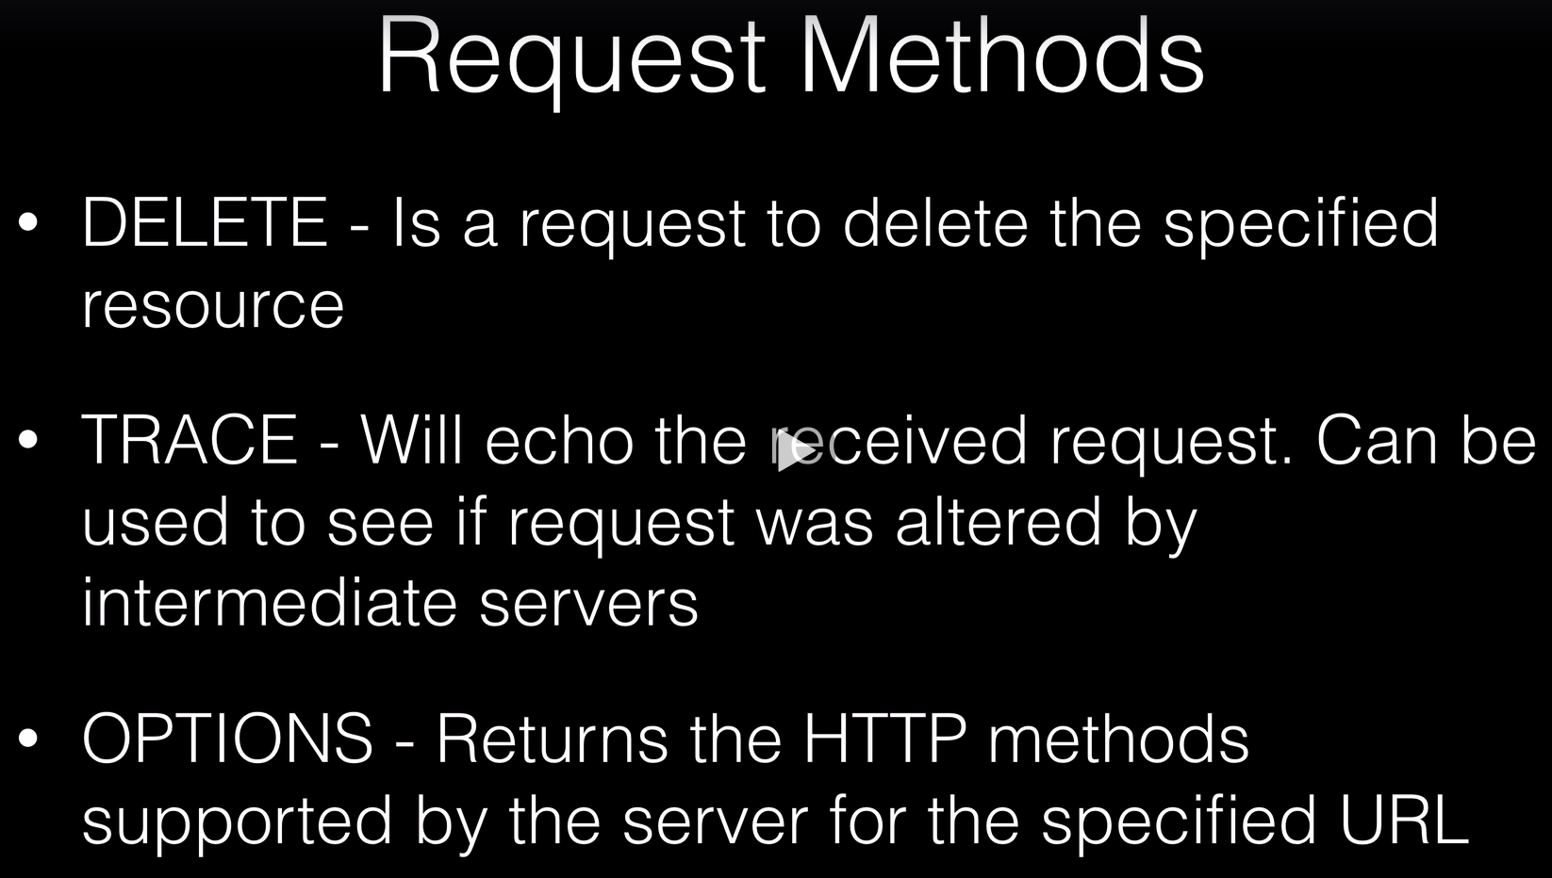

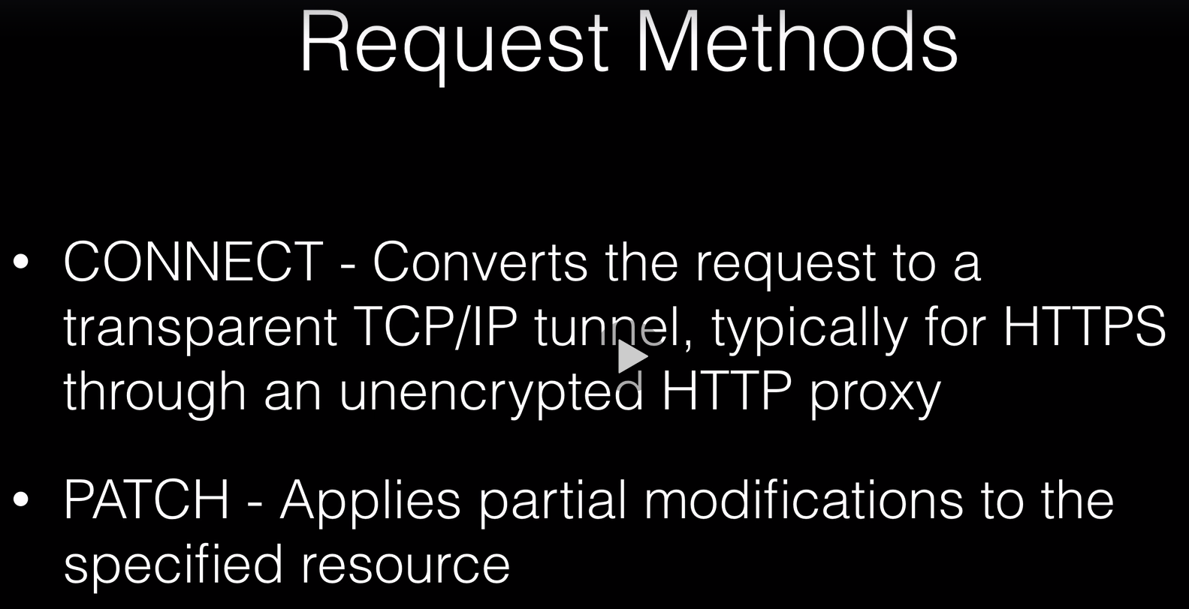

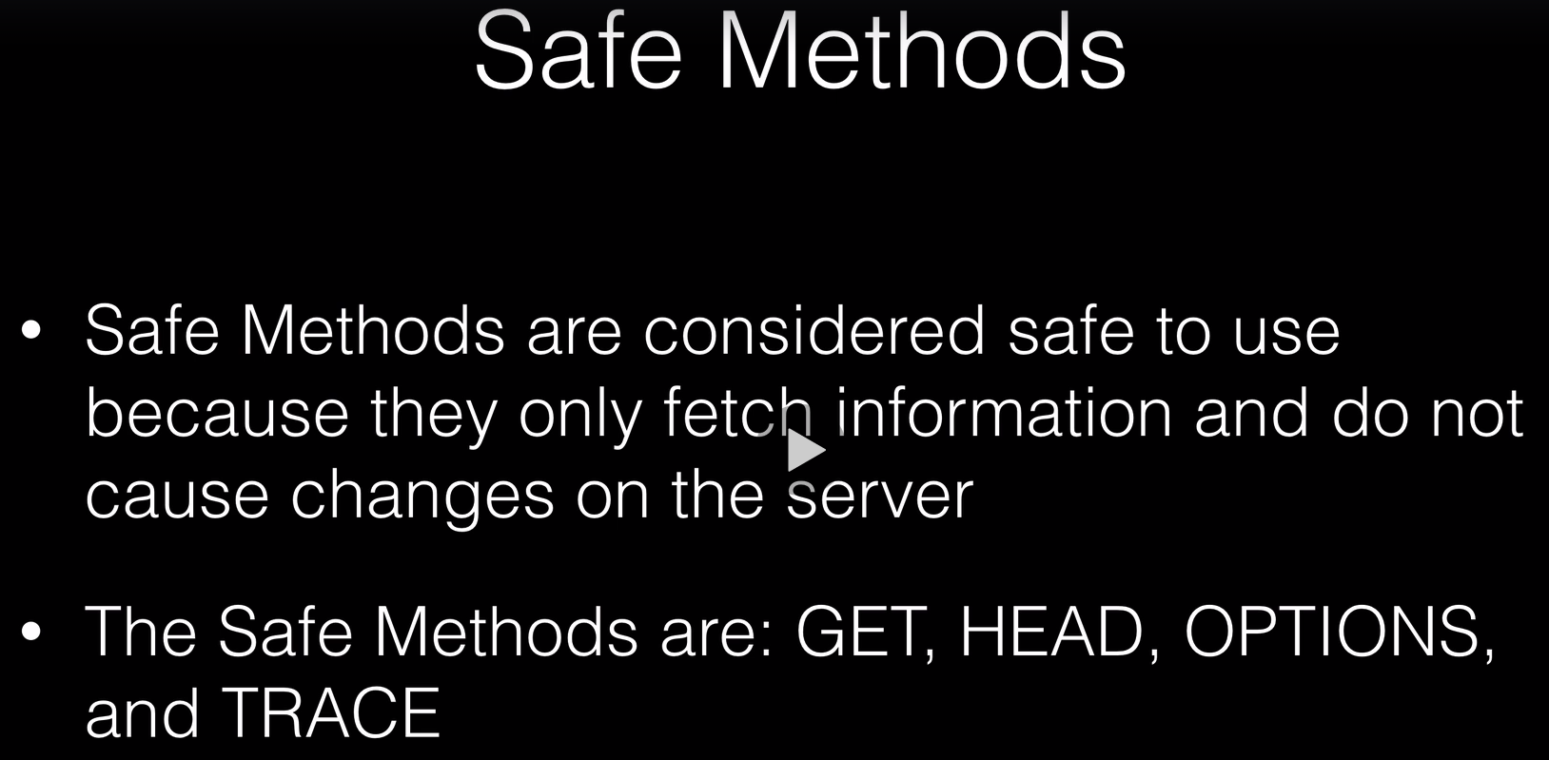

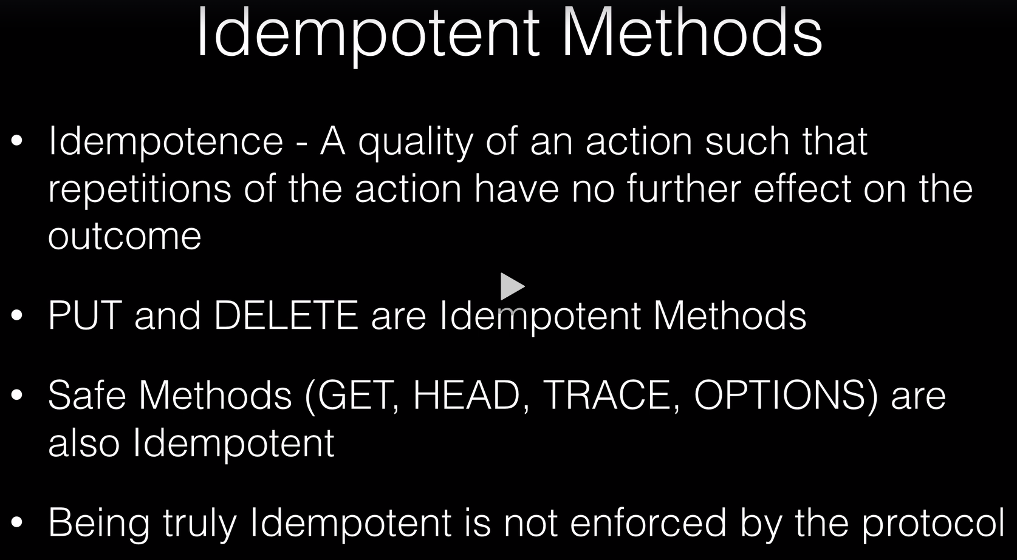

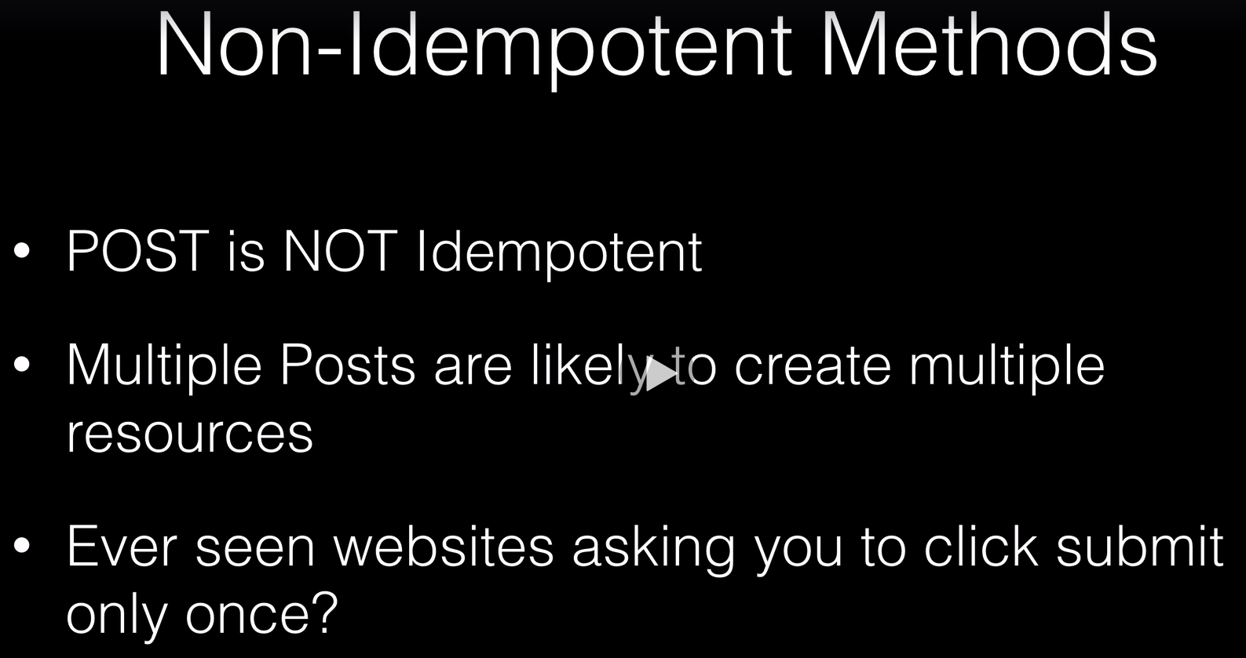

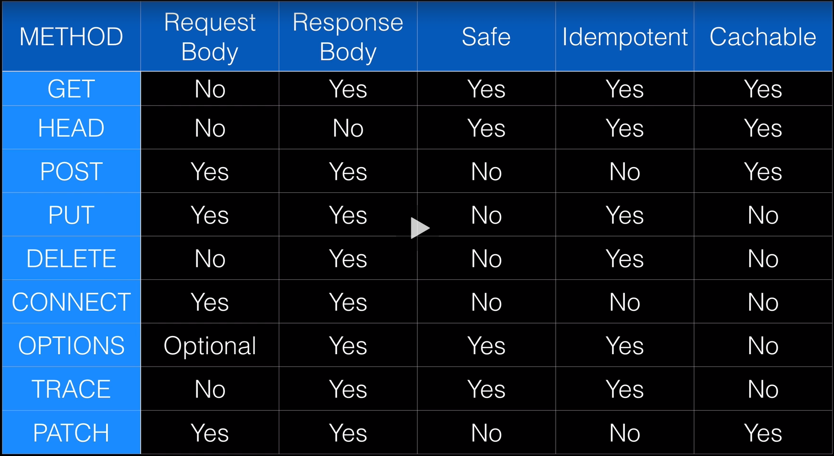

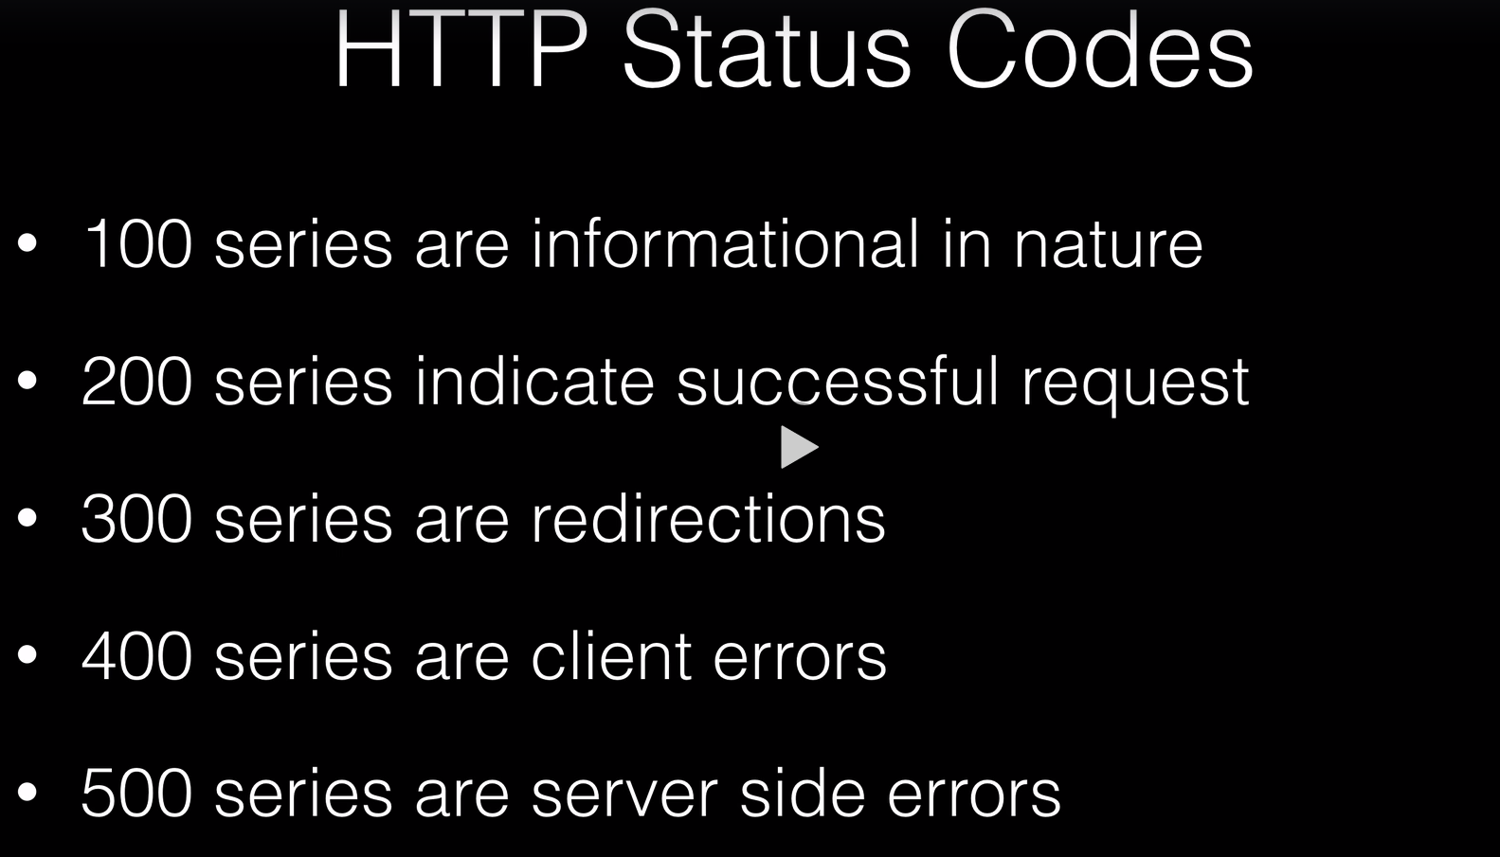

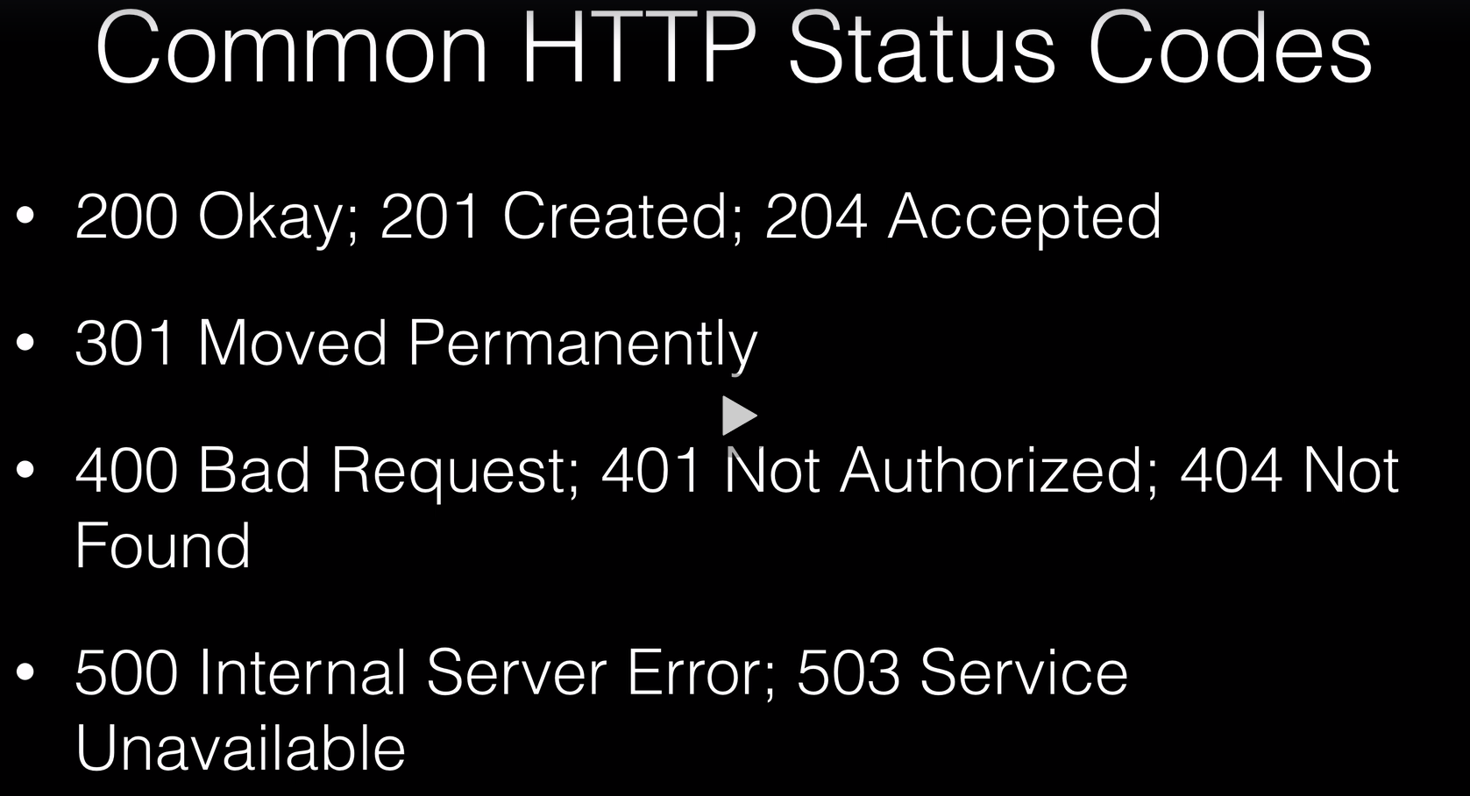

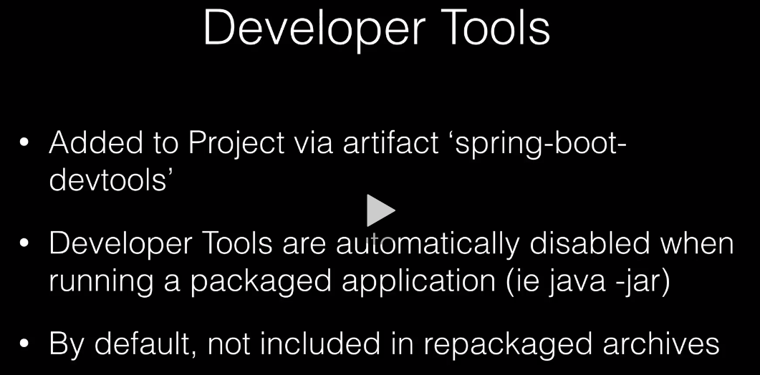

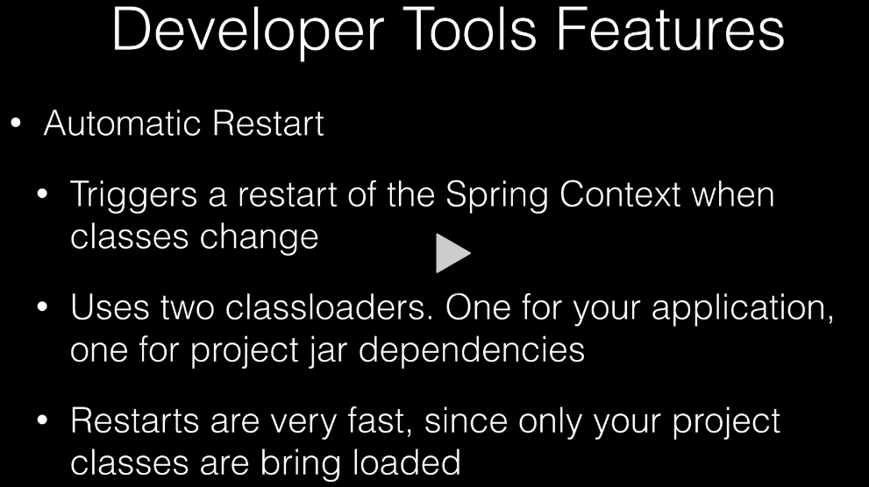

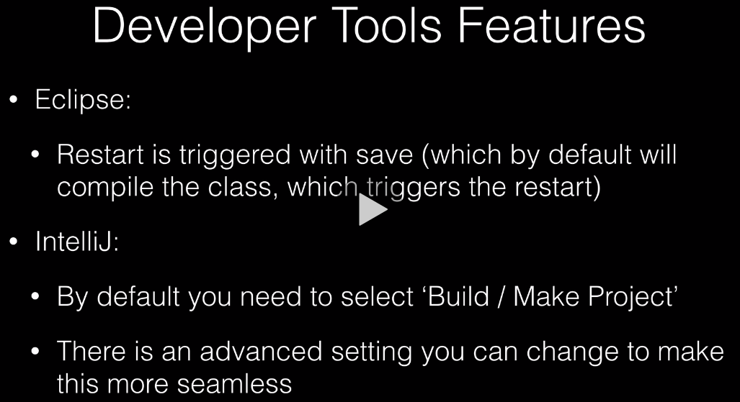

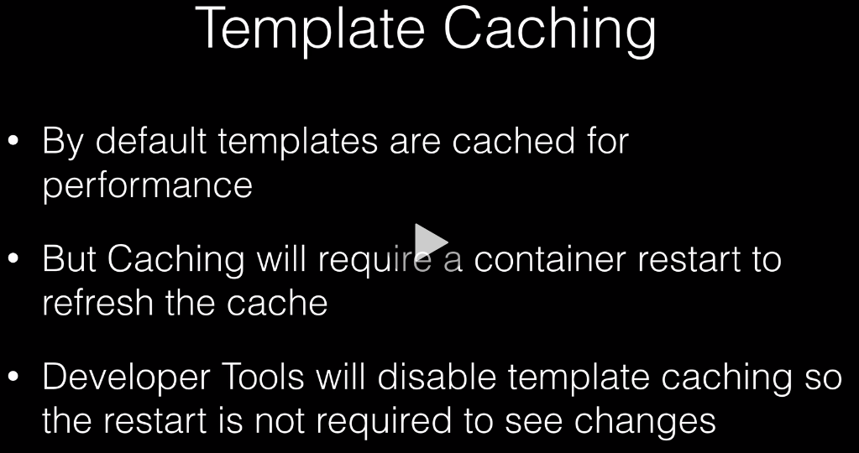



**Changes to Intellij Registry**

This saves having to select the ‘Build Project’ option after changes.

1. **Ctrl+Shift+A** Enter ‘Registry’ and select it.
2. Select ‘compiler.automake.allow.when.app.running’ and select it.
3. ‘File’, ‘Settings’, ‘Build,Execution,Deployment’,’Compiler’ then select ‘Build Project Automatically’
4. Restart the ‘ Intellij IDEA’.



